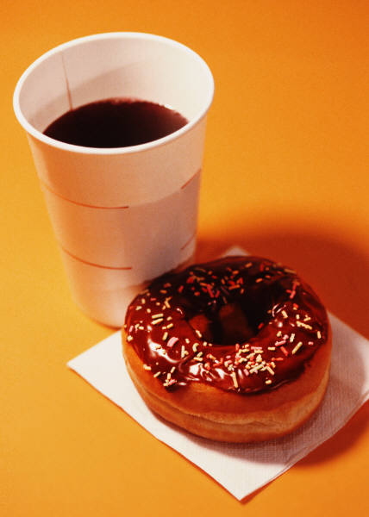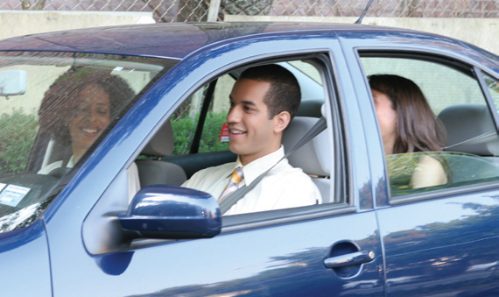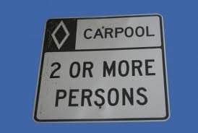

Earn a $25 Dunkin’ Donuts Gift Card!*

Carpool Challenge
April 1 – June 30, 2012

Employee Registration & Carpool Record

Please Print Clearly:
Name___________________________________________________________________
Company________________________________________________________________
Email (work preferred)_____________________________________________________
Round trip mileage (home to worksite)_________________________________________

Four round trips within one calendar month are required to receive the $25 Dunkin’ Donuts Gift Card.
(*Limited to one per person during the course of the Challenge)

Please list carpool dates:
______________________ _________________________ ______________________
______________________ _________________________ ______________________
______________________ _________________________ ______________________
______________________ _________________________ ______________________
______________________ _________________________ ______________________

I certify that I switched from driving alone to carpooling ________times to and from my worksite during the
month of________________ 2012, with ___________________________________________________,
April, May or June (name(s) of carpool partner(s)

(IF MORE THEN ONE NAME, PLEASE CONTINUE ON BACK OF THIS FORM)

_________________________________________________________________
Signature Date
I made the switch from driving alone to carpooling to work!

