Chopper timing calculations for HYSPEC

Author: M. Hagen

Issue/revision date: 1st January 2006
Revision number: 0

Revision history:
Rev. no. | Date | Pages | Subject | By whom
0 |  |  |  | M.H

Disclaimer: This is a working document and, while the content is provided in good faith, it is subject to revision. The content should not be assumed to construe any final decision or position on the subject of the document.
Table of Contents

Executive summary 3
Introduction 4
The T0 chopper open/close times and energies 6
Transmission profile of a disk chopper 11
Frame overlap conditions for 2 disk choppers 15
Fermi chopper burst times 18
General conditions for chopper matching 26
The HYSPEC T0 chopper conditions 27
The HYSPEC T2 Fermi chopper conditions 31
The HYSPEC T1A and T1B chopper conditions 32
References/bibliography 36

Executive summary

In order to determine the parameters for the choppers on the HYSPEC beamline a number of calculations have been performed. Analytic calculations have been performed to evaluate the “blocking” profile of the paddle shaped T0 chopper, the transmission profile of the single slot T1A and T1B disk choppers, the frame overlap conditions relating to T1A and T1B and the energy resolution for the T2 Fermi chopper. These calculations have been encoded into Excel spreadsheets and Fortran-90 computer code.

For the paddle shaped T0 chopper, located with its front edge 8.335m from the moderator the following parameters have been found to be effective.

Distance from rotation axis to center of blade = 250mm
Width of blade = 80mm
Height of blade = 186mm
Rotation rate = 30Hz
Phase accuracy required = ±50μs (preferred), ±100μs (possible)

For the T1A and T1B disk choppers, located respectively at 9.33m and 35.65m the following parameters have been found to be effective.

Distance from rotation axis to center of beam = 250mm
Single penetration
Angular opening of penetration = 21.68°
Inner radius of penetration <= 175mm
Outer radius of penetration >= 326mm
Rotation rate = 60Hz
Phase accuracy required = ±30μs

These parameters lead to a pulse of total length 1608μs that has 100% transmission for 400μs. Such a pulse will fully illuminate the T2 chopper but will not lead to order-contamination for T2 chopper frequencies up to 540Hz. The T1A and T1B choppers will reject frame overlap neutrons with energies above ~30μeV.

For the T2 Fermi chopper with a straight slotted (short blade) slit package, 10mm in length with 0.6mm spacing between absorbing slits, a phase accuracy of ±0.054% should be adequate. Specifically these are phase accuracies of ±1μs at 540Hz, ±3μs at 180Hz and ±9μs at 60Hz. This phase accuracy would lead to a 5% broadening of the resolution wdth.
Introduction

HYSPEC is a direct geometry spectrometer under construction at the spallation neutron source. It is to be located on beamline 14B where it will view a coupled cryogenic hydrogen moderator. The layout of the beamline has been described in the Design Criteria Document (DCD) [1] and a 3-d rendering is shown in Figure 1 below. Neutrons from the moderator exit through a Core Vessel Insert (CVI) and then pass through neutron guide, located firstly in the shutter, and then in the wall of the target monolith. On emerging from the target monolith the neutrons are further conducted by neutron guide to the first of the energy defining components in the beamline, chopper box A.

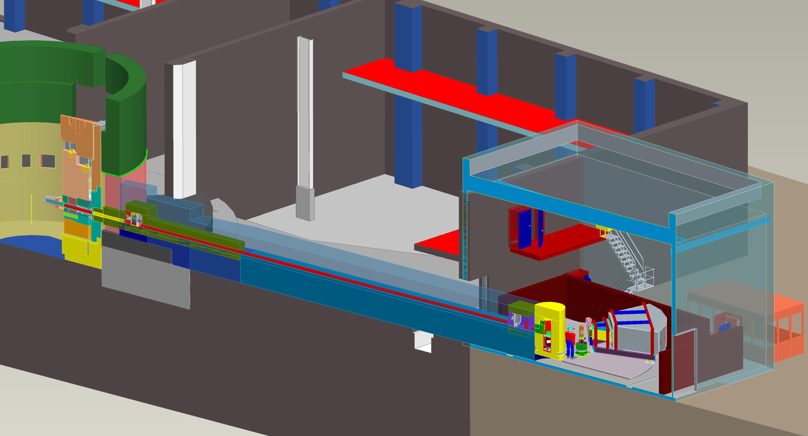
CVI
Shutter
External Building
Control Cabin
Detector Vessel
Sample
Chopper Box B
Drum Shield
Chopper Box A
Steel Shielding
Curved Beam Guide
Concrete Shielding
Figure 1: A 3-d rendering of the HYSPEC beamline from the Pro-E model.

In chopper box A there are two choppers, a T0 chopper and a disk chopper known as T1A. The purpose of the T0 chopper is to stop high energy neutrons in the range from a few eV up to 10’s of MeV from entering the remainder of the beamline. The disk chopper T1A works in combination with another disk chopper (known as T1B), which is to be described in a moment, to remove very low energy “frame overlap” neutrons from the beam. After passing through chopper box A the neutron beam is further carried by neutron guide out to the external building where the instrument part of the HYSPEC beamline is located. This guide that carries the beam out to the external building lies on a curved path so that there is no direct line of sight from the source out to the focusing crystal array (to be described in a moment) located in the external building.

At the end of the curved guide is located chopper box B, which again contains two choppers, the second disk chopper T1B and a straight slotted (short blade) Fermi chopper known as T2. The Fermi chopper T2 is the chopper that defines the incident energy of the neutrons for the beamline and will rotate at frequencies from 60Hz up to 540 or 600Hz. It is anticipated that it’s “normal” operating frequency will be 180Hz. As a consequence it will open multiple times during a 16667μs (i.e. 60Hz) SNS frame. In fact, because the blades/slots are straight, at 180Hz it will open 6 times during each frame. As a consequence it is necessary to block the 5 additional openings of the T2 chopper and this is the purpose of the T1B chopper, to act as an “order suppression” chopper. It is also, of course, the case that the T1B chopper is also working with the T1A chopper to remove frame overlap neutrons.

After passing through chopper box B the neutron beam is then focused onto the sample by Bragg scattering from a focusing crystal array located in a drum shield in the external building.

The choice of an incident energy E_{I} for the experiment requires the choppers to be phased to the production of the neutron pulse in the spallation source target/moderator. Thus to allow a nominal energy E_{I} to pass through a chopper at a distance L after the production of the pulse the chopper must be “open” at a time T given by

$$T=\text{2284}\frac{L}{\sqrt{E}}$$

where T is in μs, L is in m and E is in meV. This is the basic relationship between time of flight, distance and energy. In practice there can be a zero offset to the time, due to timing delays in electronics and also “uncertainty” in the time at which the pulse was produced. However these are issues not considered here.

In this report the calculations to determine the accuracy/precision with which the phase times for the choppers are presented. In doing this various other calculations, for example for the transmission profile of a disk chopper, need to be performed and these are also presented. The structure of the report is that initially the general formulae are derived in a series of sections of the report and then, later in the report, specific (numerical) calculations for HYSPEC are given.

The T0 chopper open/close times and energies

In Figure 2 below the arrangement of the T0 and T1A choppers on HYSPEC is shown. The purpose of the T0 chopper is to block the beam at time T = 0 (when the proton beam strikes the spallation source target) to stop high energy neutrons entering the beamline. To do this the T0 chopper has a “paddle” shape consisting of two blades and a hub, as shown conceptually in Figure 3. At time T = 0 one of the paddles is covering the beam to stop the fast neutrons. The paddle rotates with time and must therefore move (rotate) out of the beam so that by the time that the desired thermal neutrons for the experiment arrive at the location of the T0 chopper the beam is then fully open (the paddle blade has rotated out of the way).

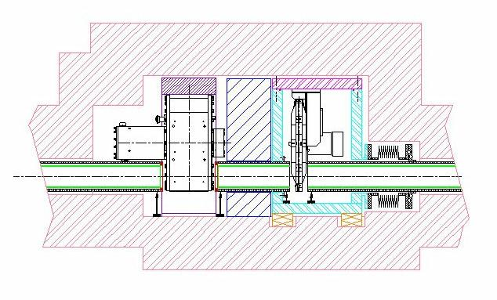  Chopper box A  T0 chopper  T1A disk chopper  Guide | 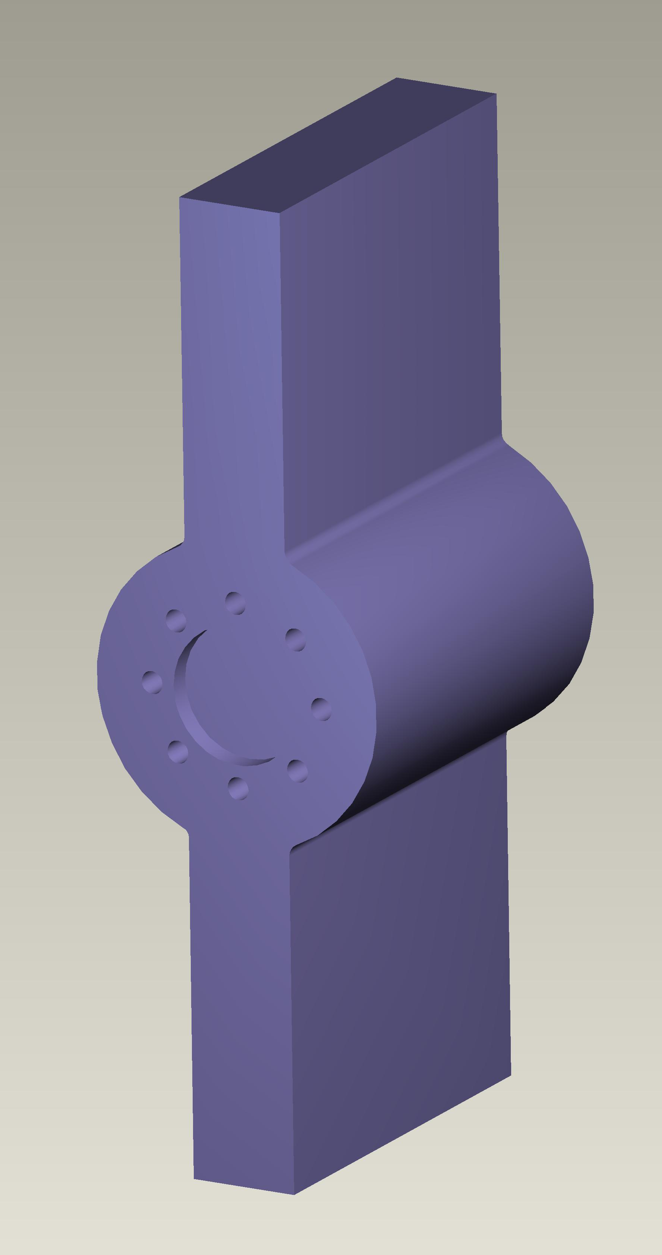
Figure 2: Chopper box A showing the T0 and T1A choppers | Figure 3: The T0 chopper blades and hub.

The time structure over which the chopper blade blocks the beam is shown schematically in Figure 4 below. The chopper blade must start to close off the beam some time before the proton beam strikes the target, and this will take an amount of time that we denote by t_{close}. Assuming

t_{phase}
t_{block}
time
t₁
t₂
t_{close}
t₃
T=0
t_{open}
Figure 4: A schematic representation of the fractional
“blocking” of the guide by the T0 chopper blade
that the size of the T0 chopper blade is wider than the width of the beam the blade will fully block the beam for a time t_{block}, after which the blade will start to uncover the beam. By symmetry the time taken for the blade to fully uncover the beam, t_{open}, is the same as that taken to fully close the beam.

It should be noted that the chopper fully closes at a time t_{phase} before the proton beam strikes the target, i.e. time t=0 and then starts to open at a time t₁ = (t_{block} – t_{phase}) and becomes fully open at a time t₂ = (t_{block} – t_{phase} + t_{open}). Thus we “block” all of the neutrons which arrive before time t₁ and transmit all neutrons that arrive after time t₂. We can convert the times t₁ and t₂ into energies via the formula
$$E={\left(\frac{\text{2284}L}{t}\right)}^{2}$$

The times t_{block} and t_{open} depend upon the geometry (dimensions) of both the guide (beam area) and the chopper blade. In the picture below the guide is shown in (a) and the chopper blade in (b). The common “center” below both the guide and the blade in (a) and (b) is the axis of rotation of the chopper paddle. The chopper blade must be oversized so that it will completely cover the guide area.

h_{G}
w_{G}
h_{B}
w_{B}
R₂
R₁
r₁
r₂
r₀
r₀
r₂
(a)
(b)
Figure 5: The guide and T0 chopper blade “dimensions”.

The various lengths r₀, r₁ and r₂ for the guide are given by

$$\begin{aligned}r_{1}=R_{0}−\frac{h_{G}}{2} \\ r_{2}=\sqrt{{\left(\frac{w_{G}}{2}\right)}^{2}+{\left(R_{0}+\frac{h_{G}}{2}\right)}^{2}} \\ r_{0}=\sqrt{r_{1}^{2}+{\left(\frac{w_{G}}{2}\right)}^{2}}\end{aligned}$$

The distances R₁ and R₂ on the blade must be such that R₁ < r₁ and R₂ > r₂ in order to ensure that there are never any “gaps” at the top or bottom of the guide. Hence we introduce an oversize parameter δ so that we have

$$\begin{aligned}R_{1}=r_{1}−δ \\ R_{2}=r_{2}+δ \\ h_{B}=R_{2}−\sqrt{R_{1}^{2}−{\left(\frac{w_{B}}{2}\right)}^{2}} \\ R_{B}=R_{2}−\left(\frac{h_{B}}{2}\right)\end{aligned}$$
We assume that the chopper is rotating anti-clockwise as we look at the page. Thus the chopper will first start to block the guide when the left hand edge of the chopper blade first crosses the bottom right hand corner of the guide face. In (b) above we represent this by the arrow r₀ on the left hand edge. If we imagine super-imposing the r₀ in (b) on top of the r₀ in (a) and then turning the blade across the face of the guide until r₀ lies parallel to r₂ in (a) then the angle turned by the chopper is

$${\text{sin}}^{−1}\left(\frac{w_{G}}{2r_{0}}\right)+{\text{sin}}^{−1}\left(\frac{w_{G}}{2r_{2}}\right)$$

However the chopper has not completely closed off the guide yet, it still has to turn a further angle until the left hand edge of the chopper crosses the top left point of the guide face. This is represented in (b) by the arrow r₂ (the radial distance to the top left corner). The extra angle to get to this position is therefore given by

$${\text{cos}}^{−1}\left(\frac{w_{B}}{2r_{2}}\right)−{\text{cos}}^{−1}\left(\frac{w_{B}}{2r_{0}}\right)$$

Thus the time taken for the chopper to close off the guide is given by

$$t_{\text{close}}=\frac{{\text{sin}}^{−1}\left(\frac{w_{G}}{2r_{0}}\right)+{\text{sin}}^{−1}\left(\frac{w_{G}}{2r_{2}}\right)+{\text{cos}}^{−1}\left(\frac{w_{B}}{2r_{2}}\right)−{\text{cos}}^{−1}\left(\frac{w_{B}}{2r_{0}}\right)}{2πf}$$

Now the chopper continues to block the guide until the right hand edge of the chopper blade passes the top right corner of the guide face. In (b) this corresponds to the mirror image of r₂. Thus the time for which the chopper fully blocks the guide is

$t_{\text{block}}=\frac{2\left[{\text{tan}}^{−1}\left(\frac{w_{B}}{2r_{2}}\right)−{\text{tan}}^{−1}\left(\frac{w_{G}}{2r_{2}}\right)\right]}{2πf}$

The T0 chopper spreadsheet calculator
In order to evaluate these equations an Excel spreadsheet calculator (T0 chopper calculator_2.xls) has been written, see below.

How the spreadsheet calculator for T0 chopper works

What are the different input values?

W_G = width of guide, h_G = height of guide

L_chop = distance from moderator to front edge of T0 chopper blade

R_0 = distance from rotation axis to middle of T0 chopper blade

Phase_shift = the time shift of the center of the T0 in us from the “symmetric” position

The phase_shift needs a bit more explanation. Imagine the situation at time T=0 when the proton beam strikes the target and the fast neutrons are produced. First consider the case when the chopper blade is symmetrically covering the guide opening. The middle axis of the chopper passes through the middle axis of the guide. Now assume that the chopper blade is wider (& taller) than the guide. If we rotate the axis off to one side of the center of the guide the chopper blade can still “cover” all of the guide at T=0. Using the velocity of the chopper we can convert this offset displacement of the chopper into a phase_shift in time. In my notation here phase_shift=0 means the chopper is in the symmetric position, a negative time eg. Phase_shift =-50us, means the chopper will pass the symmetric position after the T=0 time, and a positive phase_shift means it will pass the symmetric position before the T=0 time.

The phase_shift is important in getting the T0 chopper to “work”.

Variables in the spreadsheet blocks

W_B = width of T0 blade
H_B = required height of T0 blade to make sure that all of guide area is covered.
R_B = radial distance from center of rotation to center of T0 chopper blade
F = frequency of T0 chopper in Hz
Omega = frequency of T0 chopper in rads/s

T_open = time in us that the T0 chopper takes to completely close (or open) the area of the guide

T_blocked = the amount of time in us for which the area of the guide is completely blocked by the blade of the T0 chopper

T_phase = the time in us after the T0 chopper closes that the “T=0” (proton beam strikes target) situation occurs. It’s values in the two blocks are as follows.

- In the top block. T_phase = ½ of T_blocked, this is the situation when the chopper symmetrically blocks the guide.
- In the bottom block we have applied the phase_shift so that T_phase = ½ of T_blocked + phase_shift. Note if T_phase goes negative there is a big problem the T0 chopper is (partially) open at T=0.

T_1 and E_1 = the time and neutron energy at which the T0 chopper blade first starts to “uncover” the area of the guide. So the T0 chopper blocks all neutrons with energies E > E_1. The E’s are in meV.

T_2 and E_2 = the time and energy at which the T0 chopper blade has completely uncovered the area of the guide. So all neutrons with energies E < E_2 are transmitted.

Obviously we want E_2 > 90meV, preferably E_2 ~ 100meV. On the other hand we’d like E_1 to be as low as possible, preferably of order 1eV.

So the game is to choose a phase_shift and a value of W_B that gives us the E_2 ~100meV and E_1 as low as possible for L_chop = 8.335m and f=30Hz.

Transmission profile of a disk chopper
As noted earlier the HYSPEC beamline has two disk choppers, T1A and T1B, which are involved in frame overlap rejection and order suppression. T1A is located in chopper box A (see Figure 2) and T1B in chopper box B (see Figure 6). In order to work out the effectiveness for both frame overlap and order suppression purposes we need to now the transmission profile for such a disk chopper. Consequently in this section we work out the transmission profile equations for a generic disk chopper.

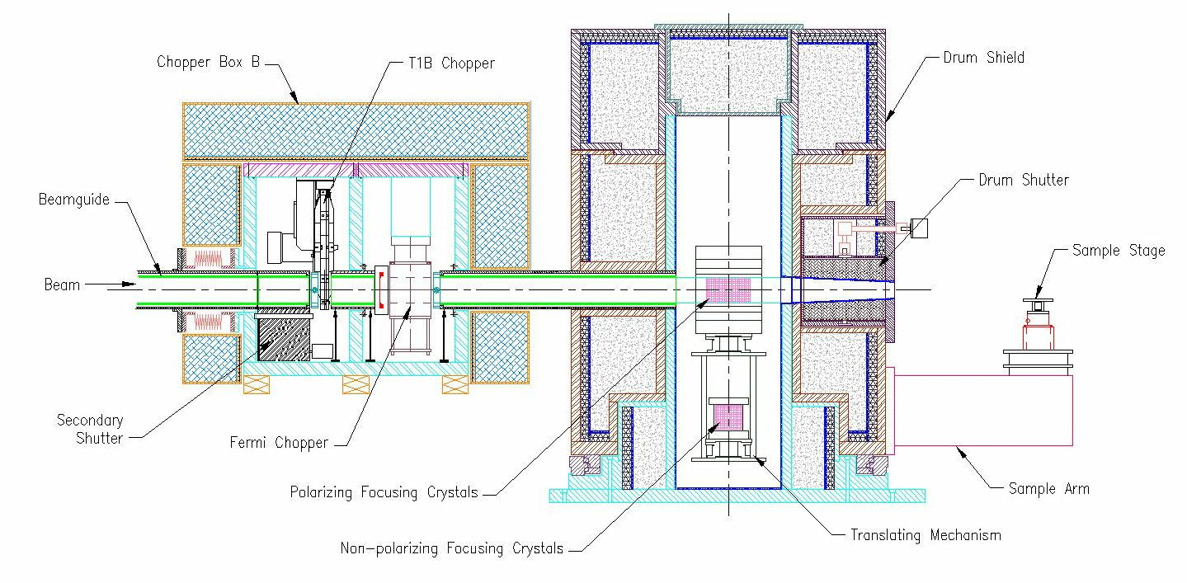
Figure 6: The location of chopper box B containing the T1B and T2 choppers.

In Figure 7 a schematic layout of the disk chopper and slot is shown. We define axes O-X and O-Y with the beam guide at the top, symmetric about O-Y. A blow-up of the beam guide and slot is given in Figure 8. The beam guide is w_{g} wide and h_{g} tall and its center is located a distance R₀ along O-Y. Note O is the rotation axis for the disk chopper. The open slot of the disk chopper is taken to be an angle α wide and the axis O-S bisects the open slot. The axis O-u is the leading edge of the slot and O-v the closing (trailing) edge, and we envisage the chopper rotating with angular frequency ω in a counter-clockwise direction.

The 4 corners of the guide are labeled a, b, c and d as shown in Figure 8 and we set up the timing in the calculation so that at time t=0 the leading edge of the slot O-u just passes through point a (the lower left corner) of the guide. As the leading edge O-u crosses the face of the guide neutrons can pass through the chopper slot. The number of neutrons is simply proportional to the uncovered area of the guide. Hence to work out the transmission profile of the guide we work out the uncovered area of the guide as a function of time.

Before starting on the calculation we can make use of a condition that will be true for our needs and also some symmetry arguments. Firstly if we look at Figure 8 the base of the guide subtends an angle 2θ_{a} = tan⁻¹( ½ w_{g} / (R₀ – ½ h_{g}) ) and we apply the condition that the open angle of the disk slot α > 2θ_{a} which means that there is a period of time over which the guide is fully uncovered (i.e. transmission profile = 1). In fact it is easy to work out this amount of time, which we can call t_{full}, and which will just be given by
$$t_{\text{full}}=\frac{α−2θ_{a}}{ω}=\frac{1}{ω}\left[α−2{\text{tan}}^{−1}\left(\frac{12w_{g}}{R_{0}−12h_{g}}\right)\right]$$

One can also apply symmetry to the situation. Starting at time t=0 the leading edge O-u opens the area of the guide and when O-u passes corner d of the guide the guide is fully open. If we continue the motion of the slot until the bisector O-S is parallel to the axis O-Y then the slot is

O  S  v  u  Y  X | a  b  d  c  w_{g}  R₀  α  θ_{a}  Y  O  u  h_{g}  X  S  v
Figure 7: Schematic layout of the disk chopper and beam guide | Figure 8: A blow-up of the geometry for the beam guide and chopper slot

now symmetric about the guide. It takes a time t_{S} = (θ_{a} + ½ α)/ω for the bisector O-S to rotate from its position at t=0 to now be along O-Y. By symmetry when O-S is along O-Y we are half way through the transmission profile. In the period of time 0 < t < t_{S} we have been uncovering the guide, in the period of time from t_{S} < t < 2 t_{S} we start to cover-up the guide. So the time 2 t_{S} is the total amount of time that (any part of the guide) is uncovered, let’s call it t_{base} and it is given by
$$t_{\text{base}}=2\left(\frac{θ_{a}+12α}{ω}\right)=\frac{1}{ω}\left(α+2{\text{tan}}^{−1}\left(\frac{12w_{g}}{R_{0}−12h_{g}}\right)\right)$$

It should be noted that another way of doing this calculation is to look at Figure 8 and observe that the guide will be open from time t=0 (the situation shown in Figure 8) until the trailing edge O-v rotates to pass through point d. The angle between O-v as shown in Figure 8 and the line O-d is (2 θ_{a} + α) and therefore t_{base} = (2 θ_{a} + α) / ω which is the same as 2 t_{S}.

Thus we can already sketch out the transmission profile for the disk chopper, which is shown in Figure 9 below. In many respects this sketch and the formulae for t_{base}, t_{full}, and t_{S} are all we really need, however we will now calculate the full profile, although if we use the symmetry information all we need to do is to calculate for 0 < t < t_{S} and then reflect in t = t_{S} to get the full profile.

t_{full}
time
t_{S}
t=0
t_{base}
1
Figure 9: Sketch of disk chopper transmission profile.

In order to do the full calculation we first need to write down the angles for the 4 corners of the guide, these are
$$\begin{aligned}θ_{a}=−{\text{tan}}^{−1}\left(\frac{12w_{g}}{R_{0}−12h_{g}}\right) \\ θ_{b}=−{\text{tan}}^{−1}\left(\frac{12w_{g}}{R_{0}+12h_{g}}\right) \\ θ_{c}={\text{tan}}^{−1}\left(\frac{12w_{g}}{R_{0}+12h_{g}}\right) \\ θ_{d}={\text{tan}}^{−1}\left(\frac{12w_{g}}{R_{0}−12h_{g}}\right)\end{aligned}$$

Next we need the times at which the leading edge O-u passes the corners b, c and d, remembering that when edge O-u is at point a we are at t=0. Thus the relevant times are

$$t_{b}=\frac{θ_{b}−θ_{a}}{ω}\text{ ; }t_{c}=\frac{θ_{c}−θ_{a}}{ω}\text{ ; }t_{d}=\frac{θ_{d}−θ_{a}}{ω}$$

We now break the time range 0 < t < t_{S} into 4 ranges and use straightforward triangular and trapezoidal geometry to work out the uncovered areas as follows.

0 < t < t_{b}
$$A=\frac{1}{2}\left[\frac{1}{2}w_{g}−\left(r_{0}−\frac{1}{2}h_{g}\right)\text{tan}\left|θ\right|\right]×\left[\frac{12w_{g}}{\text{tan}\left|θ\right|}−\left(r_{0}−\frac{1}{2}h_{g}\right)\right]$$

t_{b} < t < t_{c}
$$A=\left[\frac{1}{2}w_{g}+r_{0}\text{tan}θ\right]×h_{g}$$

t_{c} < t < t_{d}
$$A=w_{g}h_{g}−\frac{1}{2}\left[\frac{1}{2}w_{g}−\left(r_{0}−\frac{1}{2}h_{g}\right)\text{tan}θ\right]×\left[\frac{12w_{g}}{\text{tan}θ}−\left(r_{0}−\frac{1}{2}h_{g}\right)\right]$$

t_{d} < t < t_{S}
$$A=w_{g}h_{g}$$

where in all 4 ranges we parametrically use $θ=ωt+θ_{a}$. The second half of the time range, t_{S} < t < 2 t_{S,} is then obtained by symmetry. In order to this into a “transmission” profile we need to normalize the area uncovered A by the full area of the guide $A=w_{g}h_{g}$ so that the transmission a is given by $a=A/{\left(w_{g}h_{g}\right)}$.

These equations have been encoded into a FORTRAN-90 program (t1b_open.for) which can be used to calculate the transmission profile. In Figure 10 below an example is given calculated for a chopper rotating at a frequency of 60Hz (ω=120π rads.s⁻¹) with α=14°, w_{g}=0.04m, h_{g}=0.15m, R₀=0.27m and hence 2θ_{a} =11.71°.
Figure 10: Example of a transmission profile for a disk chopper.

Frame overlap conditions for 2 disk choppers
As described in the introduction the T0 chopper removes high energy neutrons from the beam, while it is the combination of the T1A and T1B disk choppers that remove the low energy (frame overlap) neutrons from the beam. These “frame overlap” neutrons are neutrons that have such a low energy (low velocity) that they travel down the beamline so slowly that the next pulse (or pulses) from the SNS overtake these neutrons. Consequently the neutrons arrive a number of frames behind the frame in which they were produced.
M=1
M=2
M=3
M=4
N=1
N=2
N=3
Time
Distance
L_{1A}
L_{1B}
Frame 1
Frame 2
Frame 3
Frame 4
Figure 11: Schematic example of frame overlap neutrons.

In Figure 11 a schematic of the situation for frame overlap neutrons is shown for two disk choppers (T1A and T1B) located at distances L1A and L1B along the beam line. Neutrons are produced as a white neutron pulse at time T=0 in frame 1. The neutrons of a desired energy travel down the beamline according to the solid line in frame 1, passing through the T1A and T1B choppers that are phased to be open at the relevant times. Neutrons that arrive at the T1A chopper at other times are absorbed because the chopper is closed, with the following exceptions. The neutrons with a velocity such that they follow the dashed line path labeled N=1 in Figure 11 will arrive at T1A when it is open in frame 2 for the desired neutrons to pass. In fact low energy neutrons from the pulse in frame 1 will “sneak” through every time that T1A opens for the desired neutrons in subsequent frames (N=1,2,3,… in Figure 11). The question then arises, will these neutrons also pass through the T1B chopper or will the T1B chopper block them (cf. the situation for the N=1 neutrons in Figure 11)?

The aim of the calculation here is to work out what is the lowest value of N for which neutrons will get through both the T1A and T1B choppers and will be “frame overlap” neutrons. It should be noted that these neutrons will still have to pass through the T2 Fermi chopper, and that there is a low energy cut-off below which neutrons cannot pass through the T2 chopper. The practical aim is therefore to arrange the T1A and T1B choppers so that the frame overlap neutrons that can pass through them is below the cut-off of the T2 chopper.

The first step in calculating a formula for the frame overlap neutrons is to define the times at which neutrons pass through the T1A and T1B choppers. The times when the desired neutrons arrive at the T1A and T1B are T_{1A} and T_{1B} and are given by the standard relations below. Thus if the periodic time for the T1A to open is τ_{1A} then subsequent N^{th} order frame overlap pulses pass through the T1A at the times T_{N} as given below. A similar formula applies to the subsequent opening times for the T1B chopper, which occur periodically every τ_{1B} and therefore occur at time T_{M} is given below.
$\begin{aligned}T_{1A}=\text{2284}\frac{L_{1A}}{\sqrt{E}} \\ T_{N}=T_{1A}+τ_{1A}N\end{aligned}$ $\begin{aligned}T_{1B}=\text{2284}\frac{L_{1B}}{\sqrt{E}} \\ T_{M}=T_{1B}+τ_{1B}M\end{aligned}$

Of course the T1A and T1B choppers don’t just open at a single time but instead are open for a range of times. We’ll denote these times as 2ΔT_{1A} and 2ΔT_{1B} so that we can describe the time ranges as T_{N} ± ΔT_{1A} and T_{N} ± ΔT_{1B} respectively. The pulse that passes through the T1A chopper will spread out in time as it passes down the beamline and what we have to compare is the “spread out” time range from the T_{N} pulse with the time ranges when the T1B chopper is open. The spreading of the T1A pulse is given by multiplying by (L_{1B}/L_{1A}) and therefore we are looking for an intersection given by

$$\left(\frac{L_{1B}}{L_{1A}}\right)\left(T_{N}±{ΔT}_{1A}\right)∩\left(T_{M}±{ΔT}_{1B}\right)$$

If we substitute in the formulae for T_{N} and T_{M} then we can manipulate this into the inequality

$$\frac{τ_{1B}}{\left({ΔT}_{1A}+{ΔT}_{1B}\right)}\left|M−\left(\frac{L_{1B}}{L_{1A}}\right)\left(\frac{τ_{1A}}{τ_{1B}}\right)N\right|≤1$$

which corresponds to an intersection of the spread out T_{N} pulse with the times at which the T1B is open. Therefore we need to search through the values of M and N to find out when this inequality is first satisfied. However we can simplify this a little by noting that we don’t have to search the M values, the term within the absolute brackets is a minimum when M satisfies the condition

$$M=\text{nint}\left(\left(\frac{L_{1B}}{L_{1A}}\right)\left(\frac{τ_{1A}}{τ_{1B}}\right)N\right)$$

and therefore we just have to search through the values of N to find the first N value for which the inequality is satisfied.

Once the value of N has been found the energy of the frame overlap neutrons can be found from the relation.

$$E_{N}={\left(\frac{1}{\sqrt{E_{i}}}+\frac{τ_{1A}N}{\text{2284}L_{1A}}\right)}^{−2}≈{\left(\frac{\text{2284}L_{1A}}{τ_{1A}N}\right)}^{2}$$

where the approximation is true once N > 4 or 5 for L_{1A} = 9.35m and τ_{1A} = 16667μs.

Frame overlap calculator
In order to evaluate the frame overlap conditions an Excel spreadsheet calculator (frame_overlap_2.xls) has been written, see below

The spreadsheet input is reasonably obvious. L1A and L1B are the distances of the T1A and T1B from the source in m. The dT1A and dT1B are the ΔT_{1A} and ΔT_{1B} in the equations above in μs. The tau_1A and tau_1B are the times τ_{1A} and τ_{1B} in the equations. In order to set the values tau_1A and tau_1B in the spreadsheet one must set the values for Freq_1A and Freq_1B. A little care should be taken here, this is not necessarily the frequency of the chopper if the chopper has more than one opening. If the chopper only has one slot then obviously it is the same frequency.

The output from the spreadsheet is in the first instance fairly obvious. For each of the values of N from 1 to 10 the value of M is calculated from the equation above and then the value on the left hand side of the inequality evaluated and presented in the “Value” row. In the example above the inequality is clearly only satisfied for N=7 and one enters 7 in for the “N overlap=” and the spreadsheet then calculates the energy of the frame overlap neutrons EN and their flight time to the T1A chopper for incident neutron energies E (=3.6 and 90 meV) who have a flight time “T1A” at the T1A chopper. In the example above the frame overlap neutrons are circa 30μeV neutrons, very low energy.

Fermi chopper burst times
The straight slotted Fermi chopper (known as T2) on HYSPEC monochromates the incident neutron energy and therefore plays a substantial role in determining the energy reolsution and intensity in the experiment. In this section formulae are developed to determine the energy resolution. From these formulae we can assess (a) the timing/phase accuracies required to maintain the desired resolution and (b) the required time widths of the pulse that emerges from the T1B chopper in order for that pulse to fully illuminate the T2 chopper, and hence ensure the maximum intensity.

The energy resolution formula
In Figure 12 below a schematic layout of HYSPEC is shown indicating the various components and distances required for the calculation of the energy resolution.
L_{MC}
L_{CS}
L_{SD}
Moderator
Fermi chopper
Focusing crystals
Sample
Detectors
τ_{M}
Δt_{C}
Figure 12: A schematic layout for HYSPEC in order to calculate the energy resolution.

Neutrons of energy E_{I} are emitted from the moderator in a pulse of FWHM τ_{M} and travel a distance L_{MC} from the moderator to the Fermi chopper. It should be note that the time width of the pulse τ_{M} is energy dependent and varies from ~200μs at energies ~3meV to ~10μs at ~100meV. The Fermi chopper has a (FWHM) burst time of Δt_{C} and in a triangular approximation is therefore open for a time 2 Δt_{C}. Those neutrons that pass through the Fermi chopper continue on for a distance L_{CS} from the Fermi chopper to the sample. At the sample the neutrons are scattered inelastically and then travel a distance L_{SD} from the sample to one of the detector tubes.

The effect of the pulse width in the moderator and the burst time of the chopper mean that there is a (FWHM) spread in the incident energy given by

$$\frac{{ΔE}_{I}}{E_{I}}=2\frac{{ΔT}_{I}}{T_{I}}=2\frac{\sqrt{{\left(τ_{M}\right)}^{2}+{\left({Δt}_{C}\right)}^{2}}}{T_{\text{MC}}}≈2\frac{τ_{M}}{T_{\text{MC}}}=\frac{τ_{M}}{\text{1142} L_{\text{MC}}}\sqrt{E_{I}}$$

where the last result is true if $τ_{M}\text{>>}{Δt}_{C}$and the flight time T_{MC} from moderator to chopper is given by

$$T_{\text{MC}}=\text{2284}\frac{L_{\text{MC}}}{\sqrt{E_{I}}}$$

A similar uncertainty occurs in our knowledge of the final energy where the error in the final energy of the neutron is

$$\frac{{ΔE}_{F}}{E_{F}}=2\frac{{ΔT}_{S}}{T_{F}}$$

where ΔT_{S} is the “burst time” at the sample, and the final flight time is

$$T_{F}=\text{2284}\frac{L_{\text{SD}}}{\sqrt{E_{F}}}$$

The burst time at the sample comes from two effects, one is the burst time of the chopper Δt_{C} and the other is the energy (velocity) spread of the pulse ΔE_{I} (Δv_{I}) of the pulse. We assume that these two add in quadrature so that

$$\begin{aligned}{ΔT}_{S}=\sqrt{{\left({Δt}_{C}\right)}^{2}+{\left(\frac{∂T_{\text{CS}}}{∂v}Δv\right)}^{2}} \\ \sqrt{{\left({Δt}_{C}\right)}^{2}+{\left(\frac{L_{\text{CS}}}{v}\frac{Δv}{v}\right)}^{2}}\end{aligned}$$

Now the velocity distribution is given by

$$\frac{Δv}{v}=\frac{{ΔT}_{i}}{T_{I}}=\frac{{ΔT}_{i}}{L_{\text{MC}}}v$$

and hence the time spread is given by

$$\begin{aligned}{ΔT}_{S}=\sqrt{{\left({Δt}_{C}\right)}^{2}+{\left(\frac{L_{\text{CS}}}{L_{\text{MC}}}{ΔT}_{I}\right)}^{2}} \\ {Δt}_{C}\sqrt{1+{\left(\frac{L_{\text{CS}}}{L_{\text{MC}}}\frac{ΔT}{{Δt}_{C}}\right)}^{2}} \\ {Δt}_{C}\sqrt{1+{\left(\frac{L_{\text{CS}}}{L_{\text{MC}}}\right)}^{2}\left(\frac{τ_{M}^{2}+{Δt}_{C}^{2}}{{Δt}_{C}^{2}}\right)}\end{aligned}$$

If we substitute back into the equation for ΔE_{F} then we obtain

$$\begin{aligned}\frac{{ΔE}_{F}}{E_{F}}=2\frac{{Δt}_{C}}{T_{F}}\sqrt{1+{\left(\frac{L_{\text{CS}}}{L_{\text{MC}}}\frac{ΔT}{{Δt}_{C}}\right)}^{2}} \\ \frac{{Δt}_{C}}{\text{1142} L_{\text{SD}}}\sqrt{1+{\left(\frac{L_{\text{CS}}}{L_{\text{MC}}}\frac{ΔT}{{Δt}_{C}}\right)}^{2}}\sqrt{E_{F}} \\ \frac{{Δt}_{C}}{\text{1142} L_{\text{SD}}}{\left[1+{\left(\frac{L_{\text{CS}}}{L_{\text{MC}}}\right)}^{2}\left(\frac{τ_{M}^{2}+{Δt}_{C}^{2}}{{Δt}_{C}^{2}}\right)\right]}^{12}\sqrt{E_{F}}\end{aligned}$$

If we ask what the absolute energy resolution is then we can get it from the following

$$\begin{aligned}ΔE=\sqrt{{\left({ΔE}_{I}\right)}^{2}+{\left({ΔE}_{F}\right)}^{2}} \\ \frac{1}{\text{1142}}\sqrt{\left(\frac{τ_{M}^{2}+{Δt}_{C}^{2}}{L_{\text{MC}}^{2}}\right)E_{I}^{3}+{\left(\frac{{Δt}_{C}}{L_{\text{SD}}}\right)}^{2}\left[1+{\left(\frac{L_{\text{CS}}}{L_{\text{MC}}}\right)}^{2}\left(1+\frac{τ_{M}^{2}}{{Δt}_{C}^{2}}\right)\right] E_{F}^{3}}\end{aligned}$$

In order to make use of this formula we need to have values for the pulse width τ_{M} and the Fermi chopper burst time Δt_{C}. These are dealt with in the following two subsections.

The moderator pulse width
The “pulse” produced in the moderator of a spallation source consists of a wide range of neutron energies and the time distribution of that white pulse is a complicated superposition of energy and time distributions. However when MCNP simulations are performed we can separate out pulses for different neutron energies and, for the purposes of our resolution calculations this is extremely useful. Simulations have been performed for various moderators at the SNS by E. Iverson[2]. For HYSPEC we are interested in the coupled hydrogen moderator, and in particular the results contained in the file hl211f_td_05.dat, which although it is for beamline 5, is for a coupled hydrogen moderator. In Figure 13 below results extracted from this file are shown for a “pulse” of 50meV neutrons as an example. There are a number of things that can be seen from this figure. Firstly there is a non-zero width to this pulse, i.e. a value for the pulse width τ_{M}. Secondly this is an asymmetric lineshape with a tail to long times. Finally the “peak” flux of neutrons is not at time zero, but in this particular case is at ~20μs. All three of these effects are energy dependent and in Figure 14 and Figure 15 below we show plots of the variation of the FWHM and peak flux position with neutron energy extracted from the file hl211f_td_05.dat.
Figure 13: Pulse shape for 50meV neutrons.

As noted earlier there is a large variation of the FWHM τ_{M} with neutron energy from ~200μs at ~3meV up to ~10μs at ~100meV. In order to include values in the resolution calculation we can
Figure 14: The variation of the FWHM of the pulse with energy.
numerically interpolate using the solid line shown in Figure 14. The peak position of the flux, Figure 15, also shows a large variation with incident energy. Such a variation will play a role when setting the chopper phasing times for a particular energy but it is a zero offset effect rather than an effect that determines the precision/accuracy with which the chopper phase times must be set.
Figure 15: The variation of the peak position of the pulse with energy.

The burst time of the Fermi chopper
The straight slotted Fermi chopper can be modeled in a simple way by considering Figure 16 below. The chopper slit package consists of an array of straight slots, of width W and length L

A
B
W
O
L
ω
Z
Figure 16: Schematic of the straight slotted Fermi chopper for calculating the burst time.

with absorbing edges. These slots are rotating at an angular frequency ω = 2πf and we can see that if the neutrons are traveling along the O-Z direction the slit is “open” from the time when the corner A passes through O-Z to the time that the corner B passes through O-Z. In order notation this “open time” is 2 Δt_{C}, two times the burst time. Thus we can obtain a formula for the burst time as follows.
$$\begin{aligned}\text{angle }\text{AOB}=2{\text{tan}}^{−1}\left(\frac{W}{L}\right) \\ 2{Δt}_{C}=\frac{2{\text{tan}}^{−1}\left(\frac{W}{L}\right)}{ω} \\ {Δt}_{C}=\frac{1}{2πf}{\text{tan}}^{−1}\left(\frac{W}{L}\right)\end{aligned}$$

Matching incident and final energy resolutions
The energy resolution formula has two parts, the incident and final energy resolutions. Across the energy transfer range of a spectrum the incident resolution component remains constant and the final energy resolution varies. The resolution components are said to be matched when they are equal to each other. From our previous formula for the resolution the energy transfer at which the incident and final beam resolutions are matched can be calculated as follows;

$$\begin{aligned}\left(\frac{τ_{M}^{2}+{Δt}_{C}^{2}}{L_{\text{MC}}^{2}}\right)E_{I}^{3}={\left(\frac{{Δt}_{C}}{L_{\text{SD}}}\right)}^{2}\left[1+{\left(\frac{L_{\text{CS}}}{L_{\text{MC}}}\right)}^{2}\frac{τ_{M}^{2}+{Δt}_{C}^{2}}{{Δt}_{C}^{2}}\right] E_{F}^{3} \\ \frac{E_{I}^{3}}{E_{F}^{3}}={\left(\frac{L_{\text{MC}}}{L_{\text{SD}}}\right)}^{2}\frac{{Δt}_{C}^{2}}{τ_{M}^{2}+{Δt}_{C}^{2}}\left[1+{\left(\frac{L_{\text{CS}}}{L_{\text{MC}}}\right)}^{2}\frac{τ_{M}^{2}+{Δt}_{C}^{2}}{{Δt}_{C}^{2}}\right] \\ {\left(\frac{L_{\text{MC}}}{L_{\text{SD}}}\right)}^{2}\left[{\left(\frac{L_{\text{CS}}}{L_{\text{MC}}}\right)}^{2}+\frac{{Δt}_{C}^{2}}{τ_{M}^{2}+{Δt}_{C}^{2}}\right]\end{aligned}$$

which means if we rearrange this last equation that the incident and final resolution is matched when
$$\begin{aligned}{\left(\frac{E_{F}}{E_{I}}\right)}^{3}={\left(\frac{L_{\text{SD}}}{L_{\text{MC}}}\right)}^{2}{\left[{\left(\frac{L_{\text{CS}}}{L_{\text{MC}}}\right)}^{2}+\frac{{Δt}_{C}^{2}}{τ_{M}^{2}+{Δt}_{C}^{2}}\right]}^{−1} \\ 1−\frac{E}{E_{I}}={\left(\frac{L_{\text{SD}}}{L_{\text{MC}}}\right)}^{2/3}{\left[{\left(\frac{L_{\text{CS}}}{L_{\text{MC}}}\right)}^{2}+\frac{{Δt}_{C}^{2}}{τ_{M}^{2}+{Δt}_{C}^{2}}\right]}^{{−1}/3} \\ \frac{E}{E_{I}}=1−{\left(\frac{L_{\text{SD}}}{L_{\text{MC}}}\right)}^{2/3}{\left[{\left(\frac{L_{\text{CS}}}{L_{\text{MC}}}\right)}^{2}+\frac{{Δt}_{C}^{2}}{τ_{M}^{2}+{Δt}_{C}^{2}}\right]}^{{−1}/3}\end{aligned}$$

At this energy transfer the energy resolution is given by

$$\frac{ΔE}{E_{i}}=\sqrt{2}\frac{\sqrt{τ_{M}^{2}+{Δt}_{C}^{2}}}{\text{1142}L_{\text{MC}}}\sqrt{E_{i}}=2\sqrt{2}\frac{{ΔT}_{i}}{T_{i}}=\sqrt{2}\frac{{ΔE}_{i}}{E_{i}}$$

which is just what one would expect since the incident and final energy resolutions are “matched” (i.e. equal).

Comparison with Monte Carlo Results
The formulae developed for the Fermi chopper burst time and energy resolution are analytic approximations. For example, on HYSPEC there is a neutron guide that transports the neutrons from the source to the Fermi chopper, which will mean that the neutron beam incident on the Fermi chopper has a divergence. This divergence can lead to a broadening of the burst time for the chopper. Monte Carlo simulations of neutron transmission along a model of the HYSPEC beamline have been performed and a comparison of the burst time Δt_{C} and incident energy width “measured” after the Fermi chopper in the Monte Carlo and calculated from the approximations is given in Table 1 below. These results correspond to a moderator to Fermi chopper distance of L_{MC}=35.4m and chopper slits of width W=0.6mm, and length L=10mm. The analytic approximation values are in blue.

Table 1: Values for the Fermi chopper burst times from the McStas simulations.
Energy (meV) | 180Hz |  | 60Hz |  | 360Hz
Energy (meV) | ΔT (μs) | ΔE_{i} (meV) | ΔT (μs) | ΔE_{i} (meV) | ΔT (μs) | ΔE_{i} (meV)
3.6 | 56 [53] | 0.032 [0.030] | 172 [159] | 0.047 [0.039] | 29 [26] | 0.032 [0.029]
5.0 | 55 [53] | 0.046 [0.045] | 169 [159] | 0.072 [0.061] | 29 [26] | 0.044 [0.043]
15 | 55 [53] | 0.166 [0.122] | 167 [159] | 0.331 [0.248] | 27 [26] | 0.132 [0.102]
30 | 55 [53] | 0.308 [0.240] | 166 [159] | 0.820 [0.655] | 27 [26] | 0.200 [0.151]
60 | 55 [53] | 0.800 [0.628] | 162 [159] | 2.053 [1.836] | 26 [26] | 0.413 [0.340]
90 | 51 [53] | 1.325 [1.140] | 162 [159] | 3.399 [3.368] | 26 [26] | 0.701 [0.599]

In general the agreement between the analytic approximation and the Monte Carlo is good, indicating that the analytic approximation can be used for calculations where a value within 10% to 20% is required. The discrepancies are bigger for the energy distribution than for the burst time, which indicates that the “tail” of the pulse shape (cf. Figure 13) is leading to a wider range of energies to reaching the Fermi chopper than is expected from the analytic “FWHM” formula.

In Figure 17 below results for the energy resolution are plotted for energies from 3.6meV up to 90meV. The axes of the plot are scaled by the incident energy E_{i} so that they will all be clearly observable on the same plot. The values used to determine the energy resolution are the Monte Carlo values taken from Table 1. Although a very similar plot would also be obtained with the analytic values.

Figure 17: Resolution calculations for a Fermi chopper.

General conditions for chopper matching
The conditions for the operation of the T0 chopper were discussed in the section on the T0 chopper. Basically one wishes to have the T0 chopper blade clear of the beam when the desired range of neutron energies 3.6 < E_{I} < 90 meV reach the front of the T0 chopper and to have the T0 chopper blade blocking the beam when T=0 and for any energies above ~10eV. Neutrons that pass the T0 chopper in the range 0.1eV < E_{I} < 10eV will (a) be absorbed by the T1A and T1B choppers and (b) well rejected by the curvature of the guide.

The conditions for the operation of the T1A, T1B and T2 choppers are however coupled together. In order to understand the requirements it is perhaps easier to state them backwards, starting with the T2 chopper.

Operating at a frequency f the T2 chopper has a burst time Δt_{C} and is capable of transmitting an energy distribution ΔE_{i}. Firstly we can note that the condition on the phase accuracy of the T2 chopper is governed by the burst width of the chopper and how precisely the incident energy must be maintained in relation to the energy resolution.

The T2 chopper also sets constraints on the T1B chopper. The T2 chopper opens every T = 1 / (2 *f) seconds. Note the factor of 2 comes from the fact that because the chopper blades are straight the chopper “opens” every 180° rather than every 360°. This sets the following requirements on the pulse from the T1B chopper.

- The pulse from the T1B chopper must be wide enough in time that it can fully illuminate the T2 chopper burst time. In other words the time T_{full} for the T1B chopper must be such that T_{full} > 2 Δt_{C}.
- The energy bandwidth transmitted by the T1B chopper must be wider than the energy width 2 ΔE_{i} that can be accepted by the T2 chopper.
- The pulse from the T1B chopper must be narrow enough in time that it can provide order-suppression. This means that ½ of the base width of the pulse T_{base} (multiplied by the ratio of the distance of the T2 chopper from the source divided by the distance of the T1B from the source) is less than 1 / (2 *f) less the burst time of the T2 chopper.

When the conditions 1 and 3 are satisfied we can evaluate how accurate the phasing of the T1B chopper needs to be in order for these conditions to remain satisfied.

The T1A chopper must also satisfy condition 2 above, it must transmit a wide enough energy band that it can fill the acceptance of the T2 chopper. However it is preferable that the T1A does not transmit too wide a range of energies. It is also the case that the T1A should transmit a pulse that is wide enough in time that it can fully illuminate the T1B chopper, but that that pulse should not spread so much in time (its width should be multiplied by the ration L_{1B}/L_{1A}) that it leads to order contamination problems with the T1B. The T1A and T1B must also work together to reduce as much as possible the amount of frame overlap.

The HYSPEC T0 chopper conditions

In Figure 18 below a schematic is shown of the end on view of the HYSPEC T0 chopper blade. For calculations to be performed using the spreadsheet it is necessary to initially decide on the distance from the axis of rotation to the middle of the blade. In the figure a value of 250mm from the axis of rotation to the middle of the blade is indicated, this will be discussed later.

250mm
Hub
Blade
Blade
Figure 18: A schematic T0 chopper indicating
the 250mm distance from axis to blade center.

When performing the calculations for the T0 chopper using the spreadsheet calculator two scenarios need to be considered. One is where the dimensions used for the guide are the “interior” dimensions, this is where one is calculating E₂ the upper limit to the energy range that is fully transmitted by the T0 chopper. The second case is where one is calculating E₁ the lower energy limit above which all neutrons are completely blocked by the T0 chopper. In this case one should use the “exterior” dimensions where one includes the thickness of the guide substrate.

In Figure 19 the spreadsheet calculator results for a 250mm distance from the rotation axis to the center of the blade is shown for the interior dimensions of the guide, width of 40mm and height of 150mm. The exterior dimensions of the guide have been taken to be a width of 60mm and a height of 170mm, i.e. allowing for a 10mm substrate to the guide. The results for this exterior dimension are shown in Figure 20.

Figure 19: The T0 spreadsheet calculator results for R₀=0.25m and the guide interior dimensions.

The results in Figure 19 show that for R₀=0.25m a T0 chopper blade of width 80mm rotating at 30Hz would fully clear the guide so that all neutrons with E < 110meV would be fully transmitted when phased to be symmetric about the guide at T=0. Under such circumstances neutrons with energies below 3.47eV would be the highest energy allowed through the guide as the T0 chopper uncovered the guide. If the chopper were given a phase shift of -100μs then energies with E < 99meV would still be fully transmitted and the upper limit on transmitted energies would be reduced to 2.03eV. If the chopper had a phase shift of 100μs then neutrons with E < 123meV would be fully transmitted and the highest transmitted energy would be 7.29eV.
Figure 20: The T0 spreadsheet calculator results for R₀=0.25m using the exterior dimensions of the guide.

In Figure 20 results are shown for the exterior dimensions of the guide. In this case we are only interested in the highest energy neutrons that are transmitted. For the configuration with R₀=0.25m and an (assumed) 10mm substrate around the 40mm wide and 150mm tall guide the highest energy neutrons transmitted (through the substrate) would be 14.89eV when phased symmetrically at T=0 for 30Hz rotation frequency. If a 100μs phase shift occurs then the highest energy transmitted would be 115.44eV, for 50μs this becomes 32.24eV, for -50μs it is 8.54eV and finally for -100μs it is 5.53eV. Clearly there is a preference to phase the chopper towards a negative phase angle.

From the results in Figure 20 it can be seen that in order to cover the guide and substrate a blade of length 186mm is required. If the distance from the rotation axis to the mid-point of the blade is 250mm then the distance from the rotation axis to the top end of the blade is 343mm. For comparison the distance from the rotation axis to the top end of the blade on POWGEN/ SNAP T0 chopper is 298mm.

If the distance R₀ is made smaller than 250mm, for example 200mm (which would lead to a rotation axis to top of blade distance within the POWGEN/SNAP envelope), then it is not possible to achieve a full transmission of neutron energies up to 100meV at 30Hz. The value of R₀=250mm is the minimum distance at which we can achieve this.

The results shown in Figure 19 and Figure 20 indicate that it is plausible to run the T0 chopper in a symmetric configuration at time T=0. If this were the case one would prefer the timing/ phase accuracy of the T0 chopper to be within the window ±50μs. However the results indicate that better results would be achieved by running the T0 chopper with a slightly negative phase shift, somewhere around -50μs or -100μs.

The HYSPEC T2 Fermi chopper conditions
For the calculations we will use the parameters in Table 2 for the HYSPEC T2 chopper.

Table 2: Parameters describing the T2 Fermi chopper.
Parameter | Value
Location | 35.4m
Frequencies | 60, 120, 180, 240, 300, 360, 420, 480, 540 Hz
Slot width | 0.6mm
Slot length | 10mm

If we choose the three frequencies 60, 180 and 540Hz for calculation then the burst times for these 3 chopper frequencies are 159, 53 and 17.7μs respectively. In the last case we can take this to be 18μs.
Table 3: Results for a 0.054% phase accuracy.
Energy E_{i} | Frequency | Burst time | Phase accuracy | % increase in Δt_{C} | % increase in ΔE_{i} | % of periodic time
3.6meV | 60Hz | 159μs | ±9μs | 5.7 | 4.4 | 0.054
30meV | 180Hz | 53μs | ±3μs | 5.7 | 5.1 | 0.054
90meV | 540Hz | 18μs | ±1μs | 5.6 | 4.9 | 0.054

If the phase T2 chopper varies with respect to the SNS pulse then this will affect the energy resolution of the instrument. In Table 3 results are shown assuming that the chopper phase remains stable to within ±0.054% of the periodic time, or put another way the frequency is stable to within ±0.054%. This means that when operating at 540Hz the phase must be stable to ±1μs, at 180Hz stable to ±3μs and at 60Hz stable to within ±9μs. Assuming that the fluctuations in phase are “random” within this window the result of these fluctuations in phase will be to create an effective broadening to the burst time Δt_{C} and the incident energy spread ΔE_{i}. In Table 3 the % increases in Δt_{C} and ΔE_{i} are given and are essentially ~5.5%. From the earlier equations for the energy resolution it can be seen that this means that the FWHM of the energy resolution will be multiplied by 1.055, i.e. 5.5% wider.

This broadening is minimal for what is a reasonable range of phase accuracies. It should be noted that the equivalent phase accuracy requested for the ARCS Fermi chopper [3] is ±0.015%, nearly 4x more demanding than our requirement. Consequently our requirement should be easily achievable.

The HYSPEC T1A and T1B chopper conditions
The first step in calculating the conditions on the T1A and T1B choppers is to evaluate the parameters for the T1B chopper so that it (a) fully illuminates the T2 chopper and (b) provides order suppression for the T2 chopper.

In order to fully illuminate the T2 chopper the time T_{full} for the pulse emerging from the T1B chopper should be greater than 2x the longest burst time for the T2 chopper. From Table 1 the longest burst time is for 3.6meV neutrons at 60Hz and is ~172μs, so T_{full} > 344μs. Adding 20% clearance let us say that T_{full} = 400μs.

In order to turn T_{full} into an α angle for the slot on the disk chopper we first need to know a value for 2θ_{a}, the angular width of the base of the guide. The dimensions of the standard SNS disk chopper from SKF-Mirrotron are shown in Figure 21. Although the HYSPEC guide is taller than the window shown it is believed that a window that can accommodate the HYSPEC guide can be included in this design. The HYSPEC guide is 0.150m tall and 0.04m wide.

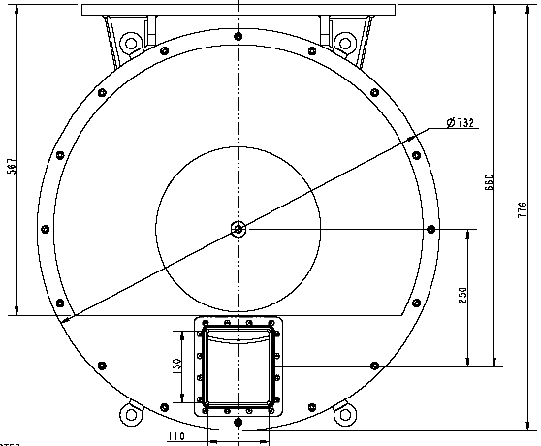
Figure 21: The “standard” SNS disk chopper configuration from Mirrotron.

The radial distance to the center of the window in this disk chopper design is 0.25m and thus the angle 2θ_{a} is given by

$$2θ_{a}=2{\text{tan}}^{−1}\left(\frac{0\text{.}\text{02}}{0\text{.}\text{250}−0\text{.}\text{075}}\right)=2×6\text{.}\text{52}\text{°=}\text{13}\text{.}\text{04}°$$

Hence from the formula for T_{full} given earlier we can calculate a value for α as

$$α=2θ_{a}+2π{\text{fT}}_{\text{full}}=\text{13}\text{.}\text{04}\text{°+}8\text{.}\text{64}\text{°=}\text{21}\text{.}\text{68}°$$
where the value of f=60Hz has been used and T_{full}=400μs.

The next step is to calculate the value for T_{base} from the relation

$$T_{\text{base}}=\frac{α+2θ_{a}}{2πf}=\frac{\left(\text{21}\text{.}\text{68}\text{°+}\text{13}\text{.}\text{04}°\right)×\left(π/{\text{180}}\right)}{2πf}=\text{1607}\text{.}4μs$$

A plot of the fractional transmission curve is shown below in Figure 22. In order to evaluate the
Figure 22: The fractional transmission for T1A and T1B.
order suppression characteristics we need (a) ½ T_{base} = 803.7μs, (b) the separation between T2 opening times at 540Hz, which is 1 / (2 * f) = 1 / 1080Hz = 925.9μs, and finally (c) the burst width of the T2 at 540Hz, which from Table 3 is 18μs. The clearance in time T_{sep} between the edge of the T1B pulse and the opening of the next T2 pulse is therefore

$$\begin{aligned}T_{\text{sep}}=\text{925}\text{.}9−\text{18}−\left(\frac{L_{2}}{L_{1B}}\right)\text{803}\text{.}7 \\ \text{896}\text{.}9−\left(\frac{\text{35}\text{.}\text{40}}{\text{34}\text{.}\text{65}}\right)\text{803}\text{.}7 \\ \text{87}μs\end{aligned}$$

Thus we have a reasonable clearance even at the highest frequency of 540Hz, at 180Hz the clearance is 1903.6μs. Thus we can set an accuracy limit on the T1B chopper phase of ±30μs and still avoid any overlap of the pulses. It should be noted that at 540Hz we are asking for ±1μs accuracy for the T2 chopper so this will have little effect on this calculation. Similarly at 180Hz or 60Hz the T2 accuracy is negligible in the calculation.

The bandwidth of energies that will be transmitted by the T1B chopper with a 21.68° slot will be at the two extremes of the incident energy range 3.60±0.14meV and 90±17meV. Both energy ranges will fully illuminate the energy bandwidth of the T2 chopper. Furthermore the maximum energy that the T2 will have to stop is 107meV, which is well within the capability of the Gd in the T2 chopper blades.

If the T1A chopper is identical to the T1B chopper with a 21.68° slot then when located at 9.33m the time and energy bandwidths through the T1A at the two extremes of the incident energy range will be as given in Table 4 below.

Table 4: Calculated time and energy bandwidths for T1A with 21.68° slot located at 9.33m.
Energy | Flight time at T1A | Pulse range (±803.7μs) | Energy range
3.6 | 11231.2 | 12034.9 | 3.135
3.6 | 11231.2 | 10427.5 | 4.176
90 | 2246.2 | 3049.9 | 48.8
90 | 2246.2 | 1442.5 | 218.2

These are reasonable values. It should be noted that the curved guide will strongly reject neutrons with energies above ~100meV. As noted earlier the T1B will also only transmit neutrons with energies < 107meV. If the pulse transmitted by T1A is 1607.7μs wide then by the time it reaches T1B it will be 5969.6μs wide (using L_{1A}=9.33m and L_{1B}=34.65m). However this is well short of the 16667-1607.7 = 15059μs time required for the T1A pulse to have any order contamination with the T1B chopper.

The frame overlap conditions for the T1A and T1B choppers have been evaluated for these parameters using the spreadsheet calculator. The results are shown below.

As can be seen the frame overlap occurs for neutrons in the 8th T1A frame (N=7) and the 27th T1B frame (M=26) and corresponds to neutrons with an energy ~30μeV. The T1A and T1B choppers with a 21.68° slot therefore provide very good rejection of frame overlap.

In considering the burst time of the T2 chopper we have only considered absorbing blades and not the potential future upgrade to supermirror reflecting blades. Such blades would broaden the burst time of the T2 chopper at low energies (3.6 and 5meV) leading to a higher flux. If the burst time of the T2 chopper gets longer then it may be that the pulse from the T1B chopper will not “fully” illuminate the T2 chopper. In order to estimate the situation if the range of time that the T2 chopper could accept was greater than 400μs let us consider what would happen if it were 800μs. In Figure 22 the transmission curve is effectively centered on 800μs, so that an 800μs acceptance time on T2 would “sample” the curve shown in Figure 22 from 400μs to 1200μs. At these times the fractional transmission is ~0.75 and so the average transmission is 0.94 and so instead of receiving an increase of 2x the flux it would be 1.88x the flux. Achieving an acceptance time as long as 800μs would be a major feat, and increases are likely to be between 400μs and 800μs where the average fractional transmission would be higher than 0.94. If we were to increase the T_{full} value for T1B to fully (100%) illuminate T2 for 800μs then it would be necessary to restrict the highest available frequency to be 270Hz instead of 540Hz. It seems a sensible compromise to retain the high frequency capability (up to 540Hz) and accept a slight reduction in the effective fractional transmission if the supermirror coated chopper slits become available in the future.

References/bibliography

- Design Criteria Document for the HYSPEC Spectrometer
- E. Iverson, SNS Website
- Equipment Specification for a Fermi Chopper System, D. Abernathy and K. Shaw, ARCS18-30-EQ0002-R01, August 2005

