SNS - HYSPEC Instrument Development Team
MEMORANDUM

Date: April 19, 2012
To: M. Lumsden, B. Winn, M. Graves-Brook, M. Hagen
Cc: J. Tranquada, S. Shapiro
From: I. Zaliznyak
Subject: The proposed HYSPEC tune-up and commissioning activities
This note lists comments and suggestions on improving beam transport and instrument readiness following my first user experience on HYSPEC.
Putting aside the quantitative issue of flux on sample, which I had not investigated, the instrument in general meets original design expectations quite well. Moreover, great number of improvements and important major technical decisions, which were made by Mark in the process of construction, turned out to be successful and advantageous. A number of minor modifications, however, are still required as part of the instrument commissioning and testing in order to make it perform to the expectations. While these changes and improvements are in general small, inexpensive, and simple to implement, their importance is hard to overestimate. Many of these changes would make the difference between the publishable and the unpublishable data, the possible and the impossible measurement.
Primary spectrometer (beam transport section before sample).
- A white beam monitor currently installed at the exit from the drum shield has to be replaced with a proper monochromatic beam monitor with the sensitivity sufficient to have ≥100 counts/sec at E_{i} = 20 meV (my estimate is ~ 10⁻⁵ – please, check).
- Neutron beam transport channel made of neutron-absorbing material and placed in either the evacuated or the He-filled tube, mountable on the neutron optics support system in front of the sample. The channel should be vertically tapered to follow the beam profile provided by the PG/Heusler crystals, while horizontally it has to match the 4 cm beam width. Having such channel is important for studies where small-angle scattering by air in the neutron flight path needs to be avoided/minimized.
Secondary spectrometer (analyzer-detector system after sample).
- The frame of the radial collimator (RC) at the analyzer entrance is made of steel and is rather transparent to thermal neutrons. It has to be covered with a sleeve of proper neutron absorbing material, such as boroflex, or Cd+boroflex, leaving open only the entrance window in front (historically, this reminds of a similar issue found in the past on HB1 spectrometer at HFIR). Currently, a rapid fix to this problem is applied by attaching Cd cutouts here and there. A permanent and properly designed shielding solution is required. It is important that this shielding is continuous with the shielding in the analyzer vessel, ensuring that detectors view to the outside ambient neutrons is limited. It is also important that this shielding does not hinder operations requiring moving/replacing the RC.
- Variable vertical aperture has to be installed in front of the RC, attached to the analyzer vessel. Eventually, it should be the same type of motorized and computer-controlled unit as the beam-defining apertures before the sample. This aperture is the only element defining the vertical size of the sample scattering volume seen by the detector bank. If installed ~40 cm behind the sample, the typical opening from 12 to 15 cm would be required for 1cm to 4 cm tall samples. At 20 cm after the sample, apertures between 6.5 cm and 9.5 cm would be required. In the cases where only central 50% of the detector height is used, this reduces to 3.8 cm to 6.7 cm. To summarize, a vertical aperture with 0 to 15-18 cm opening is required. This aperture would replace the temporary mount holding converging Cd side shields after the sample (and it can be actually used to hold such shields, would they be needed).
- A properly designed after sample beam stop, replacing the current temporary Cd shield, needs to be installed. It should allow instrument operation with the detector vessel positioned symmetrically around the scattered beam (zero scattering angle for the central detector), such as required for small-angle inelastic magnetic scattering. The beam stop must be lined on the outside with either boron or lithium-containing absorbing material, so as to avoid small angle scattering by Cd. It has to be designed to have minimum necessary size, so as to provide access to the smallest possible scattering angles.
- A monochromatic beam monitor should be incorporated in the after sample beam stop described in item (3) above (L. Passell’s suggestion). Having such monitor would allow independent way of determining the incident neutron energy without moving the analyzer.
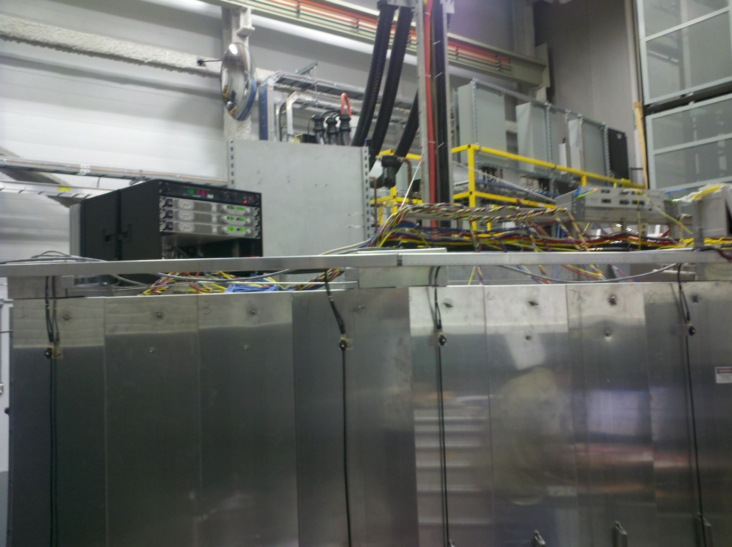
- Elements and constructions which inhibit the analyzer vessel movement should be removed/modified as much as possible. In particular, this concerns the aluminum sheet at the back of the analyzer, which sticks out by about 1”, the wire support mounted on top – which also sticks out preventing the analyzer movement to higher angles for some Ei, etc.
- The elevator door, as it is currently installed, sticks out by about 4” for no obvious structural reason, presenting another hindrance to the analyzed movement. It should be reinstalled (re-welded) to be flush with the elevator cage.
Sample stage.
- Proper mount for the currently used (borrowed from CNCS) CCR unit (on top of its compressor) should be manufactured (we should ask the sample environment group). We should hold on to this CCR – having a spare CCR is an enormous advantage when running the user program on an instrument such as HYSPEC.
- An assortment of standard male-female, inch-metric adaptors, extenders, screws etc., for attaching the sample holder to the CCR should be available.
- Proper Vanadium standard samples need to be manufactured. These must preferably have 95% transmission, or higher and therefore be either plates, or hollow cylinders with the wall thickness ~0.5 mm. I suggest making one standard sample identical to the ARCS standard sample, which is the annular cylinder of mass 17.2 grams, the diameter of 3 cm, the height of 3cm, and the wall thickness of 0.5 mm. Additionally, a narrower sample of 1 cm diameter, and a plate 4x4 cm², covering the full focused beam, would also be desirable.
Commissioning and testing activities.
In general, the HYSPEC logbook appears to be in rather poor shape and of limited usefulness (as a matter of example/comparison, nice and useful logbooks properly describing the instrument commissioning and testing can be found on ARCS). This state of affairs is unsatisfactory and adds urgency to the IDT requests for technical memos, which were regularly sent to the HYSPEC team since the beginning of the year. Below, I list the commissioning tasks which I have not found documented anywhere, but whose results are an important reference for the instrument commissioning and day-to-day operation.
- The Fermi chopper phasing scans for all rotation rates have to be measured with 5 meV to 15 meV step within the working energy range and should be properly documented in the logbook (although the electronic technical memo would be preferable). These measurements must be done using (i) the incoherent scattering off Vanadium standard, (ii) the Bragg scattering off a (nickel, Si or Al2O3) standard powder sample, (iii) the Bragg scattering off a sufficiently perfect single crystal sample, and (iv) off the monitor (after the proper monochromatic beam monitor is installed as discussed above).
- The corresponding monochromator rocking curves and the vertical focusing scans should be measured at the same energies and also documented in the similar way.
- The proper monitor intensity and the total detector intensity off standard vanadium sample also have to be measured for the same energies and also documented in the similar way.
- The prompt pulse spurion needs to be surveyed and documented, while it is still strong. Such survey would be automatically included in the measurement program described above, and would only require proper documentation.
The beam testing and characterization measurements outlined above are the absolute must for the instrument commissioning program and would only require 1-2 days. I strongly suggest that the SNS HYSPEC team considers and prioritizes them on par with other activities, and plan for the execution ASAP.

