SNS - HYSPEC Instrument Development Team

**MEMORANDUM**

Date: May 24, 2012

To: M. Lumsden, B. Winn, M. Graves-Brook, M. Hagen

Cc: J. Tranquada, S. Shapiro

From: D. Fobes, I. Zaliznyak

Subject: TOF inelastic spurion on HYSPEC

**Inelastic spurion from double elastic scattering processes on HYSPEC.**

In recent experiments we observed unusual scattering near 4 meV (see figure below). This can be characterized as spurious scattering in the following scenario. Since this is a time of flight measurement, if the elastic neutron travels some extra distance $δL$ it will appear as though it is an inelastic process. This can arise for example if neutrons from elastic incoherent scattering from the sample undergo Bragg diffraction from a source somewhere behind the sample environment at a distance approximately $1/2δL$ from the sample (Fig. 2 below). We can calculate the approximate distance that gives rise to such a feature by noting the following relation:

Figure 1. The apparent inelastic scattering at E = 4 meV arising from double elastic processes at Ei = 15 meV.

$$\frac{E_{f}}{E_{i}}={\left(\frac{L_{SD}}{L_{SD}+δL}\right)}^{2}≈1-2\frac{δL}{L_{SD}} ,$$

where $L_{SD}$ is the distance between the sample and the detector, and we have approximated the right hand side using a Taylor expansion. Also noting that $E_{f}=E_{i}-δE$, and solving for $δL$ we obtain

$$δL ≈\frac{1}{2}L_{SD}\frac{δE}{E_{i}} .$$

Using the following values from our experiment we can obtain an estimate for the extra distance that an elastically scattered neutron would need to travel to appear as though it was scattered inelastically with an energy transfer of 4 meV:

$$L_{SD}=4.5 m, \\ E_{i}=15.12 meV, \\ δE=4 meV$$

This gives us an estimate of $δL$ ~ 0.6 m in extra distance travelled for an elastically scattered neutron, meaning that our potential source is approximately 0.3 m behind the sample.

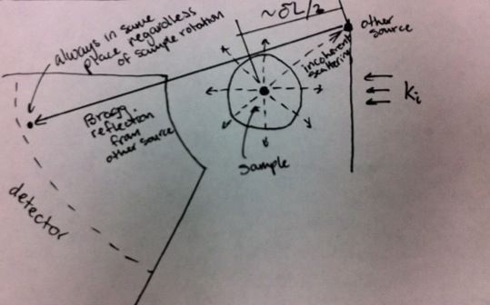Figure 2. Schematics of double elastic scattering processes giving rise to inelastic spurions.

In the current experimental setup, there are a large number of potential sources that may account for this feature, as noted by the circle in the Figure 3 below (the circle encompasses potential sources that are approximately 0.3 m behind the sample). We can go a long way to eliminating this problem by more thoroughly covering these potential sources.

**Conclusion.**

Figure 3. HYSPEC sample table with the sample in the closed-cycle refrigerator cryostat. Scattering from the sample and the cryostat illuminates structural beam line elements, such as circled in red.

On HYSPEC, the sample and the sample environment illuminated by the incident beam act as secondary sources due to coherent and incoherent elastic scattering by Al and other polycrystalline materials, and the sample. Hence, all structural elements which can be illuminated by the sample and/or cryostat as a result of such scattering (cf. Figure 3) have to be covered with neutron-absorbing material, such as Cd-layered boroflex.