ICANS-XVII
17th Meeting of the International Collaboration on Advanced Neutron Sources
April 25-29, 2005
Santa Fe, New Mexico
Optimization of the HYSPEC design using Monte Carlo simulations
V. J. Ghosh¹, M. E. Hagen², W.J. Leonhardt¹, I. Zaliznyak¹, S. M. Shapiro¹, and L. Passell¹
¹Brookhaven National Laboratory, PO Box 5000, Upton, NY, 11973 USA
²SNS, Oak Ridge National Laboratory
Abstract
HYSPEC is a direct geometry spectrometer to be installed at the SNS [1] on beamline 14B where it will view a cryogenic coupled hydrogen moderator. The ‘hybrid’ design combines time-of-flight spectroscopy with focusing Bragg optics to provide a high monochromatic flux on small single crystal samples, with a very low background at an extended detector bank. The instrument is optimized for an incident energy range of 3-90meV. It will have a medium energy resolution (2%-10%) and will provide a flux on sample of the order of 10⁶-10⁷ neutrons/s-cm². The spectrometer will be located in a satellite building outside the SNS experimental hall at the end of a 35m curved supermirror guide. A straight-slotted Fermi chopper will be used to monochromate the neutron beam and to determine the burst width. The 15cm high, 4cm wide beam will be focused onto a 2cm by 2cm area at the sample position using Bragg reflection from one of two crystal arrays. For unpolarized neutron studies these will be Highly Oriented Pyrolitic graphite crystals while for polarized neutron studies these will be replaced with Heusler alloy crystals. These focusing crystal arrays will be placed in a drum shield similar to those used for triple axis spectrometers. Hyspec will have a movable detector bank housing 160 position sensitive detectors. This detector bank will pivot about the sample axis. It will have a radius of 4.5m, a horizontal range of 60º, and a vertical range of ±7.5º. In order to reduce background at the detector bank both a curved guide and a T0 chopper will be used. A bank of 20 supermirror bender polarization analyzers [2] will be used to spatially separate the polarized neutrons in the scattered beam so that both scattered neutron spin states can be measured simultaneously. The results of Monte Carlo simulations performed to optimize the instrument design will be discussed.
1. Introduction.
HYSPEC (HYbrid SPECtrometer) is a direct geometry spectrometer to be installed at the SNS [1]. Its primary mission is to perform inelastic neutron scattering experiments on small single crystal samples. The ‘hybrid’ design combines time-of-flight spectroscopy with focusing Bragg optics to provide a high monochromatic flux on these small single crystal samples. The instrument is also designed to provide a very low background at an extended detector bank. The instrument is optimized for an incident energy range of 3-90meV. It will have a medium energy resolution (2%-10%) and will provide a monochromatic flux on sample of the order of 10⁶-10⁷ neutrons/s-cm².
HYSPEC will be installed on beamline 14B where it will view a cryogenic supercritical coupled hydrogen moderator. This moderator delivers more neutrons in the 5-50meV range than any of the other SNS moderators[3]. The experimental area of the instrument (the energy defining choppers, the focusing monochromator crystal array, the sample stage and the detector bank) will be located in a satellite building outside the SNS experimental hall at the end of a 35m curved supermirror guide. A straight-slotted Fermi chopper will be used to monochromate the neutron beam and to determine the burst width. The 15cm high, 4cm wide beam will be focused onto a 2cm by 2cm area at the sample position using Bragg reflection from one of two focusing crystal arrays. For unpolarized neutron studies these will be Highly Oriented Pyrolitic graphite crystals while for polarized neutron studies these will be replaced with Heusler alloy crystals. These focusing crystal arrays will be placed in a drum shield similar to those used for triple axis spectrometers. Hyspec will have a movable detector bank housing 160 position sensitive detectors. This detector bank will pivot about the sample axis. It will have a nominal radius of 4.5m, a horizontal range of 60º, and a vertical range of ±7.5º. In order to reduce background at the detector bank both a curved guide and a T0 chopper will be used. A bank of 20 supermirror bender polarization analyzers [2] will be used to spatially separate the polarized neutrons in the scattered beam so that both scattered neutron spin states can be measured simultaneously.
One of the primary objectives in designing HYSPEC has been to maximize the signal to background ratio in the detectors. This objective can be accomplished by doing two sets of simulations, one set to maximize the flux on sample and the second set to minimize the beam-related background. The first set of simulations was performed using the McSTAS[4] neutron ray-tracing package. The second set of simulations relating to shielding and background will be performed using MCNPX [5]. The HYSPEC shielding has to be designed so that the biological dose rate is less than 0.25mrem/hr for areas with unlimited access. The beam-related background goal for HYSPEC is to have less than 1 count per 2.5cm detector per minute.
The layout of the instrument is described in Section 2. Design features that reduce beam-related background are highlighted in Section 3, and instrument performance is discussed in Section 4.
2. Description of HYSPEC.
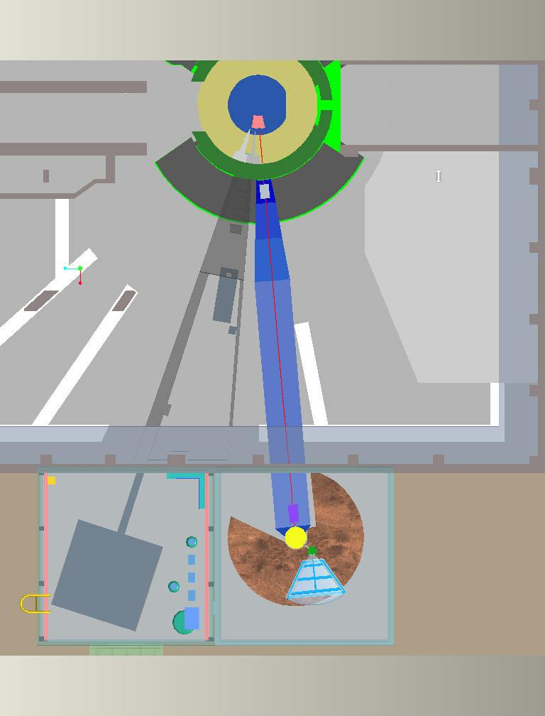
Box A
Box B
Curved guide
Drum shield
Detector vessel
Sample stage
Figure 1: Schematic layout of HYSPEC with the monochromator and detector bank in a separate building outside the instrument hall
Figure 1 is a schematic layout of HYSPEC with the experimental area of the instrument (the energy defining choppers, the focusing monochromator crystal array, the sample stage and the detector bank) located in a separate building outside the SNS experimental hall. HYSPEC will be installed on beamline 14B where it will view a 10cm by 12cm cryogenic supercritical coupled hydrogen moderator. This moderator delivers more neutrons in the 5-50meV range than any of the other SNS moderators [3]. The moderator-monochromator distance is expected to be around 37m. Sections of the primary guide are curved so that the monochromator is out of the line of sight of the moderator. The spatial offset at the monochromator is expected to be about 16cm.
As illustrated in Figure 1 the major components of HYSPEC are the guides that transport the neutrons from the moderator to the monochromator, Box-A, Box-B, the drum shield surrounding the focusing monochromator crystal array, the sample stage and the detector bank. Box-A and box-B are virtual boxes containing choppers, motors and pieces of guides. Box-A contains the T0 and T1A (frame overlap) choppers, and Box-B contains the T1B (order suppressor) and T2 (wavelength defining) choppers. Detailed descriptions all these components can be found in reference [6] and references therein. The schematic layout of Box-A and Box-B are shown in Figs 2 and 3, and that of the HYSPEC guides in Figures 4 and 5.
T0 chopper
T1A chopper
Guides

Figure 2: Box-A containing the T0 and T1A choppers
Guides
T1B chopper
T2, Fermi chopper
Figure 3: Box-B containing the T1B and T2 choppers.

The primary function of the guides is to transport the neutrons from the moderator to the monochromator. Guides G1a and G1b extend through the primary shutter, the biological shield and the chopper archway. The guide is 4m long, 4cm wide and it expands in height from ~13.2 to 15cm. Guides G2, G3 and G4 are 4cm wide and 15cm high. The guide coating is m=3 supermirror. Guide section G2 is curved with a radius of curvature of 2542m. This radius of curvature was chosen to obtain a 16cm offset (4 times the guide width) at the monochromator. This offset completely removes the monochromator from the line of sight of the moderator, thereby reducing the fast neutron flux by a factor of the order of 10⁻⁵ . The curved guide, along with the T0 chopper, significantly reduces the background at the detector bank.

Guides G1a, G1b
G3 G4
Box-A
Box-B
Moderator
Vertical profile
Horizontal profile
G2
Figure 4: Schematic layout of HYSPEC upstream of the monochromator

G3
G4
Figure 5: Arrangement of the 1.75m straight guide + Box B & drum shield

The primary function of the four choppers is to define the energy and time profile of the neutron pulse incident on the sample. The secondary function is to reduce the background at the detector bank. The T0 chopper is a “dumbbell-shaped” rotor made of inconel which can be rotated at 30 or 60 Hz. The T0 chopper removes a significant fraction of the fast neutrons and the initial gamma rays from the neutron beam. The T1A (frame overlap) and T1B (order suppressor) choppers are single-slot single-disk choppers which will rotate at 30 or 60Hz. They will be made of boron-loaded material. Their function is to remove contributions due to frame overlap and order contamination from the neutron beam that reaches the focusing crystals. The function of the T2 chopper is to select the burst width (time and energy) of the incident neutrons. This chopper is envisioned as a vertical axis rotor with a Fermi-type, straight-slotted slit package insert. The rotation rates are expected to be integral multiples of the source frequency ranging from 60 to 480Hz. Two different slit package inserts are under consideration: one with aluminum beam channels and Gd metal channel defining absorbers, the other with supermirror-coated single crystal silicon beam channels and Gd metal channel defining absorbers. The slit package is expected to be 4.2cm wide, 15cm high and 1cm long, and has been optimized to provide a time burst of 55µs at 180 Hz.

A focusing crystal array will be placed downstream of the T2 chopper inside a drum shield. A double-focussing array of ZYB grade HOPG (highly oriented pyrolytic graphite) 30cm wide and 20.4cm high will be used to produce the non-polarized neutron beam. A Heusler Cu2MnAl crystal array will be used to produce a polarized neutron incident beam. The crystal array will be surrounded by a conventional drum shield. The angular rotation range of the drum shield will be 15º < 2θ_{M} < 90º , where 2θ_{M} is the deflection angle of the beam. This corresponds to an initial energy range of 3.6-90meV. At this time it is estimated that the internal diameter of the drum shield will be 60cm, and the outer diameter will be 180cm. MCNPX simulations are being done to determine the dimensions and composition of the drum shield.
The focusing crystal-sample distance will be allowed to vary from 1.4 to 1.8m. The sample and the sample environment (a CCR, cryostat, furnace or cryomagnet) will be carried on a sample stage that will move on air pads across the dance floor. Immediately above the air pads will be a motorized and encoded rotational stage that will be used to rotate and position the detector bank. On top of this will be another rotational stage to rotate the sample, and on top of that a goniometer to translate and tilt the sample.

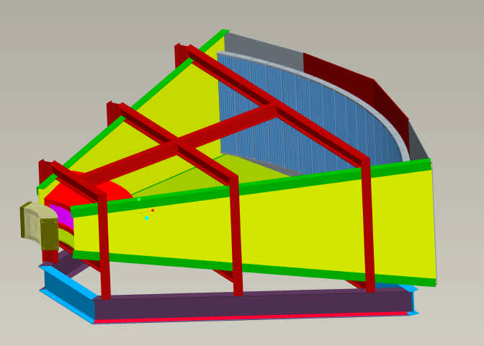
Radial collimator or polarization analyzer
Coarse collimator
LPSD tubes in 20 “8-packs”
Figure 6: A schematic 3d rendering of the detector vessel.

A schematic of the HYSPEC detector vessel is shown in Figure 6. The detector vessel will rotate about an axis through the center of the sample stage. The detector vessel will carry 20 120cm long LPSD 8-packs at a nominal distance of 4.5m. The horizontal angular acceptance of the detector bank will be 60º , and the vertical angular acceptance of the detector bank will be ±7.5º . The vessel will be filled with argon gas at ~1 atmosphere pressure. The front window of the detector vessel will be 70cm from the sample, and will be made of 0.05mm aluminum foil. The detector vessel walls will be shielded both internally and externally.
For experiments that do not require polarization analysis a radial collimator will be mounted between the sample and the front face of the detector vessel. For polarization analysis experiments the radial collimator will be replaced by an array of 20 supermirror bender transmission polarizers. These are shown in Figure 7 and described in detail in reference [2]. The choice of 20 polarizer benders matches the 20 “8-packs” of detectors and the 20 segments in the coarse collimator.

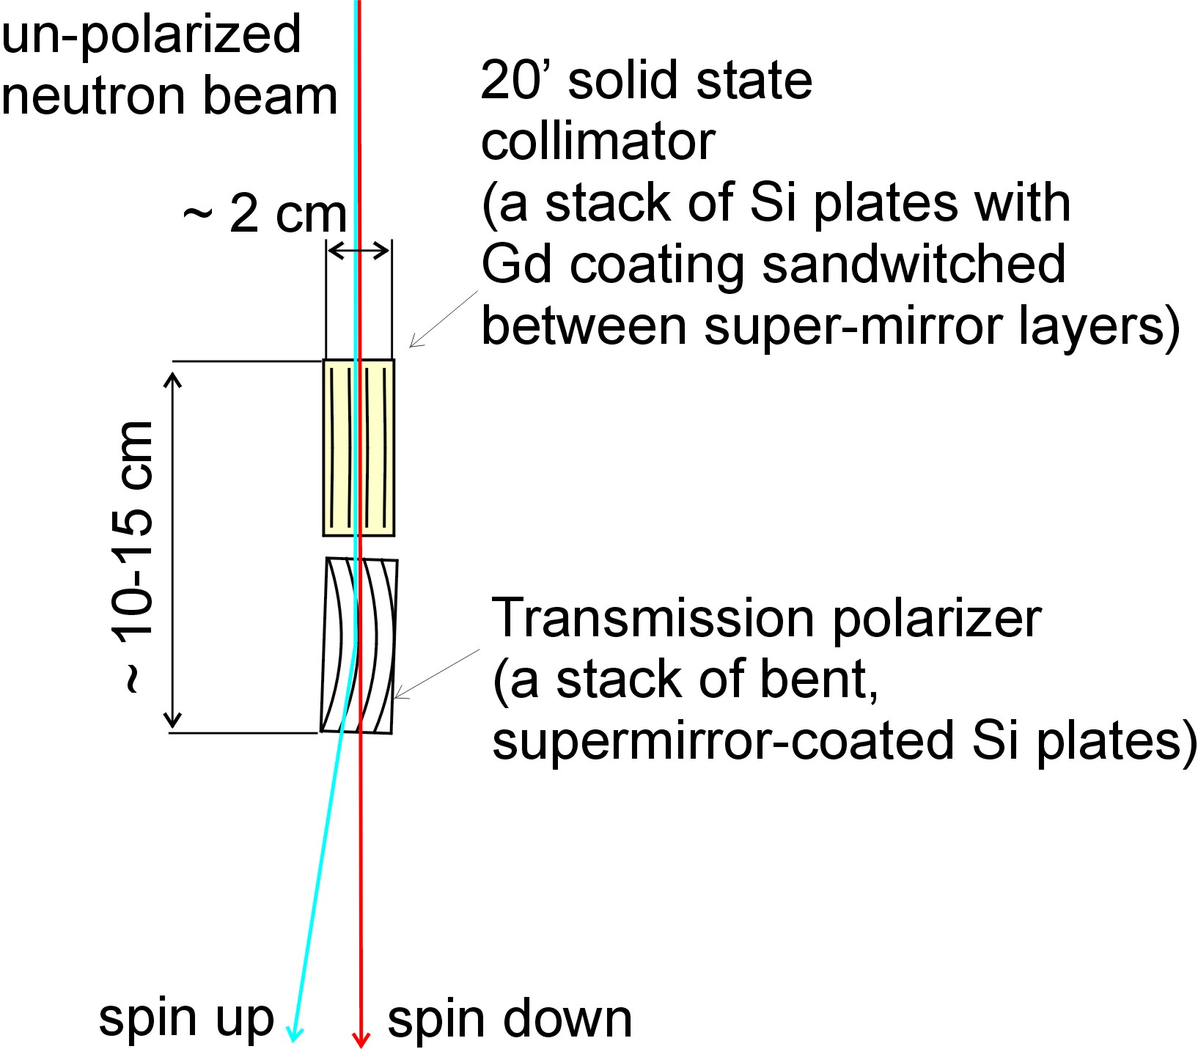 | 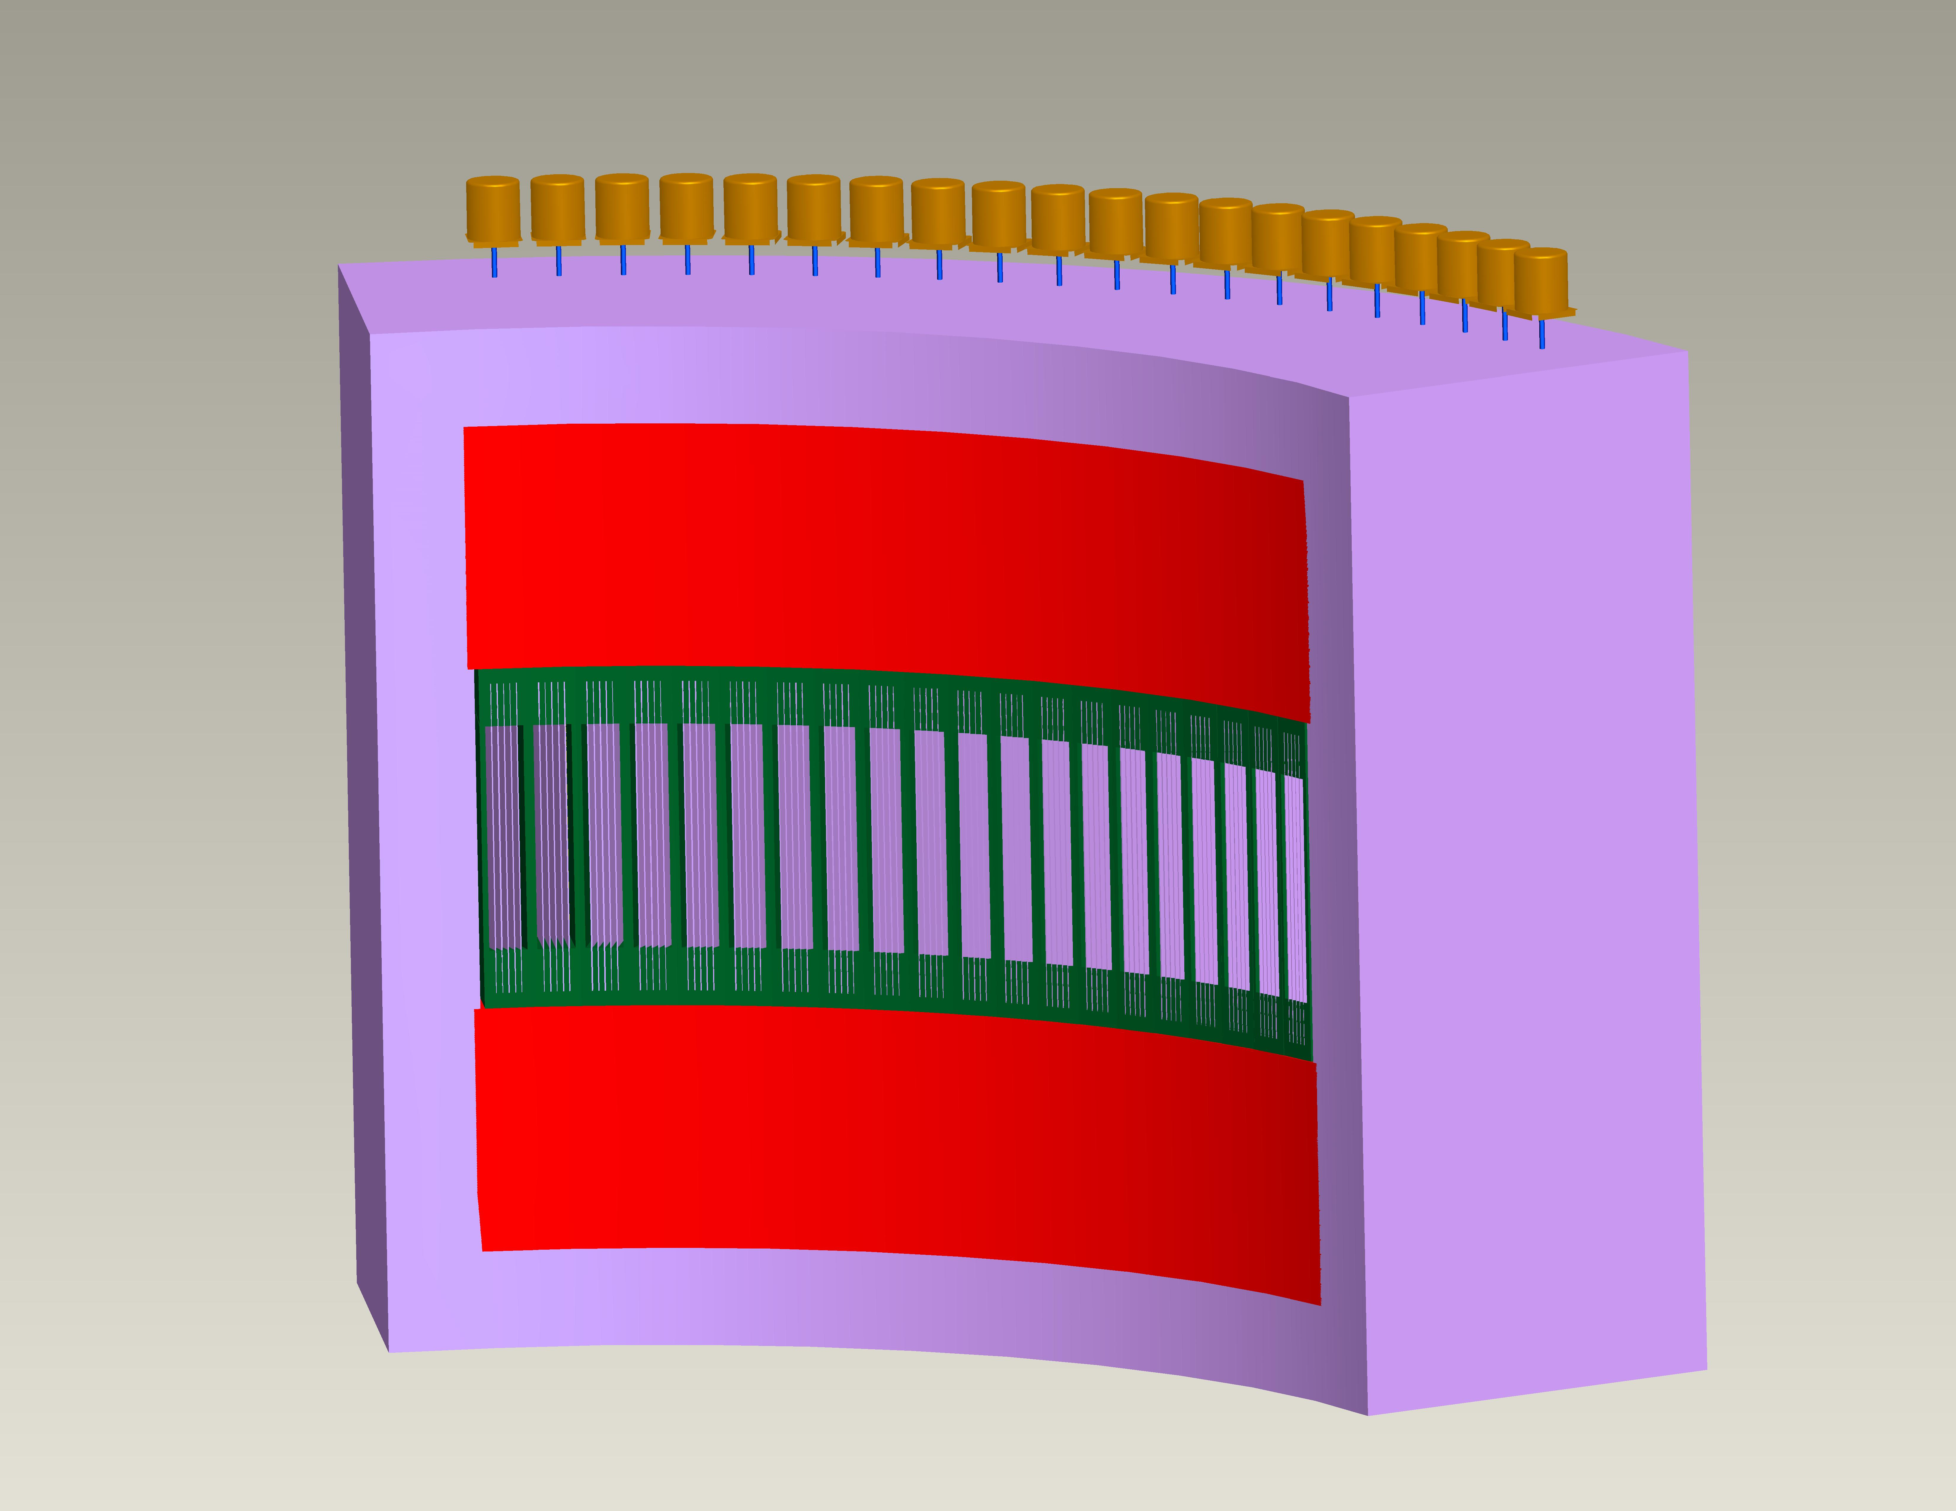
Figure 7: Arrangement of the solid state collimator and bender polarizer (left). Array of 20 polarizer benders with magnets, yoke, and motors (right).
3. Plan to minimize beam-related background
In order to minimize the beam related background at the HYSPEC detectors we have to reduce the fluence of both fast and unwanted thermal neutrons at the focusing crystal. The selected thermal neutrons are Bragg scattered down the exit tube and onto the sample. The unwanted neutrons are scattered (non-Bragg scattering) into the drum shield as well as down the exit tube. Neutrons can get moderated or absorbed as they pass through the drum shield, also gamma rays can be created due to neutron absorption. Both neutrons and gamma rays will contribute to the biological dose rate and have to be absorbed in the drum shield. The drum shield will be designed so that the biological dose rate requirements are satisfied.
HYSPEC will use both a T0 chopper and a curved guide. The curvature of the guide is such that the focusing crystal is displaced 16cm with respect to the moderator. This displacement is 4 times the width of the guide and it will remove the crystal array completely out of the line of sight of the moderator. Preliminary simulations have shown that this reduces the fast neutron flux to about 10⁻⁵ times the flux for a similar straight guide. In addition to the T0 chopper there are three other choppers in the lineup – the T1A, T1B and the T2 chopper. The T1A and T1B choppers will be boron-loaded so that they can absorb both thermal and fast neutrons. The T2 Fermi chopper will have gadolinium in the slit package to absorb thermal neutrons. The choppers and the curved guide will reduce the flux of neutrons reaching the crystal array.
The He3 detectors in the detector vessel detect only low-energy neutrons. The absorption curve for the HYSPEC detectors is shown in Figure 8. Neutrons of energies upto 1keV can easily be prevented from entering the detector vessel by putting appropriate shielding outside the detector vessel. Gadolinium on the inside of the detector bank can absorb the thermal neutrons scattered by the argon in the detector vessel.

Figure 8: The absorption curve for the HYSPEC detectors.

4. Monte Carlo simulations of HYSPEC performance.
Simulations to optimize the instrument performance are documented in references [7] and [8]. The impact of the guide curvature on the thermal neutrons is illustrated in Figure 9. The reduction in flux at 90meV is almost a factor of 2 when the displacement at the crystal array is 16cm or 4 times the guide width. Despite this loss of flux curving the guide is considered an advantage because it results in an attenuation of fast neutron flux by almost 10⁻⁵ . This allows us to reduce the thickness of the drum shield and to move the sample position closer to the crystal.
Figure 9: Effect of the guide curvature on the neutron fluence at Box-B.

The wavelength-defining T2 chopper is placed at 35.5m from the moderator. The slit package of the Fermi chopper has been optimized to give a burst time of ~55µs at a rotation frequency of 180Hz. Transmission through the chopper can be changed by changing the rotation frequency of the chopper, transmission increases as the rotation frequency decreases. These results are plotted in Figure 10.
Figure 10: Fluence of neutrons passing through the Fermi chopper at different energies for rotation frequencies of 60,180, and 360Hz.

The fluence in a 2cm by 2cm area at the sample position is plotted in Figure 11 for three different configurations of the focusing crystal array plus a “baseline” case. The “baseline” is a unfocussed (flat) crystal array using the ZYA grade (24’ mosaic) of HOPG. The other three configurations use ZYB grade (48’ mosaic) of HOPG in the flat, only vertically focused, and both horizontally and vertically focused arrays. Vertical focusing has a huge impact, increasing the fluence by a factor of ~6.
Figure 11: The fluence of neutrons at a 2cm by 2cm area at the sample position.

The rotation frequency of the Fermi chopper also determines the burst time at the sample and the incident energy width. The burst times (immediately downstream of the Fermi chopper) and the incident energy widths are tabulated in Table 1 for rotation rates of 60, 180, and 360 Hz.

Table 1: Burst times and incident energy widths for rotation frequencies of 180, 60, and 360Hz.

Energy (meV) | 180Hz |  | 60Hz |  | 360Hz
Energy (meV) | ΔT (μs) | ΔE_{i} (meV) | ΔT (μs) | ΔE_{i} (meV) | ΔT (μs) | ΔE_{i} (meV)
3.6 | 56 | 0.032 | 172 | 0.047 | 29 | 0.032
5.0 | 55 | 0.046 | 169 | 0.072 | 29 | 0.044
15 | 55 | 0.166 | 167 | 0.331 | 27 | 0.132
30 | 55 | 0.308 | 166 | 0.820 | 27 | 0.200
60 | 55 | 0.800 | 162 | 2.053 | 26 | 0.413
90 | 51 | 1.325 | 162 | 3.399 | 26 | 0.701

An estimate of the energy resolution of the instrument for elastic scattering can be obtained from the burst times at the sample position. ΔE_{F} /E_{F}= 2*ΔT_{S} /T, where ΔT_{S} is the time burst width at the sample and T is the time taken to traverse the distance between the sample and the detector bank.

Table 2: Energy resolution of the instrument for elastic scattering. The rotation rate of the Fermi chopper is 180, 60, and 360Hz.

Energy (meV) | ΔE_{F} /E_{F}= 2*ΔT_{S} /T
Energy (meV) | 180Hz | 60Hz | 360Hz
3.6 | 0.025 | 0.078 | 0.013
5.0 | 0.026 | 0.081 | 0.014
15 | 0.045 | 0.138 | 0.022
30 | 0.063 | 0.193 | 0.032
60 | 0.091 | 0.265 | 0.043
90 | 0.103 | 0.327 | 0.053

The energy resolution of the instrument for inelastic scattering is plotted in Figure 12.
Figure 12: FWHM resolution widths for the Fermi chopper running at 180 Hz for various energies.

The scaled energy transfer E/E_{I} = (E_{F}-E_{I})/E_{I}, and the scaled energy resolution is ΔE/E_{I}. The energy resolution for zero energy transfer or elastic scattering is dominated by the energy resolution of the secondary spectrometer. The energy resolution at large energy loss is due to the energy resolution of the primary spectrometer ΔE_{I}/E_{I} .
Summary.

As these simulations show HYSPEC will deliver a high monochromatic flux on small samples for an incident energy range of 3-90meV. The instrument will have a moderate energy resolution (2%-10%) for a Fermi chopper rotation rate of 180 Hz. The flux on sample can be increased by decreasing the rotation rate of the Fermi chopper, thereby increasing the burst width at the sample. However, this gain comes at the expense of the energy resolution. The energy resolution of the instrument can be improved by increasing the rotation rate of the Fermi chopper. This will decrease the burst width and flux on sample. This versatility in instrument performance will allow the users to customize the mode of operation for individual samples.
HYSPEC will also have a large signal to background ratio. The long curved guide, the system of choppers, the design of the drum shield and detector vessel will combine to reduce the beam-related background.
A tested, maintenance-free polarization analysis capability will allow polarized neutron experiments.
Acknowledgements.
We would like to thank members of the SNS instrument team for their assistance. We would also like to acknowledge the assistance of the SNS shielding group with the MCNPX simulations, G. Granroth for sending us his codes, and L. Daemen and P.A. Seeger for assistance with the NISP code.
Work at BNL is supported by the US DOE under contract No. DE-AC02-98CH10886
References.
[1] S. M. Shapiro, I. Zaliznyak, L. Passell, V. Ghosh, ICANS-XVI, May 2003, proceedings (2003).
[2] Igor Zaliznyak, V. Ghosh, S. M. Shapiro, L. Passell, Physica B 356 150-155 (2005).
[3] E. Iverson, MCNP data for BL5 coupled H2 moderator obtained from http://www.sns.gov/users/instrument_systems/components/moderator/HPTS-sct.shtml as of 31st July 2002.
[4] User and Programmers Guide to the Neutron Ray-Tracing Package McStas, version 1.8, P.Willendrup, E. Farhi, K. Lefmann, P.O. Astrand, M. Hagen and K. Nielsen, Riso-R-1416(EN), Riso National Laboratory, Roskilde, Denmark, May 2004
[5] MCNPX 2.4.0, Radiation Safety Information Computer Center, Oak Ridge National Laboratory, September 2002
[6] M.E. Hagen and W.J. Leonhardt, Design Criteria Document for the Hybrid Spectrometer (HYSPEC), Hyspec-00-DC00D1-R0001, March 2005
[7] V.J. Ghosh, McStas Simulations for HYSPEC Guide Configuration Optimization, HYSPEC Technical Note 0009 (February 2005)
[8] M.E. Hagen, McStas Results for HYSPEC focusing crystals, HYSPEC Technical Note 0012 (March 2005)

