³He Transmission Polarizer Options for HYSPEC.
It is now widely recognized that, after approximately a decade of intense and coherent efforts at different laboratories around the world, significant progress has been achieved in developing the neutron polarization techniques using the polarized ³He gas transmission cells [1]. The current state of the field was extensively reviewed in a number of presentations at the International Workshop on Polarized Neutrons in Condensed Matter Investigations, PNCMI-2004, in June of 2004. It was consequently suggested at the HYSPEC IDT meeting held in Oak Ridge on September 10, 2004, that an updated analysis of the possible options for using the helium-3 transmission polarizers (H3TP) for defining/analyzing the neutron polarization on HYSPEC is performed by the Instrument Design Working Group. In particular, it was proposed, following a suggestion by Dr. E. Lelievre-Berna of ILL that an attractive application of the H3TP in HYSPEC would be as a polarizer immediately upstream of the instrument's pyrolytic graphite (PG) focusing monochromator. Here we summarize the advantages and the disadvantages of different polarized beam options using the H3TP on HYSPEC.
- Incident beam polarization
Using the H3TP in combination with the PG monochromator is an alternative to using the Heusler crystal monochromator for obtaining the polarized neutron beam incident on the sample. In practice, this approach requires installing immediately upstream of the instrument's PG focusing monochromator a continuously-optically-pumped SEOP cell, or a continuous-flow MEOP cell that would maintain a constant ³He polarization in the 70 – 75 percent range. The gas pressure in such a cell must be adjustable so as to provide an optimal compromise between the neutron polarization and the cell transmission for the selected neutron energy range.
  - Practical feasibility
At the place the H3TP cell would be located on HYSPEC the neutron beam is 4 cm wide and 15 cm high. Therefore, in order to intercept the whole beam, the cell cross-section would have to be roughly 4.5 cm wide and 16 cm high. Although this cross-sectional area is larger than that of the cells built thus far, according to T. Gentile of NIST Center for Neutron Research it is not outside the limits of current technology [2]. In particular, he suggests that a blown, cylindrical cell of about 10 cm in diameter and 16+ cm long should be within the realm of the cell construction technology and should be able to provide a good lifetime of the ³He gas polarization. The volume of such a cell would be about 1.3 liters. With such cell standing vertically, the 4 cm width of the beam would pass through the center of the cell, where the gas thickness would be reasonably uniform. More advanced cell designs could appear on the longer term. The cell must be placed inside a cavity in the massive concrete beamline shielding. The top shielding block will thus have to be removed whenever the cell change/maintenance is required.
    - Spin-Exchange Optical Pumping (SEOP) approach
According to T. Gentile [2], the broadband laser power needed for pumping a 1.3 liter cell described above could be prohibitive. Instead, a 100 W of spectrally narrowed laser light might be required to maintain a 70 – 75% polarization; better estimates require more R&D effort, but can be provided in the near future. Although such power is not available yet, it seems reasonable to expect that it will be available in the near future. However, it is very likely such lasers will not be the "black-box" devices as the broadband lasers are, and may require substantial maintenance and operation expenses. Finally, a SEOP cell will have to be placed in an oven, which could probably be a 20 cm by 20 cm by 25 cm box heated with hot air. The need to lower the cell with the oven into a concrete cavity inside the neutron guide shielding may present a difficult issue. A related issue might be the question of stability of the guide supermirror coating at high temperature.
It is important to consider the spin-transport and the magnetic field homogeneity requirements. The laser light must always be parallel to the magnetic field; hence for vertical neutron polarization the laser must come from above and/or below the cell. If the cell is pumped from the top, one has to deal with the issue of the cell's lensing of the laser light, but this might be surmountable. Also, in the case of vertical neutron polarization an adequate space must be allowed for the horizontal coils. Another option is polarizing cell along the neutron beam and using the metal-coated silicon wafers to reflect the laser light. Then, one could use a solenoid with a field along the neutron beam, and adiabatic rotation of the neutron polarization into a vertical guide field. The nearby motor(s) may present an issue. Ideally one would use a shielded solenoid for the 3He cell, with the motor outside.
Overall, building a SEOP cell seems technically feasible but requires very significant near-term R&D and hardware (laser) investment, perhaps 250k$, or more. Maintenance and operation of such a cell may also be costly.
    - Metastable-Exchange Optical Pumping (MEOP)
Although a MEOP cell with continuous gas flow and maintaining the 70% – 75% ³He polarization have not yet been built, it does not seem to be outside the reach of the near-future technology. Such system would require a pumping station installed nearby, probably immediately outside the beam-line shielding, connected to the cell with the magnetically shielded gas flow lines. The whole system also needs a homogeneous guide field, and has to be shielded from the field disturbances caused by motors, sample magnets, etc. Overall, this approach requires very significant R&D investment, perhaps 250k$, or more, in addition to the already high price tag on the MEOP pumping station.
Finally, the “poor man’s” solution could consist in installing an exchangeable MEOP cell inside a magnetically shielded solenoid placed in the cavity in the neutron guide shielding. The cavity will have to be opened/closed every time the cell is replaced. Such operation would require closing the secondary shutter and removing the heavy shielding piece topping the cavity. The main advantage of this approach is the minimum R&D costs, as MEOP cells with the initial ³He polarization of up to 75% and the lifetime of several days are already available today.
  - Performance analysis
In order for the H3TP to present a viable option, it must provide neutron beam polarization in excess of 90% and with the transmission that is equal, or better than the reflectivity of the Heusler crystal’s (111) reflection. The polarization-dependent transmission of the neutron beam passing through the cell of a given length filled with polarized ³He gas as a function of the gas pressure and polarization was considered by L. Passell, [1], and is discussed in Appendix A. The results for the l = 10 cm long cell and for E = 15 meV neutrons are shown in Figure 1. It is clear from the figure that if we require the polarization of the neutron beam transmitted through the cell to exceed 95%, a typical figure of merit for the Heusler crystal monochromator, the pressure of the ³He gas with 70% – 75% polarization must be larger than about 1.5 atmospheres. In this case, the cell’s transmission would fall in the 25% – 30% range (third dot-dash line from the top in Figure 1). Lowering the gas pressure to 1 atmosphere would reduce the neutron beam polarization to below 90%, while only increasing the transmission to slightly above 30%.
Figure 1. Polarization (solid lines) and transmission (dot-dash lines) of E =15 meV neutron beam passing through the l = 10 cm long cell filled with ³He gas, as a function of the gas polarization, for different pressures. The pressures are 0.5, 1, 1.5, 2, 2.5 and 3 atmospheres, from top to bottom (transmission), and from bottom to top (polarization).

  - Comparison with Heusler crystal
Typical Heusler crystals used in today’s neutron spectrometers, such as IN22 at the ILL, have mosaic spread of 0.3° – 0.35°, with a reasonably good homogeneity (although not as good as PG, which is essentially an ideal mosaic crystal). The resulting (total) thermal neutron reflectivity is in the 15% – 17% range [3]. Under these conditions they routinely provide the polarization of the reflected neutron beam exceeding 95%. From the analysis presented above, it is clear that a 10 cm long transmission cell filled with 1.5 atm of ³He with 70% – 75% polarization can provide significantly better performance, with 1.5 times higher transmission for neutrons of selected polarization. However, the recent developments in the Heusler crystal manufacturing technology resulted in development of crystals with mosaic spread of 0.5° – 0.55° and with the mosaic’s homogeneity that is very comparable to that of PG [3]. Consequently, the reflectivity (for neutrons of selected polarization) of the Heusler crystals available today approaches that of an ideal mosaic crystal, and is nearly the same as of the pyrolitic graphite. For example, the total thermal neutron reflectivity of the new Heusler crystals for the IN22 monochromator is expected to be in the 25% – 27% range. Therefore, in thermal neutron range a combination of the PG crystal and of an optimized ³He transmission cell described above provides neutronic performance essentially equal to that of the modern Heusler crystals.
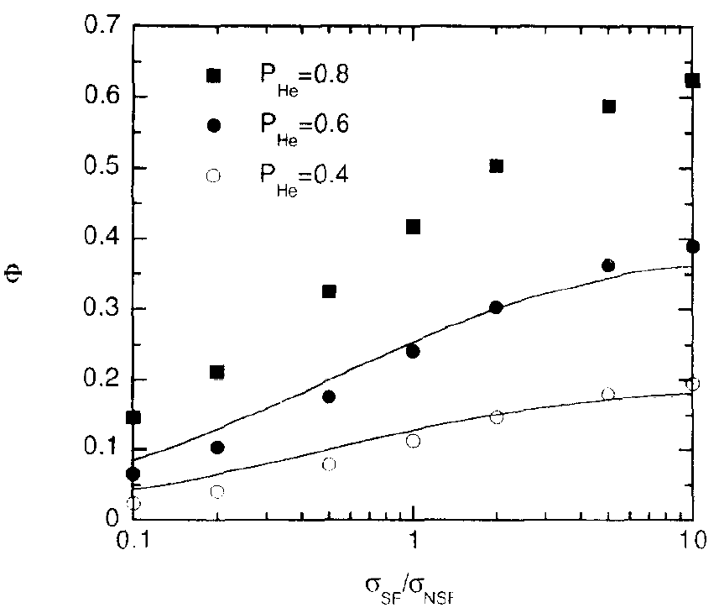
Figure 2. Comparison of the figure of merit for an optimized H3TP + PG setup with ³He gas polarization of 40% (open circles), 60% (filled circles), and 80% (filled squares), with that for a Heusler crystal with total reflectivity (for both spin states) equaling to 10% and 20% of the PG (the lower and the upper curves, respectively); adapted from Ref. [4].
A slightly different approach to comparing performance of the H3TP+PG setup and of the Heusler crystal was presented in Ref. [4]. There, the authors defined the figure of merit for a neutron crystal spectrometer as a reciprocal of the relative error in the value of the measured spin-flip cross-section, σ_{SF}, and considered it as a function of the flipping ratio, σ_{SF}/σ_{NSF}. Their results for the typical flipping ratios encountered in the polarized neutron measurements, in the range 0.1 < σ_{SF}/σ_{NSF} < 10, are reproduced in Figure 2. The figure shows that an optimized H3TP+PG setup with the ³He gas polarization of 40% and 60% provides roughly the same performance as a Heusler crystal with the total reflectivity equal to 10% and 20% of the PG reflectivity, respectively. A Heusler crystal with the reflectivity near 50% of PG (i.e. with the same reflectivity as PG for the selected neutron polarization) would then outperform an optimized H3TP+PG setup even with 80% ³He gas polarization. This agrees very well with the results of our analysis which lead us lo conclude that a modern Heusler crystal with total reflectivity in 0.25 – 0.27 range (i.e. roughly 80% – 90% of the PG reflectivity for the selected neutron polarization) would provide a similar, or better performance as a H3TP+PG combination with ³He gas polarization in the 70% – 75% range.
  - Summary
It is reasonable to expect that a polarized ³He gas transmission cell suitable for using for the incident neutron beam polarization on HYSPEC can be designed and constructed in the very near future. However, design, installation and operation of such a H3TP cell inside a cavity in the beam-line concrete shielding could present a major hurdle. It seems reasonable to expect this problem to be surmountable, but associated with significant R&D and, perhaps, operational expenses. Overall, keeping in mind the large volume of the R&D efforts required by the H3TP project and high costs associated with the related hardware components such as lasers, it does not seem reasonable to expect that the price tag of the H3TP system would be lower than that of the Heusler crystal monochromator. In addition, using the H3TP system would require a non-negligible maintenance and operational expenses (which are practically nil for the Heusler crystal setup).
On the other hand, a combination of the H3TP cell having ³He gas polarization in the 70% – 75% range, which is within the realm of the current or near-future technology, and of a PG monochromator, would only provide performance that is roughly similar to that of the best Heusler crystals available today. Given the equal, or lower procurement and lower operational costs of the Heusler monochromator, its higher versatility (polarization is not time-dependent, allowing for more possibilities in measuring the flipping ratio, σ_{SF}/σ_{NSF}, or the difference σ_{SF} – σ_{NSF}; a higher polarization can be achieved by tightening the beam collimation), reliability (essentially fail-safe), lower sensitivity to the magnetic field environment and low production risks (relies on the well-established technology), it clearly seems to be the option of choice for HYSPEC.

- Scattered neutrons polarization analysis
The feasibility of using the wide-angle H3TP cell instead of an array of the supermirror-bender polarizers for the scattered neutrons polarization analysis in the cold neutron energy range was demonstrated at ILL [5]. The authors have used a 7 cm tall glass-blown cell 10 – 15 cm in diameter and with the horizontal angular coverage of 90°, filled with ³He gas with about 52% nuclear polarization at a pressure roughly 2.7 atm, Figure 3. The cell lifetime of 72 hours was reported. The nuclear and magnetic scattering from the amorphous metal Y₆ErNi₃ measured on the D1B spectrometer equipped with the H3TP cell described above was similar to that measured on the D7 TOF spectrometer. However, a more restricted angular acceptance of the H3TP setup resulted in the truncation of the dataset at low and high wave vector transfers, which appeared as a noticeable handicap of this measurement.
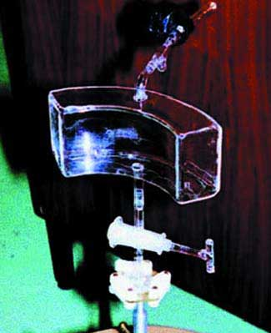
Figure 3. The H3TP cell used in the demonstration measurement on D1B at the ILL described in the text.
Use of the H3TP in place of the supermirror-bender transmission polarizers (SBTP) on HYSPEC provides an attractive option in cases where (i) the sample environment allows enough space for installing the H3TP cell and the associated hardware, (ii) the magnetic field associated with the sample environment and other hardware does not cause significant disturbances of the ³He nuclear polarization in the H3TP, (iii) the simultaneous reduction of the background and of the scattered intensity that is obtained by installing the 20′ collimators associated with the SBTP setup does not improve the signal-to-background ratio. H3TP provides a unique opportunity in cases where the transmission of the 20′ SBTP collimators imposes prohibitively high loss of the scattered intensity, or where the higher scattered neutron energies, E > 25 meV, for which the SBTP performance becomes unacceptably poor, have to be analyzed.
In summary, it seems reasonable to incorporate a possibility of using the polarized ³He transmission cell for analyzing the polarization of the scattered neutrons in the HYSPEC design, as an option alternative to the SBTP array.
References
- L. Passell and R. I. Schermer, Phys. Rev. 150, 146 (1966).
- T. Gentile, private communication.
- L.-P. Regnault, private communication.
- J. Kulda, A. Wildes, A. Martin-Martin, W. Muller, H. Weil, H. Humblot, F. Tasset, Physica B 241-243, 136 (1998).
- J. R. Stewart, K. H. Andersen, H. Humblot, C. Ritter and T. Roberts, R. Cywinski, W. Heil, ILL Annual Report, http://www.ill.fr/AR-02/site/areport/fb_108.htm (2002).
Appendix A. Operation of the ³He Polarizing Filter (L. Passell)
M. E. Rose has shown that the spin dependent neutron cross section σ is of the form

σ = I/(2I+1)(1-f_{n}f_{N})σ_{I-½}+(I+1/(2I+1))[ 1+I/(I+1)f_{n}f_{N}]σ_{I+½},

where f_{n} and f_{N} represent, respectively the neutron and nucleus polarizations and the other terms are defined below. From this expression it is straightforward to show that the polarization P_{n} and transmission Τ_{n} of a neutron beam passing through a ³He polarizing filter can be calculated from the expressions

P_{n}(f_{3He},Nτ) = tanh(N l σ_{p}f_{3He})

Τ_{n}(f_{3He},Nτ) = exp(-N l σ₀)cosh(N l σ_{p}f_{3He}),
where
f_{3He ≡} ³He nuclear polarization
σ₀ ≡ I/(2I+1)σ_{I-½} +(I+1/(2I+1))σ_{I+½}
σ_{p} ≡ I/(2I+1)(σ_{I-½} - σ_{I+½})
I ≡ ³He nuclear spin = ½
σ_{I-½} ≡ cross section for the I-½ spin state of the compound
nucleus
σ_{I+½ ≡} cross section for the I+½ spin state of the
compound nucleus
N ≡ number of ³He atoms/unit volume and
l ≡ length of the ³He filter.

In ³He, σ_{I-½} >> σ_{I+½} hence it is an excellent approximation to assume that σ_{p} = σ₀ = 6928 bn at 15.0 meV.

