Argon scattering in the Hyspec detector vessel
Vinita J. Ghosh
August 9, 2006.

Executive Summary

At the Hyspec IDT meeting (April 7, 2006) concern was expressed that scattering by the argon gas in the detector vessel could create an unacceptable background. The specific issue that needs to be addressed is as follows: Some small part of the neutrons in a Bragg peak beam passing through the detector bank will inevitably be scattered by argon atoms. They will lose or gain energy in the scattering process and, in addition, their paths to the detector bank will be longer than those of the unscattered, Bragg-peak neutrons. Argon gas scattering will therefore generate a beam-related, time-dependent background that will spread over the entire detector array. This background, if too large, could negatively impact on instrument sensitivity.

In general, inelastic peaks can be expected to have integrated intensities roughly four orders of magnitude smaller than their Bragg equivalents. To be clearly identified and quantified it is obviously important that they not be significantly obscured by scattering from the argon gas. What would be acceptable in the way of gas-scattered background will depend on the specific experimental situation and is to some extent a matter of opinion but a consensus view would probably be that it should be least one and preferably two orders of magnitude smaller than a typical inelastic signal.

In order to asses the impact of argon scattering several sets of simulations were performed. First the time-integrated neutron intensity was mapped for a representative set of neutron energies assuming a collimated, monochromatic source of neutrons located at the sample position. These results are presented in Figs 2-7.

In making a definitive evaluation of the effect of the gas-scattered background, however, it is important to keep in mind that what is important is not only its magnitude but the range of energy transfers that it would obscure. Thus it is also necessary to simulate the "times of arrival" of these neutrons relative to the unscattered Bragg-peak neutrons. The time-dependent neutron flux at the detector bank was therefore simulated as realistically as possible, taking into account the energy, angle and time distribution of neutrons at the sample-source. This model and its results are presented in Figs 8-15. Representative simulations of unscattered and scattered neutron arrival times are plotted in figs. 12 and 14 and the simulation results are replotted in terms of "apparent energy transfers" in figs. 13 and 15.

In addition, the argon scattering results were compared with scattering by helium and air (figs 16 and 17). If the HYSPEC detector vessel were evacuated it would require 3.6mm Al windows according to W.J. Leonhardt’s calculations. When the detector vessel is filled with argon it would require an Al window which is 0.81mm thick. These two scenarios were simulated and the simulation results are presented in Fig 18.

It was found that the maximum time-integrated flux due to argon scattering on the non-Bragg peak detector cells was a few times 10⁻⁵ of the flux in the Bragg peak near the Bragg peak detector. The background flux decreased to ~10⁻⁶ as the distance from the Bragg peak detector was increased (see Fig 17). The impact of adding a thin Al window (0.81mm thick) is negligibly small. If the HYSPEC detector vessel were evacuated it would require 3.6mm Al windows. The scattering from the thicker (3.6mm) Al window (see Fig 18) is a background flux ~10⁻⁶ times the flux of the Bragg peak.

Given these results, the question to be addressed is whether a time-integrated background flux due to scattering from the argon in the detector vessel which is five to six orders of magnitude smaller than the Bragg peak flux is ‘small enough’ to resolve low-intensity, small-energy-transfer peaks in near-neighbor detectors.

Simulation model

In order to map the time-integrated Bragg-peak induced gas-scattered background at the HYSPEC detector bank some simple MCNPX simulations have been performed, For simplicity the detector vessel was represented as a rectangular box rather than a segment of a cylinder as shown in the following figure. (The effect of this is to slightly increase the path lengths of the gas-scattered atoms and thus slightly increase their time of arrival at the detector bank).

Bragg peak neutrons
Length (450-70)=380cm
Width 260*2cm
Height 120 cm
Extended detector bank
Neutrons scattered by argon atoms

Figure 1. Layout of the simulation model

For the first set of simulations a perfectly collimated monoenergetic beam of neutrons enters the detector vessel at the middle of the z = 70 cm face. The z = 450cm face represents the extended detector bank. For a sample-detector distance of 450 cm the box had a length of (450-70) = 380 cm, the width of the detector bank was 450*2*tan30 = 2*260 cm, and the height of the detector bank was 2*450*tan7.5 = 2*60 cm. A mesh tally was performed on the extended detector bank. The pixel size was 2cm by 2cm. The intensity in the Bragg peak was set equal to one. A 10⁹ neutron simulation was performed for some representative neutron energies.

Results:
The mesh plots showing the time-integrated distribution of the argon-scattered neutrons at the detector bank are shown in figures 2-7. The neutron intensity in each 2cm by 2cm detector pixel obviously depends on the size of the pixel.
Fig. 2. Integrated intensity distribution for a Bragg peak energy of 3.5meV
Fig 3. Integrated intensity distribution for a Bragg peak energy of 5meV

Fig 4. Integrated intensity distribution for a Bragg peak energy of 15meV
Fig 5. Integrated intensity distribution for a Bragg peak energy of 30meV
Fig 6. Integrated intensity distribution for a Bragg peak energy of 60meV
Fig 7. Integrated intensity distribution for a Bragg peak energy of 90meV

In these figures the blue region represents integrated intensities less than 10⁻⁶, and the green regions represent integrated intensities less than 10⁻⁵. Around the Bragg peak there is a small area of higher intensity. Parts of the detector bank where the integrated intensity was less than 10⁻⁶ have not been shown. It is obvious from a comparison of Figs. 2-7 that lower energy neutrons are more effectively scattered by argon than those of higher energy. This is consistent with the values of the argon scattering cross-sections shown in Appendix 1. It is obvious from figure A1 that the absorption cross-section of argon decreases from ~3 to 0.3 barns as the neutron energy increases from 1 to 100meV, and from figure A2 that the elastic scattering cross-section of argon decreases from ~1 to 0.7 barns as the neutron energy increases from 1 to 100meV. Since the magnitude of the argon scattering cross-sections decreases as the neutron energy increases, the integrated intensity of the argon scattering background is expected to decrease as the neutron energy increases (as is evident in fig 2-7).

Time dependence of the argon scattering

The time dependence of the argon-scattered Bragg peak neutrons was next explored using MCNPX. For this simulation the model of the extended detector bank was modified and only one array of detector cells centered at the scattering plane was examined in detail (see Fig 8). These cells were either 2.5 or 5cm wide and 10cm high. The central cell (cell 1) and the Bragg peak are centered at x=0 y=0. For the time-dependent simulations the cell width was chosen to be twice the actual width of a detector tube. In addition to that the outputs of symmetrical cells on both sides of the Bragg peak were combined to reduce statistical errors. These large cell sizes had to be used to make the time bins equal to 10 microseconds.

4 3 2 1 2 3 4
Simulated pixels 2.5 or 5cm wide, 10cm tall, centered at y=0
Extended detector bank showing location of simulated pixels

Figure 8: Location of the detector pixels

To make the time-dependent simulations as realistic as possible the energy and time dependence of the neutron beam at the sample position were taken into account. The energy (see Fig 9) and time distribution (see Fig 10) of the 15meV (nominal energy) neutrons at the sample position was obtained from HYSPEC McStas simulations.
Fig 9. Energy distribution of the 15meV (nominal incident energy) neutrons immediately downstream of the wavelength selecting chopper. These are McStas results for a simulation with a moderator-monochromator distance of 37m.
Fig 10. Time distribution of the 15meV (nominal incident energy) neutrons immediately downstream of the wavelength selecting chopper, at the sample position and at the detector bank provided there was no air or argon scattering. These are McStas results for a simulation with a moderator-monochromator distance of 37m.

The energy spectrum shown in Fig 9 was used as input for MCNPX. The time distribution of the neutrons at the sample position is illustrated in Fig 10. To simplify the calculations it was assumed that the time pulse was triangular and had a FWHM of 50 microseconds at the sample. This triangular distribution was convoluted with the time dependence of the scattered neutrons at the detector bank to obtain the results presented in Fig 12.

Fig 11. The time-integrated flux on each detector cell normalized to the flux in the Bragg peak cell as a function of the distance from the Bragg peak cell.

The normalized time-integrated flux is plotted in Fig 11 for each detector cell in the scattering plane. We see from Fig 11 that the Bragg peak typically spreads out over two detector cells. This spreading is almost entirely due to the 20 minute divergence of the source neutron beam at the sample position. The third cell (whose center is 10 cm from the Bragg peak center) has a neutron flux of ~10⁻⁵ of the flux in the Bragg peak cell. The flux in the detector cells decreases as the distance from the Bragg peak increases. This flux is entirely due to argon scattering. When a simulation was done with no gas in the detector vessel the flux in detector cells 3 and larger was zero (as expected). It is relevant to note that the simulation of Fig 11 has the same space dependence as that in Fig 4.

Fig. 12. The time dependence of the argon scattered neutrons in various detector cells.
Fig 13. The apparent energy of the argon-scattered neutrons in various detector cells calculated from the time of arrival of the neutrons at these cells.

The time dependence and the apparent energy dependence of the argon-scattered neutrons for a nominal energy of 15meV are plotted in figures 12 and 13. For these simulations the sample-source neutrons had an energy distribution shown in Fig 9 and angular divergence of 20 minutes. In order to simulate the time dependence of the neutrons incident on the sample a triangular time pulse with a FWHM of 50micrseconds was convoluted with the time dependence of the argon-scattered neutrons at the detector. The apparent energy plots of Fig13 are very informative. They show that because of the finite size of the sample and the divergence of the sample-source the Bragg peak spreads out onto adjacent detectors. Because of the energy and time width of the source pulse the smallest energy loss that could be measured would be approximately 0.75meV (energy resolution ~5%). One should remember that for this simulation the time width at the wavelength-selecting chopper was ~50μs. The time and hence the energy width of the incident neutron pulse can be changed (both increased and decreased) by changing the rotation rate of the T2 chopper.

The figure also shows that for detectors that are more than 35cm from the Bragg peak
detector the argon-scattering flux is less than 10⁻⁶. Detectors that are closer than 35cm have an argon-scattering flux that is higher than 10⁻⁶ but lower than 10⁻⁵.

The time and apparent energy dependence of the argon-scattered neutrons for a nominal energy of 5meV are plotted in figures 14 and 15. The apparent energy plots in Fig 15 show the same qualitative behavior as those of the 15meV neutrons plotted in Fig 13. For a nominal incident energy of 5meV the smallest energy loss that could be resolved would be ~(5-4.85) = 0.15meV (energy resolution ~3%) because the incident beam has a finite time and energy width. One should remember that for this simulation the time width at the wavelength-selecting chopper was ~50μs. The time and hence the energy width can be changed (both increased and decreased) by changing the rotation rate of the chopper.

Fig 14. The time dependence of the argon scattered neutrons in various detector cells.

Fig 15. The apparent energy of the argon-scattered neutrons in various detector cells calculated from the time of arrival of the neutrons at these cells.

The figure also shows that for detectors that are more than 35cm from the Bragg peak detector the argon-scattering flux is less than 10⁻⁶. Detectors that are closer than 35cm have an argon-scattering flux that is higher than 10⁻⁶ but lower than 10⁻⁵.

These time-dependent simulations were not performed for higher neutron energies. Since the scattering cross-section of argon decreases as the neutron energy increases (see Appendix 1) the background time-dependent flux due to argon scattering is expected to decrease as the neutron energy increases.

Background generated by argon, helium and air scattering

Simulations were performed to compare the impact of the scattering due to argon, ⁴He, and air (80% N, 20% O) on the Bragg peak. The detector vessel was filled with the selected gas at room temperature and one atmosphere pressure. The normalized time-integrated flux on the various detectors is plotted in Fig 16. The control simulation with vacuum in the detector vessel has not been plotted because the neutron flux on the non-Bragg peak detectors was zero. It is obvious from this figure why detector vessels are evacuated – the scattering due to air is much larger than the scattering due to argon or ⁴He. The scattering cross-sections for ⁴He, N and O are plotted in Appendix 1.
Fig 16. Comparison of the background neutron flux when the detector vessel is filled with argon, helium or air. In this simulation the space between the sample and the detector vessel is a vacuum.
Fig. 17. Comparison of the background neutron flux when the detector vessel is filled with argon, helium or air. In this simulation it is assumed that the sample is surrounded by an evacuated dewar with a radius of 10cm. The space between the sample dewar and the detector vessel is filled with air.

It is clear from comparing figs 16 and 17 that the impact of the scattering due to 60cm of air upstream of the detector vessel is insignificant compared to the scattering due to the gas in the detector vessel.

Scattering due to Al windows

W.J. Leonhardt has estimated the thickness of the upstream aluminum window for the HYSPEC detector vessel. According to his calculations the thickness of the Al window would have to be 3.6mm if the HYSPEC detector vessel were evacuated. If the detector vessel is filled with argon the thickness of the Al window could be reduced to 0.81mm. This of course suggested a comparison between the scattering due to the Al window and the scattering due to the argon in the detector vessel.

In order to study the impact of the Al scattering two simulations were performed:
- The Al window thickness was 3.6mm and there was a vacuum in the detector vessel.
- The Al window thickness was 0.081mm thick and the detector vessel was filled with argon at 1bar.
In both cases the space between the sample dewar and the detector vessel was filled with air. MCNPX treats all materials as dense gases with no positional order and therefore does not separate the scattering into coherent elastic Bragg and temperature diffuse (phonon) components. Al is a polycrystalline material and the greatest part of the scattering from it will be Bragg scattering (most of which will be intercepted and stopped by the radial collimator in the detector tank). The simulations therefore significantly overestimate the scattering from the Al windows. The results of these simulations are presented in Fig. 18.

Fig 18. Impact of the Al window on the Bragg peak neutrons. The blue triangles represent the scattering due to the 3.6mm Al window when the detector vessel is evacuated. The red circles represent the scattering due to the 0.81mm Al window when the detector vessel is filled with argon.

It is clear from this figure that the background due to argon scattering is somewhat larger than that due to the thicker Al window near the Bragg peak. The contribution of the very thin (0.81mm) Al window to the argon scattering background is very small.

Summary and conclusions

In order to asses the impact of argon scattering several sets of simulations were performed. First the time-integrated neutron intensity was mapped for a representative set of neutron energies assuming a collimated, monochromatic source of neutrons located at the sample position. These results are presented in Figs 2-7.

In making a definitive evaluation of the effect of the gas-scattered background, however, it is important to keep in mind that what is important is not only its magnitude but the range of energy transfers that it would obscure. Thus it is also necessary to simulate the "times of arrival" of these neutrons relative to the unscattered Bragg-peak neutrons. The time-dependent neutron flux at the detector bank was therefore simulated as realistically as possible, taking into account the energy, angle and time distribution of neutrons at the sample-source. This model and its results are presented in Figs 8-15. Representative simulations of unscattered and scattered neutron arrival times are plotted in figs. 12 and 14 and the simulation results are replotted in terms of "apparent energy transfers" in figs. 13 and 15.

In addition, the argon scattering results were compared with scattering by helium and air (figs 16 and 17). If the HYSPEC detector vessel were evacuated it would require 3.6mm Al windows according to W.J. Leonhardt’s calculations. When the detector vessel is filled with argon it would require an Al window which is 0.81mm thick. These two scenarios were simulated and the simulation results are presented in Fig 18.

It was found that the maximum time-integrated flux due to argon scattering on the non-Bragg peak detector cells was a few times 10⁻⁵ of the flux in the Bragg peak near the Bragg peak detector. The background flux decreased to ~10⁻⁶ as the distance from the Bragg peak detector was increased (see Fig 17). The impact of adding a thin Al window (0.81mm thick) is negligibly small. If the HYSPEC detector vessel were evacuated it would require 3.6mm Al windows. The scattering from the thicker (3.6mm) Al window (see Fig 18) is a background flux ~10⁻⁶ times the flux of the Bragg peak.

Given these results, the question to be addressed is whether a time-integrated background flux due to scattering from the argon in the detector vessel which is five to six orders of magnitude smaller then the Bragg peak flux is ‘small enough’ to resolve low-intensity, small-energy-transfer peaks in near-neighbor detectors.

Appendix 1
Scattering and absorption cross-sections of argon, helium, nitrogen and oxygen generated using MCNPX. The x axis in Figs A1-A8 is incorrectly labeled meV. The energy units should be MeV
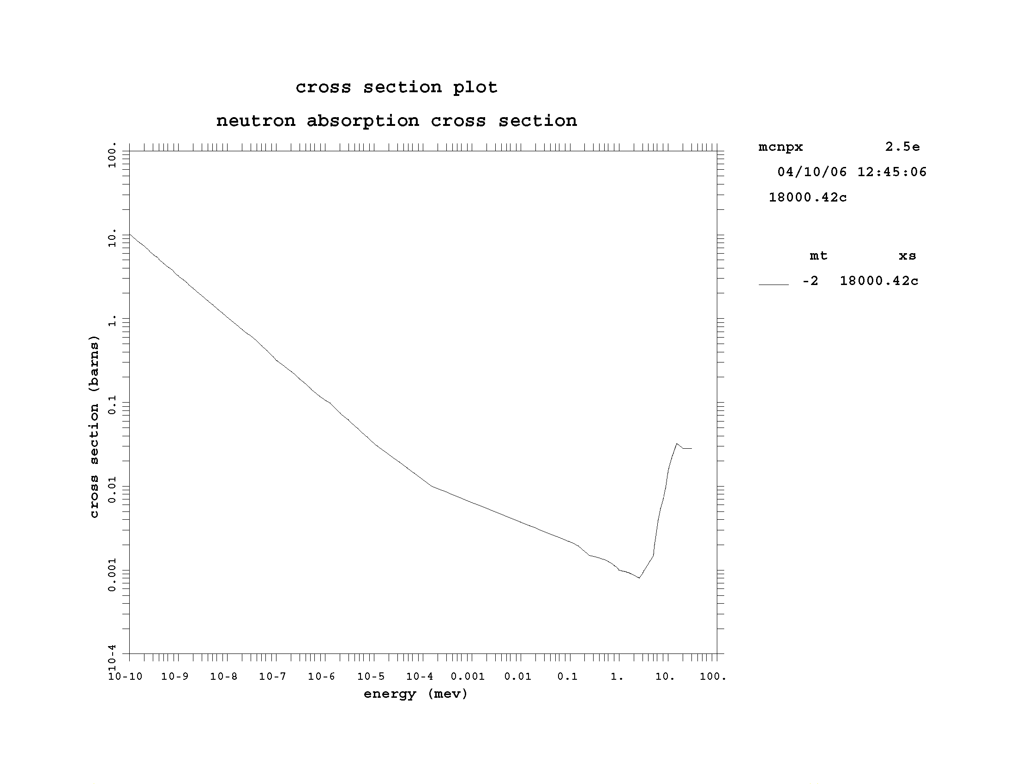

Fig A1. Absorption cross-section of argon as a function of energy
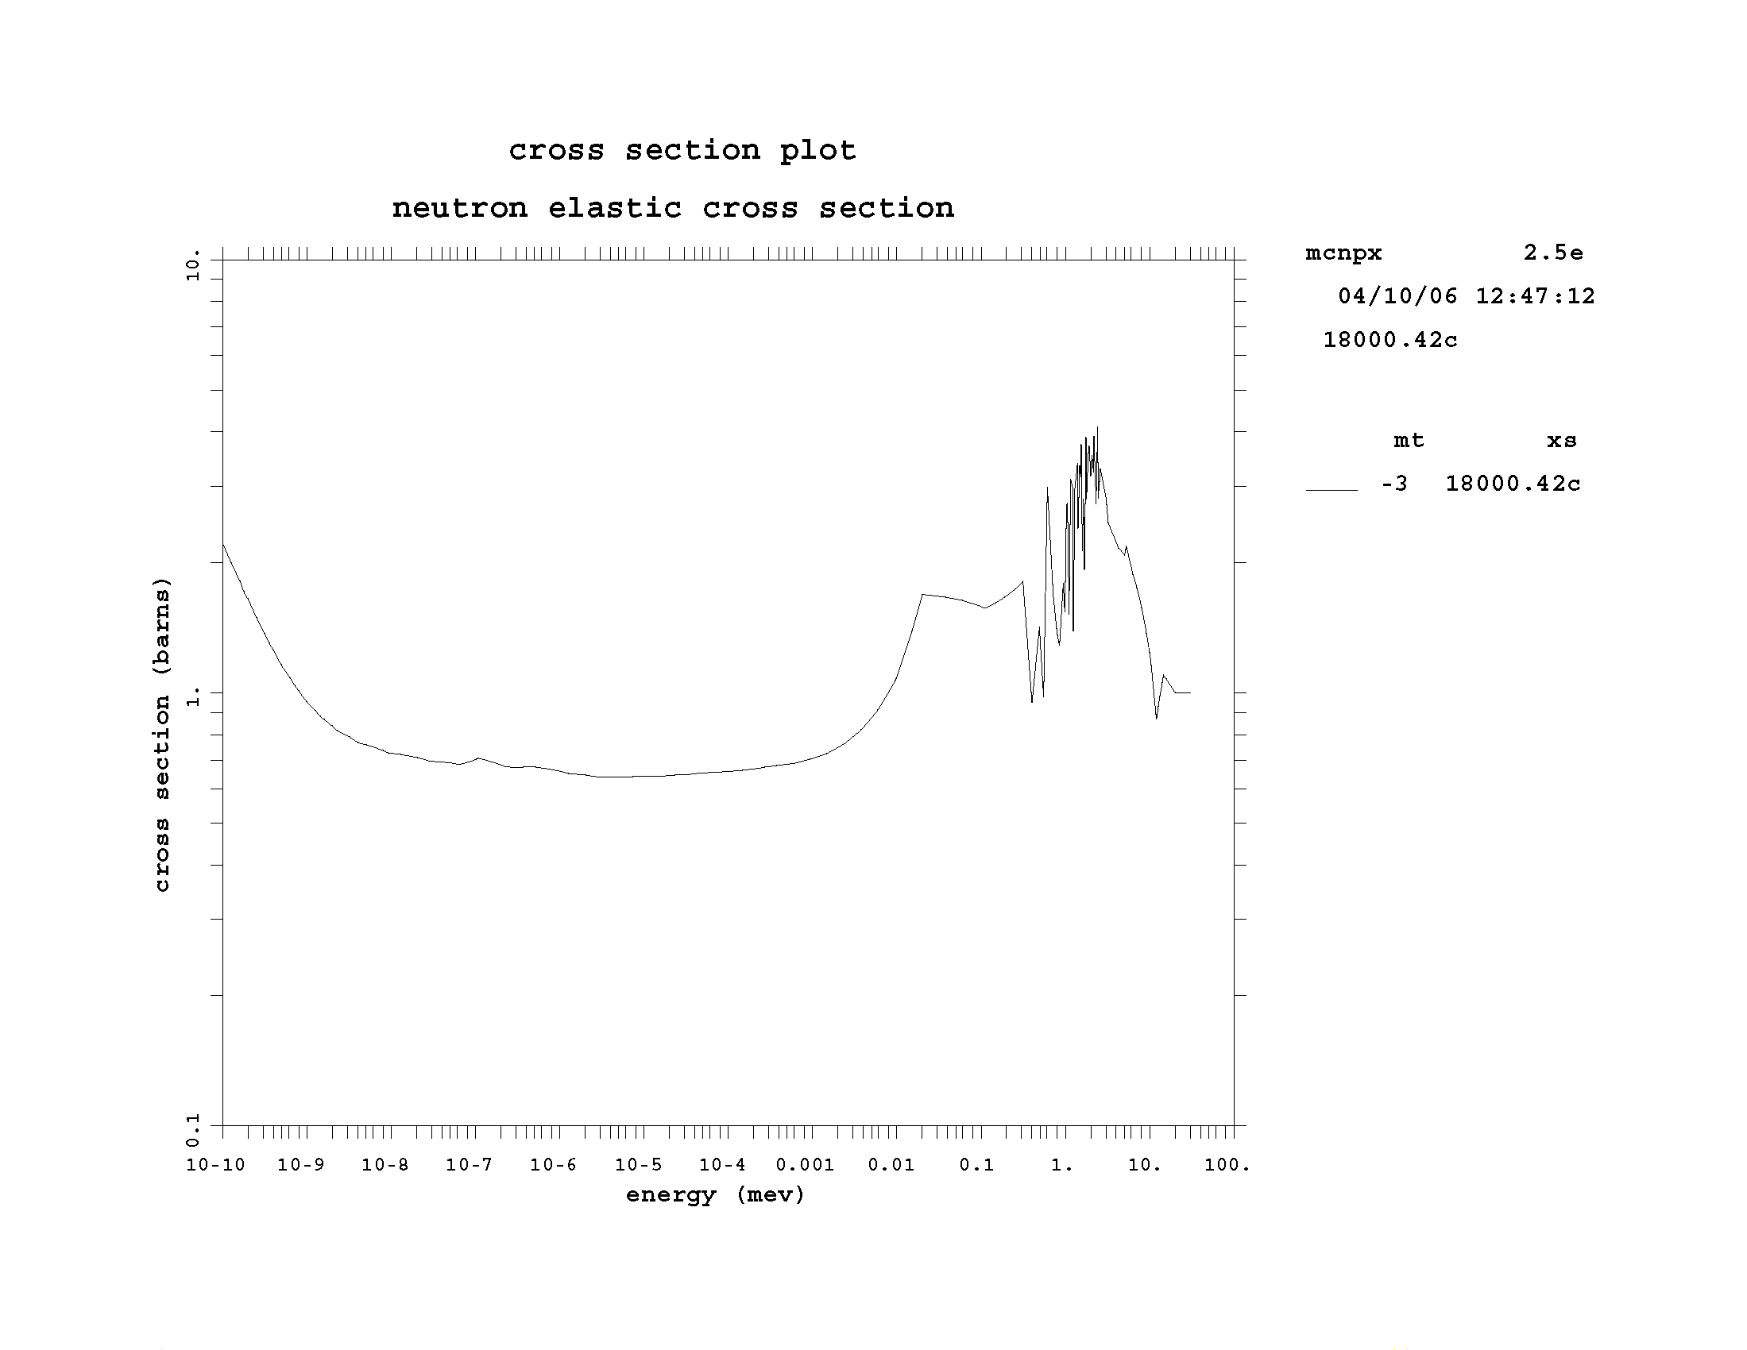
Fig A2. Elastic scattering cross-section of argon as a function of energy

It is obvious from figures A1 and A2 that the absorption cross-section of argon decreases from ~3 to 0.3 barns as the neutron energy increases from 1 to 100meV, and from figure 9 that the elastic scattering cross-section of argon decreases from ~1 to 0.7 barns as the neutron energy increases from 1 to 100meV. Since the magnitude of the argon scattering cross-sections decreases as the neutron energy increases the integrated intensity of the argon scattering background is expected to decrease as the neutron energy increases, as shown by the simulation results in figures 2-7.
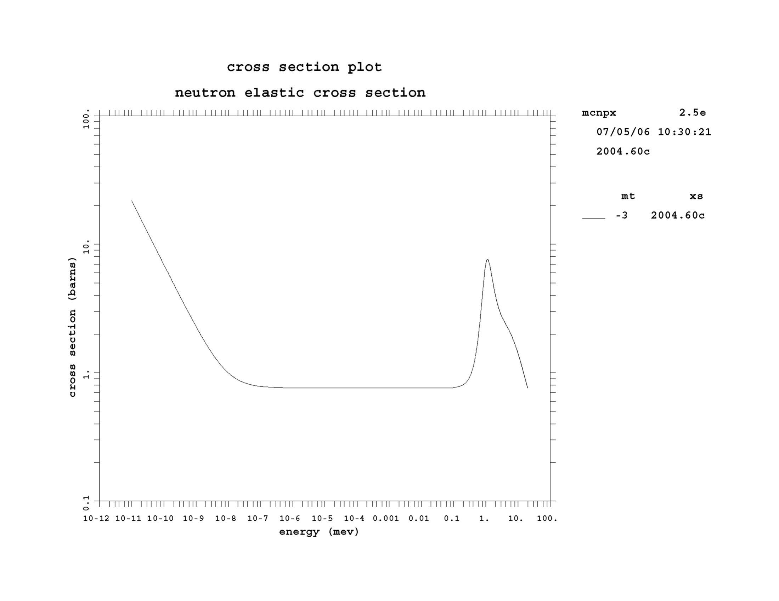
Fig A3. Elastic scattering cross-section of ⁴He.
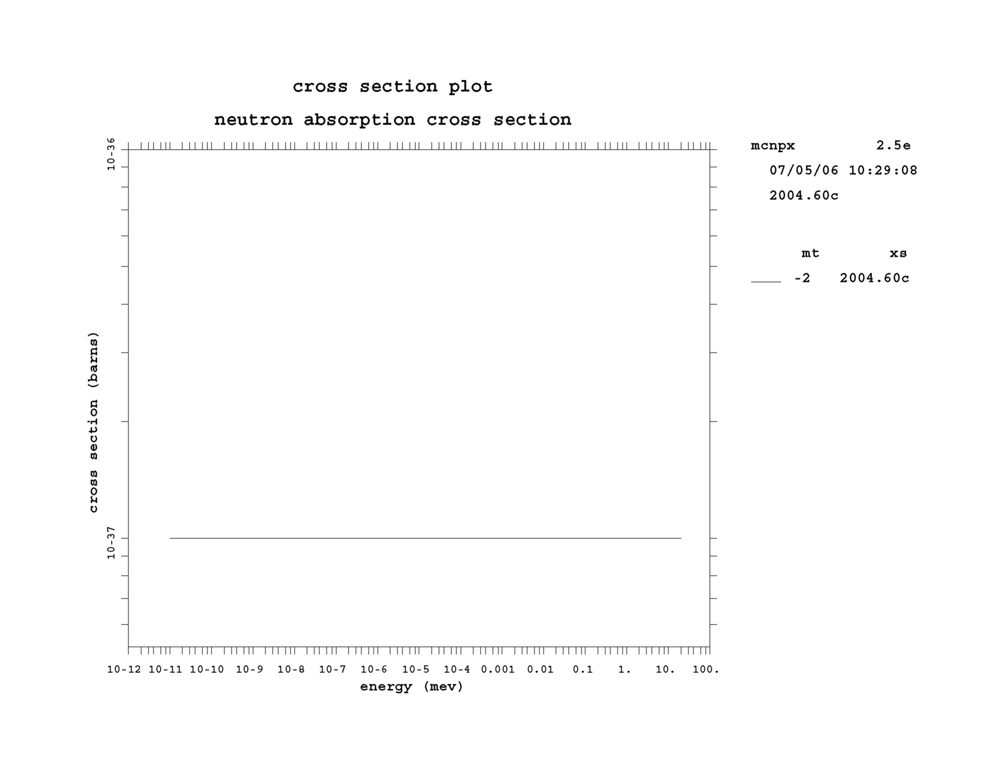
Fig A4. Absorption cross-section of ⁴He.

The elastic scattering cross-section of ⁴He is somewhat but not much larger than that of argon. However, the absorption cross-section is negligibly small.
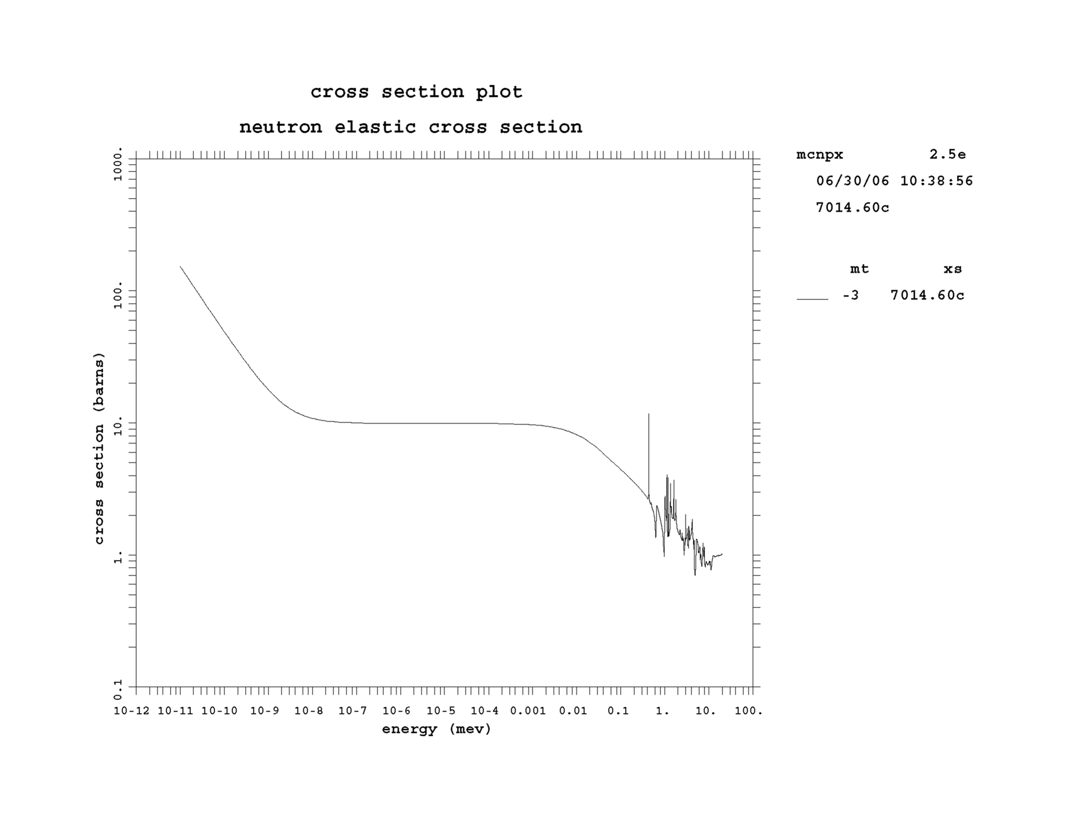
Fig A5. The elastic scattering cross-section of nitrogen

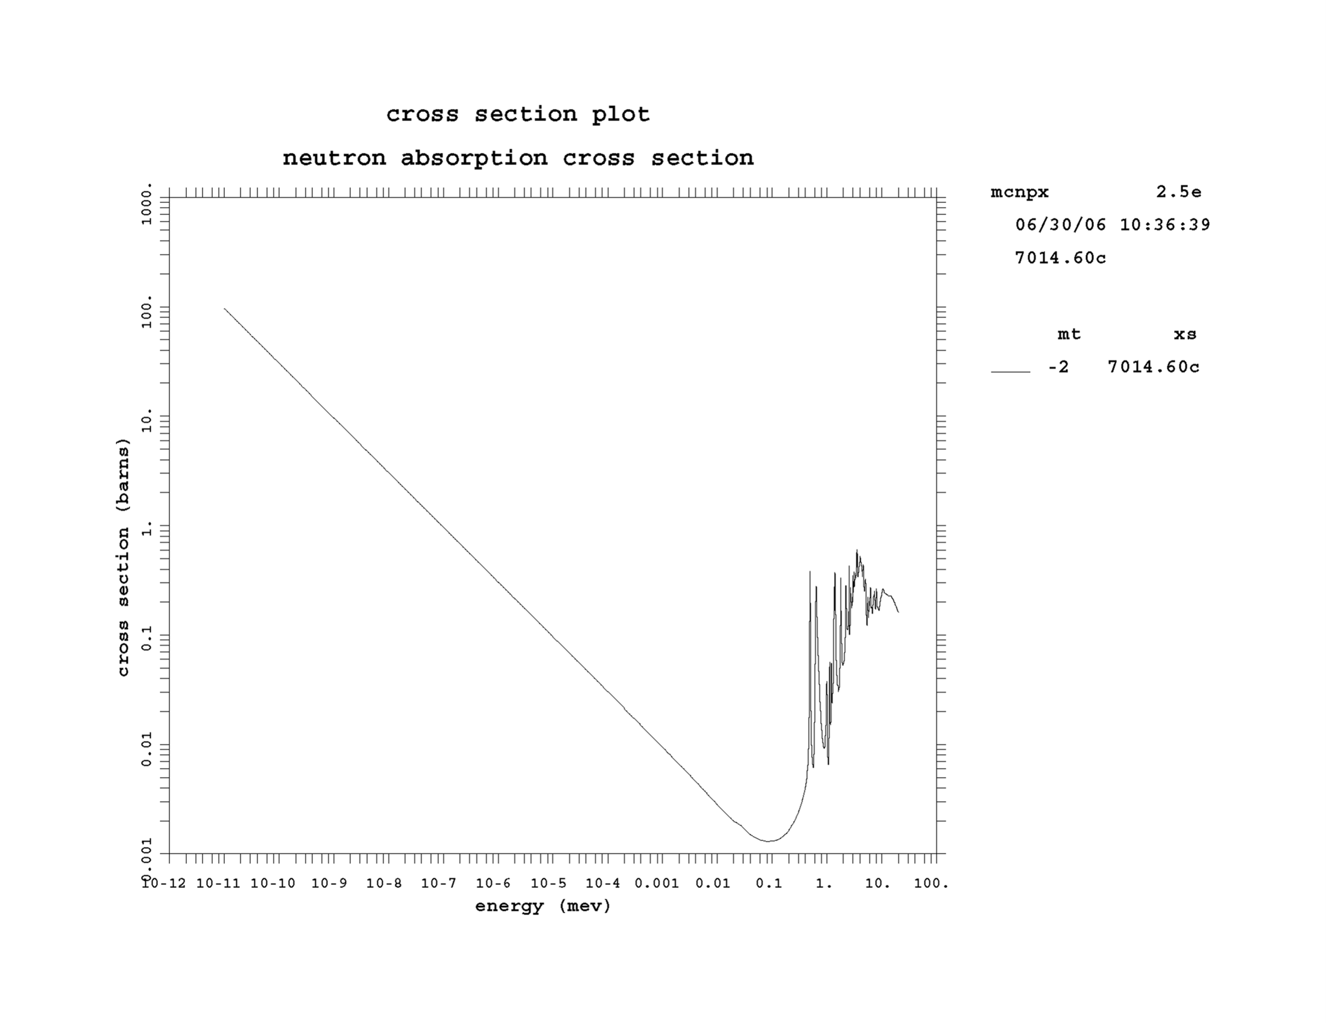
Fig A6. The elastic scattering cross-section of nitrogen.

The scattering cross-sections of nitrogen and oxygen are ~ 13-15 times the scattering cross-sections of argon and 4He.

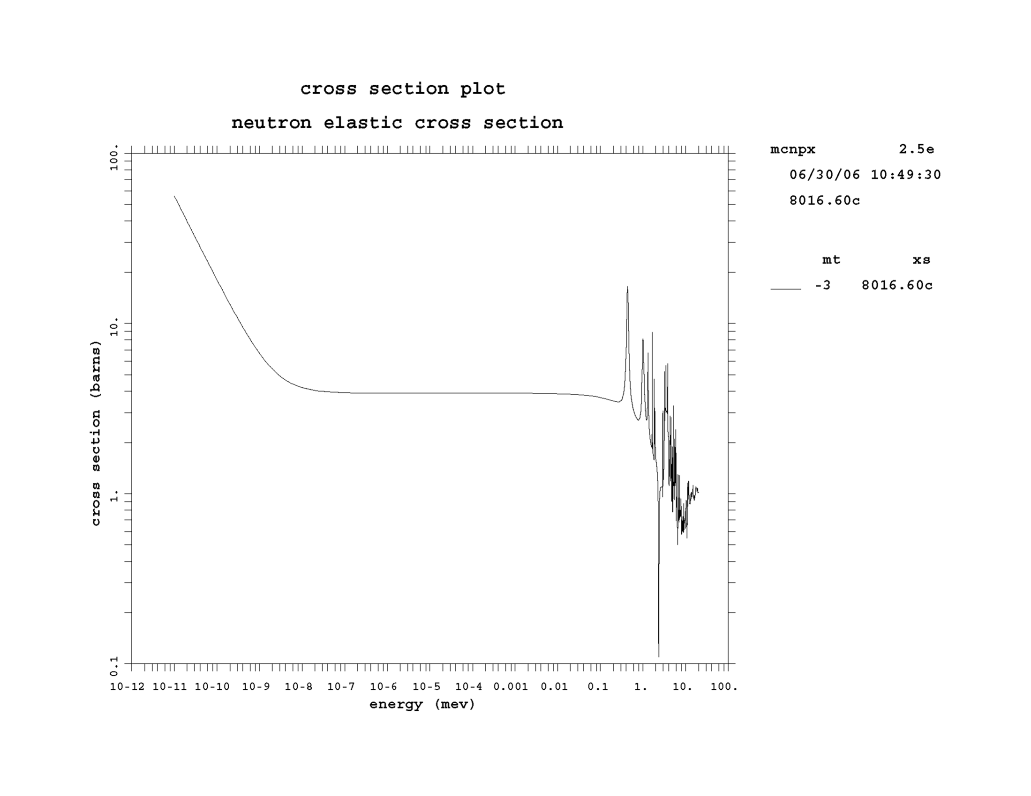
Fig A7. The elastic scattering cross-section of oxygen.
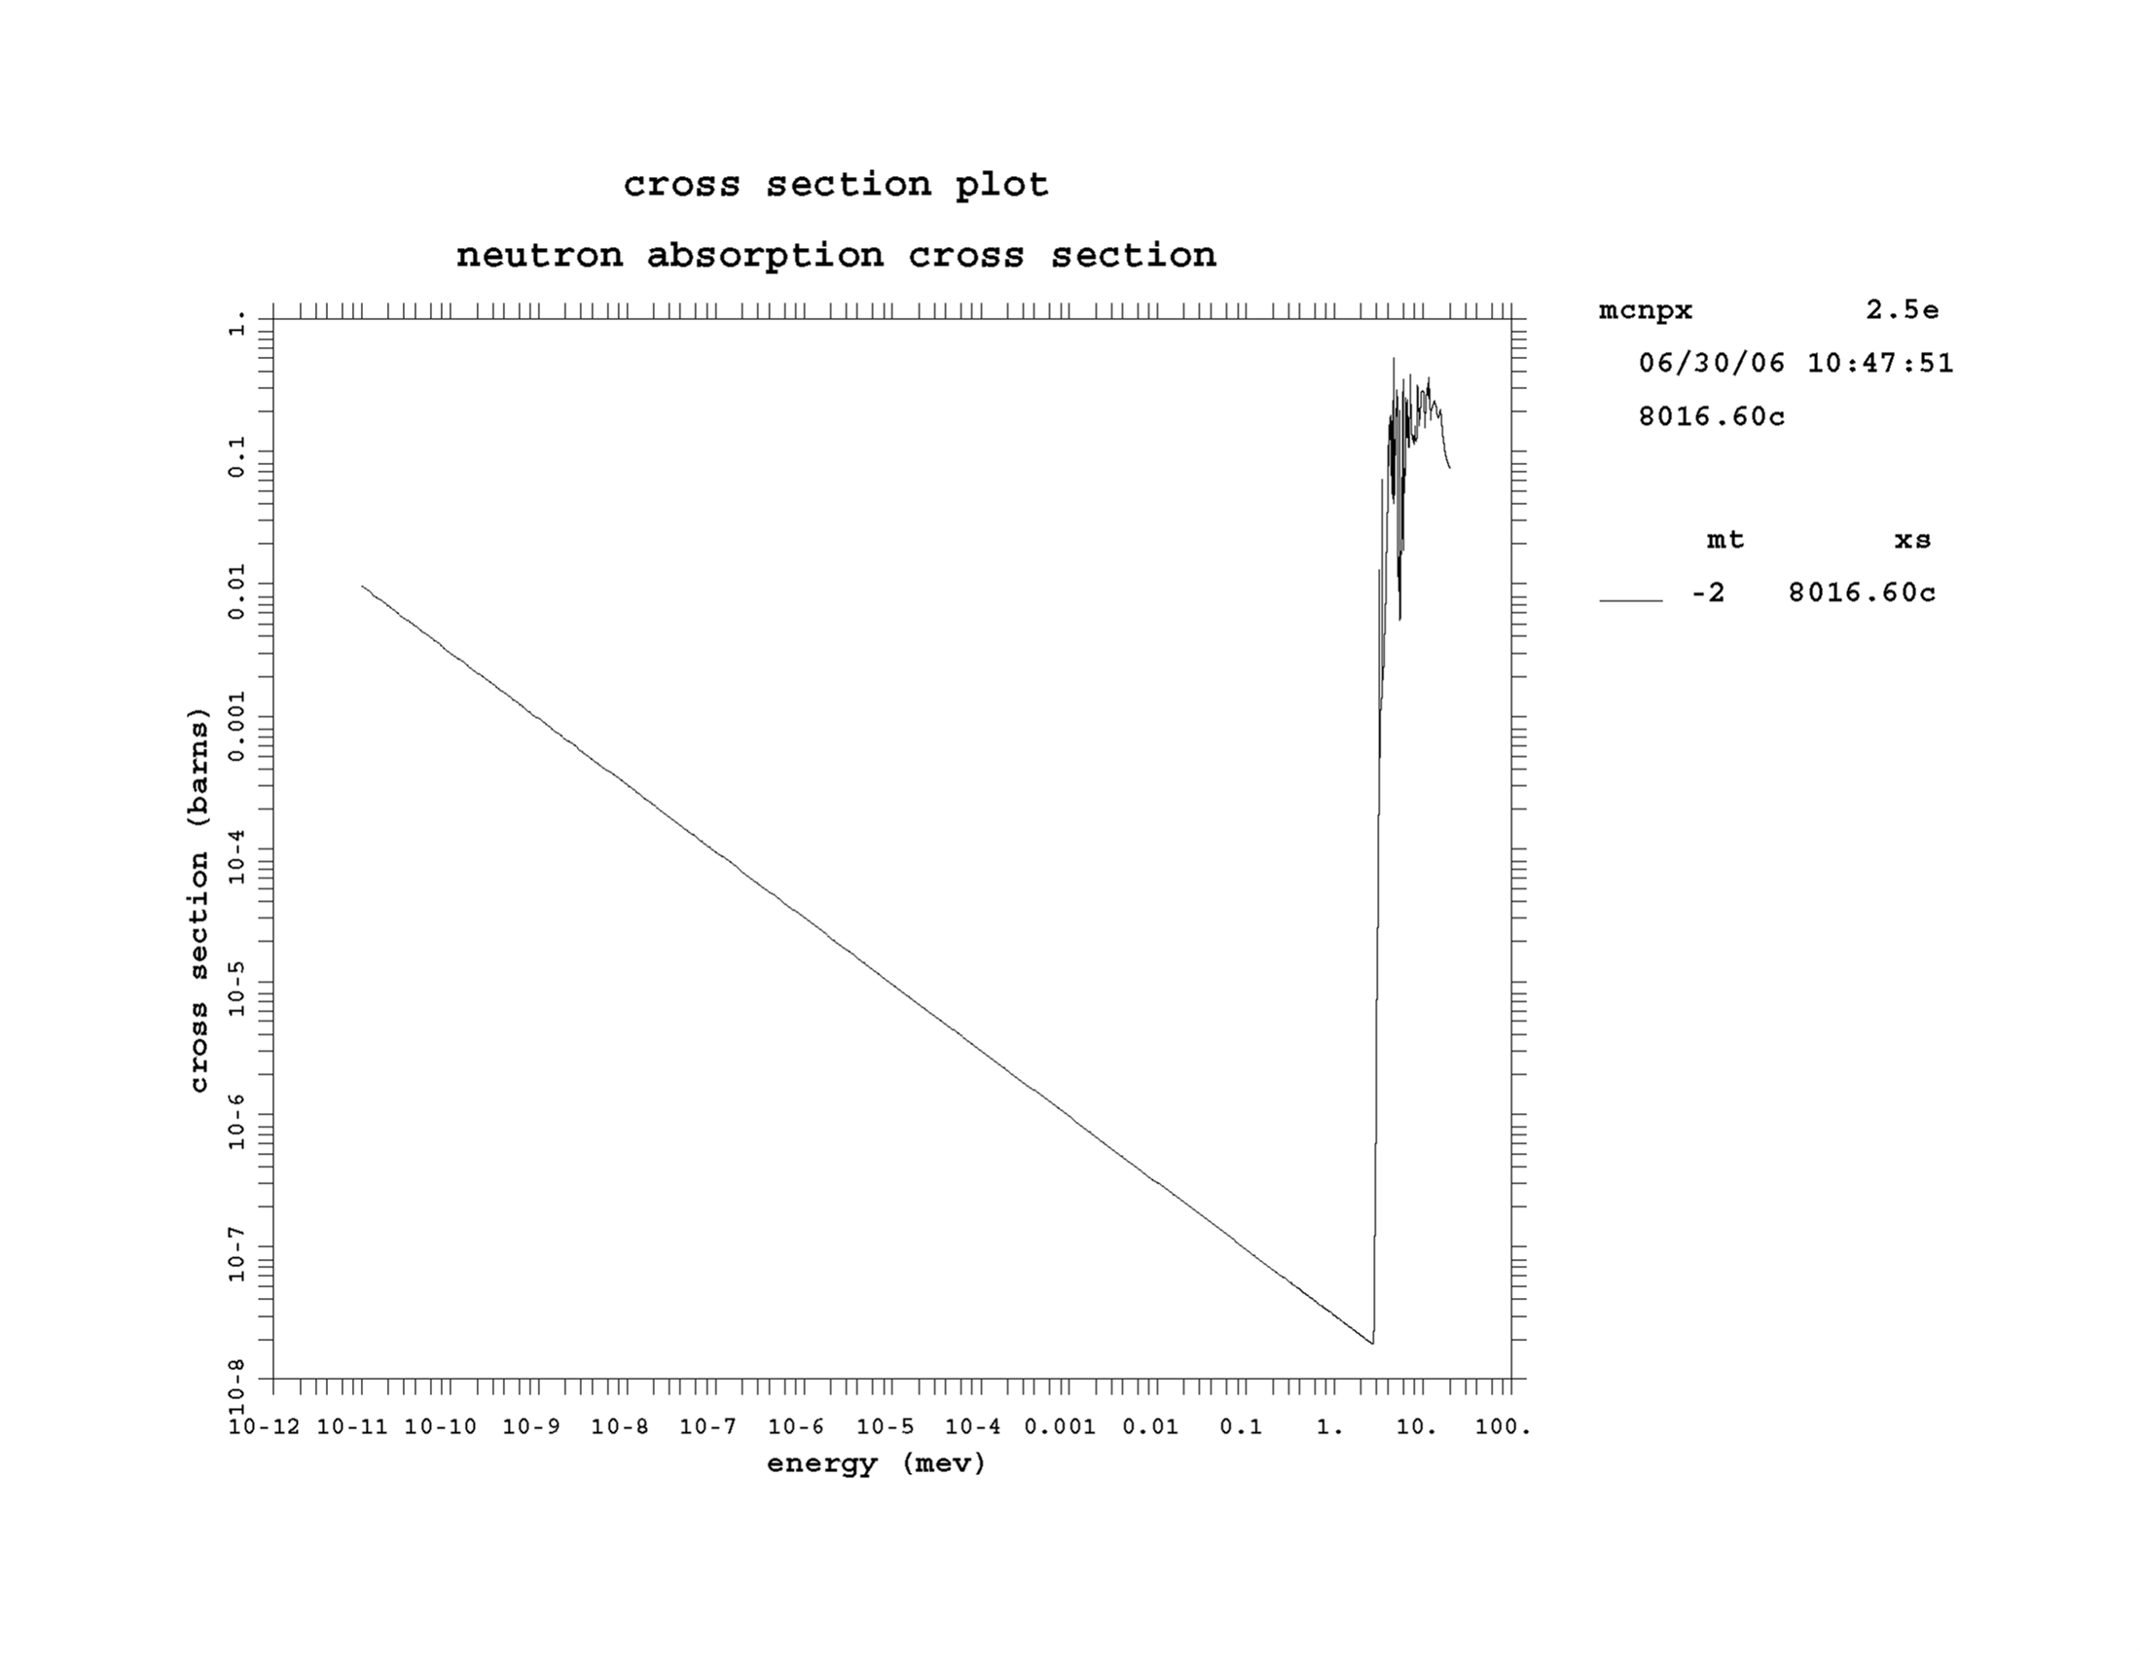
Fig A8. The absorption cross-section of oxygen.

A comparison of the scattering cross-sections of argon, helium, nitrogen and oxygen explains why detector vessels are evacuated. Filling the detector vessel with argon or helium will result in a small time-dependent background due scattering by these gases.

