Drum shield results with Heusler alloy monochromator
Vinita J. Ghosh
August 10, 2005

Description of drum shield
The drum shield is modeled as a hollow cylinder of inner radius 30cm, outer radius 90cm, 300cm tall, 150cm above and 150cm below the beam centerline. The drum shield is composed of concentric rings of 1cm of borated poly (30% nat B) 5cm stainless steel, 43cm high density concrete, another 1cm of borated poly (30% nat B) followed by 5cm of stainless steel. This drum shield will effectively shield the PG monochromator so that the only beam related background is due only to the neutrons and photons coming out the exit guide.

The simulated model starts at the end of the curved guide and includes the straight guides G3, G4, Box-B and the drum shield (see Fig 1).The center of the cylinder is at 430cm from the end of the curved guide G2. The fast neutron source was generated by tallying the number of neutrons of energies E>1.12x10-6 MeV crossing a 8x19 surface at the end of the curved guide. This 8x19 area includes the guide interior, the 1cm substrate and the 1cm void surrounding the guide. The fast neutron source is placed at the entrance to guide G3. The thermal (E<1.12x10-6 MeV) neutron source is generated by doing a MCSTAS simulation that records the energy distribution of the neutrons at the end of G2, G3 and G4. For the drum shield simulations the energy distribution at the end of G4 is used as a source. To be conservative in our drum shield design the neutron source weights are multiplied by 2.
G3
G4

Figure 1. Arrangement of the 1.75m straight guide + Box B & drum shield

I have used the NIST doubly focusing monochromator (shown in Fig 2) as a model for the HYSPEC HOPG monochromator. The dimensions of the NIST monochromator have been altered for the HYSPEC 4cm wide 15cm high beam.

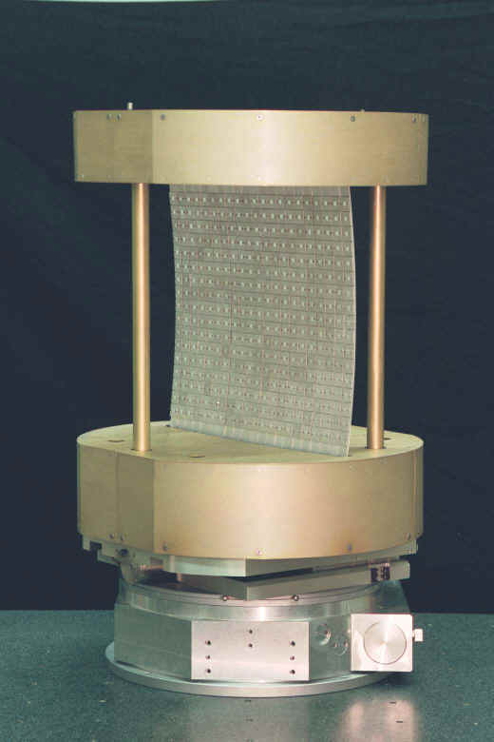
Fig 2. The NIST doubly focusing PG monochromator.

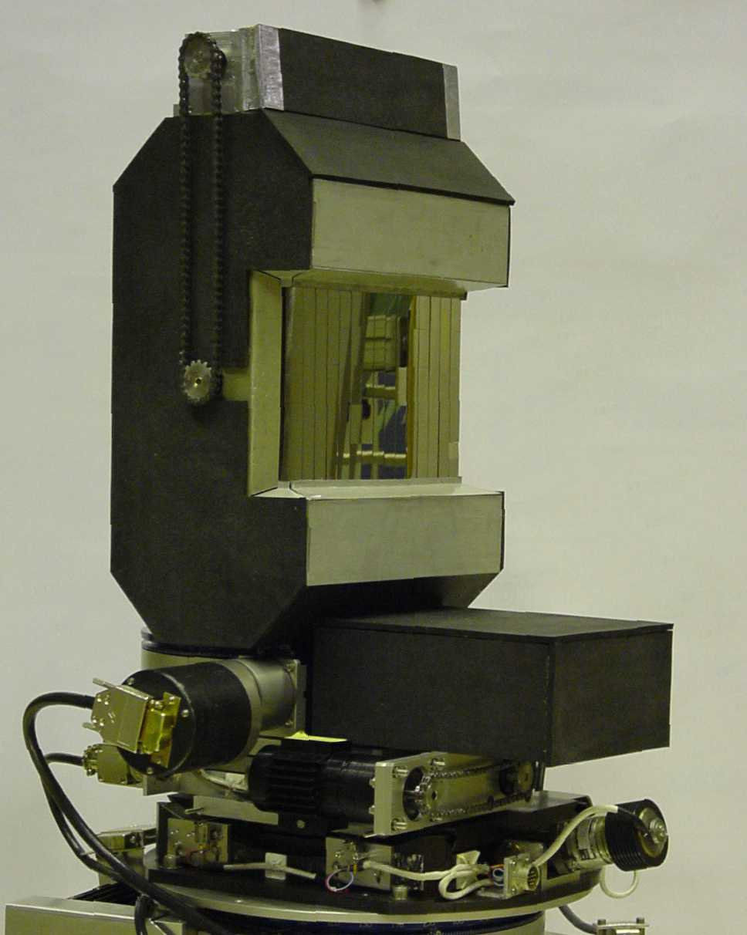

Figure 3: The double focusing Heusler alloy monochromator for In20 at ILL
For the simulations the PG crystal surface is 20cm high, 30cm wide and 2mm thick. The crystal has 1mm Al-6061 backing. The top and bottom support discs are made of AL-6061 36cm in diameter, and 12cm high. The goniometer is modeled as a steel disc 36cm in diameter, 8cm high. There are four support rods, 2cm in diameter also made of Al. The MCNPX drawings for the monochromator are stored in drt16.pdf. Simulations were done with the crystal making an angle of 45 or 10 degrees to the incident neutron beam.

Model of Heusley alloy monochromator

I have used the IN20 (ILL) doubly focusing monochromator (shown in Fig 3) as a model for the HYSPEC Heusler alloy monochromator. The width of the crystal is 20cm and the height is also 20cm. The crystal is 1cm thick. The C magnet is also 20cm wide. The upper and lower straight portions of the C are made of iron, and the middle section is made of AlNiCo alloy – used for making permanent magnets. This particular form of AlNiCo contains no cobalt, the composition by weight is 12% Al, 25% Ni, 3% Cu and 60% Fe.

The first simulation of the drum shield with a Heusler alloy monochromator has just been finished. The dose rate contour plots are shown in Figs 4 a-e. The drum shield is composed of concentric rings of 1cm of borated poly (30% nat B) 5cm stainless steel, 43cm high density concrete, another 1cm of borated poly (30% nat B) followed by 5cm of lead and 5cm of stainless steel. This drum shield will effectively shield the PG crystal. These results are for thermal(E<1.12eV) neutrons, with all choppers open.

Fig 4a. Neutron dose rates (mrem/h) in the horizontal plane at the level of the guide.

Fig 4b. Neutron dose rates (mrem/h) in the vertical plane at the level of the guide.

From Figs 4a and b it is obvious that the neutrons are scattered preferentially towards the –y direction, which is the direction of the reflected beam. These neutrons however are absorbed by the B4C or the steel and HDC.

Fig 4c. Photon dose rates (mrem/h) in the horizontal plane at the level of the guide.

Fig 4d. Photon dose rates (mrem/h) in the vertical plane at the level of the guide.

Fig 4e. Photon dose rates (mrem/h) in a vertical plane perpendicular to the Z axis immediately downstream of the drum shield

Figs 4c-d show that the drum shield will not stop all ~8MeV photons. Fig4e shows that the dose rates immediately downstream of the drum shield may be as high as 100mrem/h, much higher than the 0.25mrem/h allowed for unlimited access.

