Starting model and results for the drum shield, including NIST-like PG monochromator
Vinita J. Ghosh
July 14, 2005

Description of model
Simulation starts at the end of the curved guide and includes the straight guides G3, G4, Box-B and the drum shield (see Fig 1). The drum shield is modeled as a hollow cylinder of inner radius 30cm, outer radius 90cm, 300cm tall, 150cm above and 150cm below the beam centerline. The center of the cylinder is at 430cm from the end of the curved guide G2. The fast neutron source was generated by tallying the number of neutrons of energies E>1.12x10-6 MeV crossing a 8x19 surface at the end of the curved guide. This 8x18 area includes the guide interior, the 1cm substrate and the 1cm void surrounding the guide. The fast neutron source is placed at the entrance to guide G3. The thermal (E<1.12x10-6 MeV) neutron source is generated by doing a MCSTAS simulation that records the energy distribution of the neutrons at the end of G2, G3 and G4. For the drum shield simulations the energy distribution at the end of G4 is used as a source. To be conservative in our drum shield design the neutron source weights are multiplied by 2. Pictures of the drum shield generated by MCNPX are saved in drf4.pdf.

G3
G4

Figure 1. Arrangement of the 1.75m straight guide + Box B & drum shield

I have used the NIST doubly focusing monochromator (shown in Fig 2) as a model for the HYSPEC HOPG monochromator. The dimensions of the NIST monochromator have been altered for the HYSPEC 4cm wide 15cm high beam.
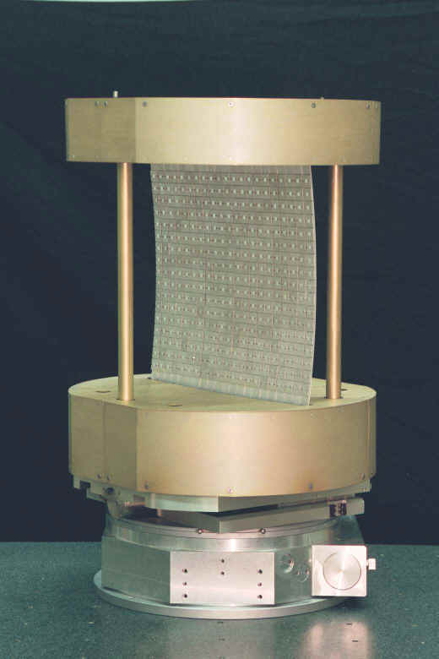
Fig 2. The NIST doubly focusing PG monochromator.

For the simulations the PG crystal surface is 20cm high, 30cm wide and 2mm thick. The crystal has 1mm Al-6061 backing. The top and bottom support discs are made of AL-6061 36cm in diameter, and 12cm high. The goniometer is modeled as a steel disc 36cm in diameter, 8cm high. There are four support rods, 2cm in diameter also made of Al. The MCNPX drawings for the monochromator are stored in drt16.pdf. Simulations were done with the crystal making an angle of 45 or 10 degrees to the incident neutron beam.

Results of simulations performed using this drum shield model:

Drf17: Fast neutron source, drum shield has 1cm of B₄C, 5cm SS, 43cm HDC, 1cm B4C, 5cm SS, 5cmPb. Monochromator supports are Al6061, angle is 45degrees.
Drt17: Thermal neutron source, drum shield has 1cm of B₄C, 5cm SS, 43cm HDC, 1cm B4C, 5cm SS, 5cmPb. Monochromator supports are Al6061, angle is 45degrees.
Drf18: Fast neutron source, drum shield has 1cm of B₄C, 5cm SS, 43cm HDC, 1cm B4C, 5cm SS, 5cmPb. Monochromator supports are Al6061, angle is 10degrees.
Drt18: Thermal neutron source, drum shield has 1cm of B₄C, 5cm SS, 43cm HDC, 1cm B4C, 5cm SS, 5cmPb. Monochromator supports are Al6061, angle is 10degrees.
Drt19: Thermal neutron source, drum shield has 1cm of B₄C, 5cm SS, 43cm HDC, 1cm B4C, 5cm SS, 5cmPb. Monochromator supports are Al-1100 (containing boron), angle is 10degrees.
Drt20: Thermal neutron source, drum shield has 1cm of B₄C, 5cm SS, 43cm HDC, 1cm B4C, 5cm SS, 5cmPb. Monochromator supports are Al-6061 coated with 1mm of B4C.
Drt21: Thermal neutron source, drum shield has 1cm of borated poly (30%natural boron), 5cm SS, 43cm HDC, 1cm borated poly, 5cm Pb, 5cmSS. Monochromator supports are Al-6061 coated with 1mm of B4C, angle is 10degrees.
Drt22: Thermal neutron source, drum shield has 1cm of B₄C, 8cm W, 40cm HDC, 1cm B4C, 5cm SS, 5cmPb. Monochromator supports are Al6061, angle is 10degrees.

Fig 17a.
Fig 17b
Fig 17c
Fig 17d

The 7-8MeV photons produced by neutrons hitting the Al supports for the monochromator are not absorbed efficiently by the HDC, SS or lead. There is very little photon leakage from the drum shield, but it is enough to create ‘hot spots’ near the drum shield face.
Fig 17e
Fig 17f

The fast neutrons are not scattered significantly by the PG crystal or the Al supports. They do not generate many photons and both neutrons and photons are stopped effectively by the drum shield.
Fig 18a
Fig 18b

It is obvious from Figs 117a and 18a that a large number of thermal neutrons are backscattered towards the guide. This will have to be taken into account when designing the shielding around Box-B.
Fig 18c
Fig 18d

When the PG crystal is at 10 degrees far more neutrons are scattered out of the beam by the crystal and its Al backing. Consequently more photons are generated in the Al supports. Unless these photons are effectively stopped we mat get unacceptably high dose rates in some spots just outside the drum shield.
Fig 18e
Fig 18f

The fast neutrons do not appear to cause any shielding problems.

To reduce the number of photons produced in the Al supports we can coat the Al supports with boron loaded material or add boron to the Al alloy. Eagle Picher makes a boron-loaded alloy (Al-1100) to which a user-specified amount of boron can be added. In the following simulation (drt19) the Al supports for the monochromator are make of Al-1100 with 4.5% enriched boron by weight. The boron additive is 95% B10.
Fig 19a
Fig 19b
Fig 19c
Fig 9d

Comparing figures 19c and d to18c and we notice that far fewer photons are being created.

In the next simulation (drt20) the Al-6061 supports are coated with 1mm of B4C.
Fig 20a
Fig 20b
Fig 20c
Fig 20d

When I compare the output for drt20 and drt18 I find that more 0.5MeV photons (generated by boron) and fewer 7-8MeV photons (generated by Al) are being produced. A comparison of 20c&d and 18c&d shows that this change in the photon energy results in lower photon dose rates. We may consider increasing the thickness of the boron layer to ensure that there is no photon leakage from the drum shield.
Bill is considering using a boron loaded epoxy instead of B4C as the innermost layer of the drum shield. When shielding simulations were performed for the CERN detector ATLAS borated poly as used to model boron loaded epoxy. I replaced the 1cm of B4C in the drum shield with a cm of borated poly containing 30% natural boron by weight.
Fig 21a
Fig 21b

Comparing figures 21a&b with 20a&b we note that not all neutrons are absorbed by the borated poly (the atomic density of boron in the poly is less than in B4C). However, they are absorbed in the HDC so everything is OK.
Fig 21c
Fig 21d

Comparing 21c&d with 20c&d we note that there is no significant change in photon dose rates.
Million dollar drum shield
In simulation drt22 the inner 5cm of SS was replaced by 8cm of tungsten, and the Al-6061 monochromator supports had no B4C coating. These results should be compared with drt18.

Fig 22a
Fig 22b
Fig 22c
Fig 22d

Comparison of figures 22c&d with 18c&d shows that the tungsten does a much better job of stopping high-energy photons than either steel or lead. No wonder it is used in primary shutters, T0 choppers and beamstops. We will have to design the shielding around the upstream part of the drum shield carefully.

