LETTER OF INTENT

HYSPEC: Crystal-Time-of-Flight Hybrid Spectrometer
for the Spallation Neutron Source

INTRODUCTION :
The most informative neutron scattering investigations of the atomic-scale dynamical properties of crystalline solids nearly always require single crystal samples and – to date - have mostly been carried out on crystal spectrometers at high-flux, reactor-based, steady-state neutron sources. Because such measurements tend to be made with small samples and are invariably flux-limited, the spectrometers typically employ focussing Bragg optics to concentrate the neutron beam on the sample. In the not too distant future the high-luminosity pulsed Spallation Neutron Source (SNS) at Oak Ridge will provide intense neutron beams with time-averaged fluxes equal to those at medium-flux reactors. Recognizing that the SNS will open new opportunities for neutron scattering, an Instrument Development Team (IDT) composed of national laboratory and university based scientists has been formed with the objective of designing and building a spectrometer specifically optimized for pulsed beam investigations of the microscopic dynamics of small, single crystal samples. Drawing upon experience acquired during decades of such studies with crystal spectrometers, the IDT has developed a conceptual design for a focussed-beam, time-of-flight instrument for the SNS called HYSPEC (an acronym for hybrid spectrometer). This Letter of Intent is a request by the IDT for approval of HYSPEC as an instrument for the SNS and for the allocation to HYSPEC of a beamline served by a coupled, 20 K supercritical hydrogen moderator.

SCIENTIFIC OBJECTIVES:
HYSPEC is intended to supply users of the SNS with a platform for studies of the low-energy dynamical properties of single crystal samples. These samples tend to be grown specifically for such investigations and are usually small so concentrating the incident beam to a size that matches the sample is vital if acceptable data collection rates are to be achieved. A further complication is that the signal of interest is often weak because the scattering cross-section is small: a reduced background (increased signal-to-noise ratio) is therefore crucial for meaningful measurements. Moreover, many of the experiments involve parametric studies extending over limited ranges of Q, and ω − the external parameters being magnetic or electric field, stoichiometry and pressure and temperature - and require special environments provided by cryostats, magnets, pressure cells, etc. Placed in the neutron beam, such devices become additional sources of background; an important consideration in developing a spectrometer for such studies. All of these concerns are addressed in the design of the HYSPEC spectrometer. Additionally, we note that polarization analysis is expected to become increasingly important in exploring the properties of magnetic system and that HYSPEC (unique at the SNS) will be an instrument that can be easily configured to polarize the incident beam and analyze the polarization of the scattered neutrons with well-tested (and very efficient) methods.
Below we highlight a selection of problems that are currently at the forefront of condensed matter research and that demonstrate the need for an instrument such as HYSPEC. They are intended to be illustrative; there are many more that - space permitting - could be mentioned.

- Correlated Phases in Many-electron Systems:

The ground states of many-electron systems with spin, orbital and/or charge/valence degeneracy often exhibit non-trivial arrangements of these degrees of freedom which lead to many fascinating physical properties. Recently much attention has been paid to exploring the charge and/or orbitally ordered phases in transition metal oxides such as the superconducting cuprates and magnetoresistive manganites. Understanding the nature and origin of these phases is of both fundamental importance and technological interest. Neutron scattering is the most informative and least perturbing experimental way of providing information on the correlated structural distortions and/or magnetic correlations in the charge/orbital/spin-ordered phases. Among the unique features inherent to the neutron scattering approach is that it provides both good energy and wavevector resolution, which permits accurate discrimination between the static and dynamic correlations and allows separate characterization of the corresponding correlation ranges. Examples where this is of crucial importance are the recent observations of striped liquid phases in the doped layered nickelates, incommensurate dynamical correlation in the cuprate superconductors and characterization of dynamical slow-down in the course of the spin-glass freezing transition in the half-doped cobaltate La_{1.5}Sr_{0.5}CoO₄.
A spectrometer, optimized for studies of the short- and long-range static and dynamic correlations in single crystals should be designed to have both a small elastic and negligible inelastic background, a symmetric and well-reproduced resolution function (permitting a straightforward and reliable (de)convolution procedure) and have a polarization analysis capability to distinguish between structural and magnetic scattering. Equally important, it should provide complete and continuous coverage of a significant volume in the reciprocal space of the crystal with both energy and wavevector resolution easily adaptable to the type of the problem studied. Finally, it is essential that such an instrument be easily equipped with a variety of sample environments since definitive insight into the nature of many-electron correlated phases is often obtained by studying how they are affected by changes in external magnetic field, temperature, pressure, etc. As will be evident, the proposed HYSPEC spectrometer is designed to both provide superior performance and to address these concerns.

- Nanomagnetism:
Molecular magnets exhibit spectacular physical properties (such as macroscopic tunneling and quantum coherence) and some of these may be exploited in emerging technologies ranging from spin valves to quantum computing and photonic switches. The more recently synthesized molecular magnets are composed of molecules, containing a number of 3d or 4f magnetic ions connected by organic or inorganic linking atoms. These systems are ideal for studying the transition between atomic and nano-scale magnetic phenomena, since molecules incorporating as few as two, and, to date, as many as 30 magnetic ions (Mo₇₂Fe₃₀) have been synthesized. In addition, these structures make it possible to explore a range of associated magnetic phenomena from S =1/2 quantum spins (e.g. Cu, V ions) to essentially classical spins (such as Fe³⁺ (S = 5/2) and Tb³⁺ (J = 6) ions). A critical advantage of molecular magnets over conventional nanosized magnetic particles is that single crystals composed of identical molecular units can be grown for detailed neutron scattering studies. The polarization analysis capability of HYSPEC will be an invaluable tool for the study of these systems because it is essential to establish the origin (magnetic or nuclear) of the large number of peaks observed in the existing studies of these materials by elastic or inelastic neutron scattering techniques. Moreover, these systems can only be grown in limited sizes and the focussing capabilities of HYSPEC will maximize the incident flux and most likely be the determining factor for definitive experiments.

- Quantum Critical Points:

A quantum critical point is a phase transition in which the temperature at which long-range order is established is suppressed to zero by quantum disorder. This may be induced either externally, e.g. with the application of pressure or magnetic field, or internally through either compositional variations or by increasing disorder. Close to a quantum critical point, the energy scale of critical fluctuations is determined by the temperature which leads to highly unusual scaling of the critical dynamics. Universal scaling in ω/T has been observed by inelastic neutron scattering in at least two systems believed to be close to quantum critical points, UCu_{5-x}Pd_{x} and CeCu_{6-x}Au_{x}. Such experiments are challenging because they require measurements over a wide range of energies. Thus far, the most complete data have been obtained on time-of-flight spectrometers at both reactor and pulsed neutron sources. However, the need for large samples has necessitated the use of systems in which quantum criticality is induced by sample non-stoichiometry rather than by an extreme sample environment. Theoretically, it is important to reproduce this scaling behavior in high-quality single crystals that are stoichiometric so that atomic disorder can be discounted as a contributory factor. For instance, the most reliable examples of quantum phase transitions are in systems such as CePd₂Si₂ and ZrZn₂, occuring at pressures of 28 kbar and 21 kbar respectively. There is also evidence that metamagnetic transitions in some heavy fermion compounds - commonly occurring in fields of greater than 10 T -may be associated with quantum phase transitions. The ability to utilize extreme sample environments on HYSPEC will be especially important in investigating quantum phase transitions. Also, the focussing properties of HYSPEC will be vitally important because of limited sample sizes and volumes.

- Low Dimensional Magnetism:

Amazing progress has been made in the field of low-dimensional quantum magnetism in the past twenty years, almost entirely driven by inelastic neutron scattering experiments. The simplest fundamental model systems are by now very well understood. Today the challenge is to learn about more complex phenomena such as the effects of disorder and impurity substitution, spin-lattice interactions and one- and two-dimensional to three-dimensional crossover effects.
One example of a new research direction in quantum magnetism is the problem of random-exchange spin chains. Consider the case of a S=1/2 quantum spin chain with nearest-neighbor Heisenberg exchange interactions of random magnitude. In the simplest model, a given percentage x of the bonds are of magnitude J₁, and the remaining (1-x) bonds correspond to a coupling strength J₂, the strong and weak bonds being distributed randomly. For a fixed x the limiting cases are easy to understand. For J₁<<J₂ the chain breaks up into an ensemble of finite-sized clusters: dimers, trimers, tetramers, etc. Each cluster has a discrete excitation spectrum, that in a neutron experiment appears as a series of sharp excitations at well-defined energies. For J₁=J₂ the situation is entirely different. In a uniform spin chain such as this, the spectrum is an exotic continuum of states with no sharp excitations and a strong wave vector dependence. The question is: how does the spectrum look in the intermediate case of J₁<~J₂?
To date, the answer is not known, even theoretically. The main reason is that an experimental realization of a model suitable for inelastic neutron experiments has not been available until the recent preparation of the new model compound BaCu₂(Si_{x}Ge_{1-x})₂O₇. Solid solutions with 0<x<1 are characterized by susceptibility curves that can be fitted to a Bonner-Fisher law with an intermediate value of J and are expected to be realizations of the S=1/2 random-exchange model. Inelastic neutron scattering experiments on BaCu₂(Si_{x}Ge_{1-x})₂O₇ single crystal samples are expected to provide unique insight into the role of disorder in quantum magnets.
Previous work on the x=1 system was carried out on thermal and cold triple-axis instruments at reactor sources as well as on the MARI time of flight instrument at ISIS. It is clear from these measurements that none of these instruments will be fully adequate for the study of the solid solution BaCu₂(Si_{x}Ge_{1-x})₂O₇ . First of all, the excitation bandwidth for x close to unity is expected to be of the order of 150 meV and using a spallation source instrument becomes mandatory if one wants to cover the relevant energy range. At the same time, the small sample size (the largest existing crystals of BaCu₂SiGeO₇ are about 4x4x10mm³) will require the ability to focus the incident beam to a small spot size; a major feature of HYSPEC. Moreover, the weak and diffuse nature of continuum scattering requires a very low and well-controlled instrument background. Finally, to gain a detailed understanding of the spin dynamics, polarized neutron experiments will be needed. All of these needs will be satisfied by the proposed HYSPEC instrument.

- Anomalous Phonon Behavior in Functional Materials:

It has long been known that structural phase transformations occurring in materials such as ferroelectrics are driven by a lattice vibrational mode whose frequency tends to zero at the transformation temperature. This so-called ‘soft’ mode usually occurs at a well defined wavevector in a particular optic or acoustic phonon branch and is frequently accompanied by a ‘central’ peak, i.e. divergent elastic scattering. The anomalies associated with the soft mode result in very anisotropic dispersion curves. Recent work on ferroelectics like PZT and PMN and on shape memory alloys such as Ni-Al, Ti-Pd, and Ni₂MnGa have demonstrated the need for good wave-vector resolution and for minimization of the extraneous elastic scattering from the sample environment. It also makes clear that single crystals are necessary. Most often these crystals are grown explicitly for neutron scattering experiments and tend to be small. Focussing of the incident beam is therefore vital to assure the maximum number of neutrons impinging on the sample; a requirement met by the proposed HYSPEC instrument.

THE HYSPEC SPECTROMETER
Our primary objective in formulating the design of the HYSPEC spectrometer was that it deliver the highest possible monochromatic flux to few-cm-sized samples over a broad range of thermal and sub-thermal neutron energies (5-100 meV). Additionally, we wanted to develop a design that would (i) minimize beam-related background such as that arising from sample environments, (ii) provide reasonably good (and easily adjustable) energy and scattering vector resolution (δE/E ≈ 0.03- 0.10; δQ/Q ≈ 0.01-0.03), (iii) be readily adapted to polarization analysis, (iv) permit rapid alignment of samples and easy installation of specialized sample environments and (v) allow for straightforward, direct, on-line monitoring and analysis of incoming data. Ultimately these criteria led us to the direct geometry, hybrid concept shown schematically in Fig. 1. The instrument parameters are summarized in Table I.
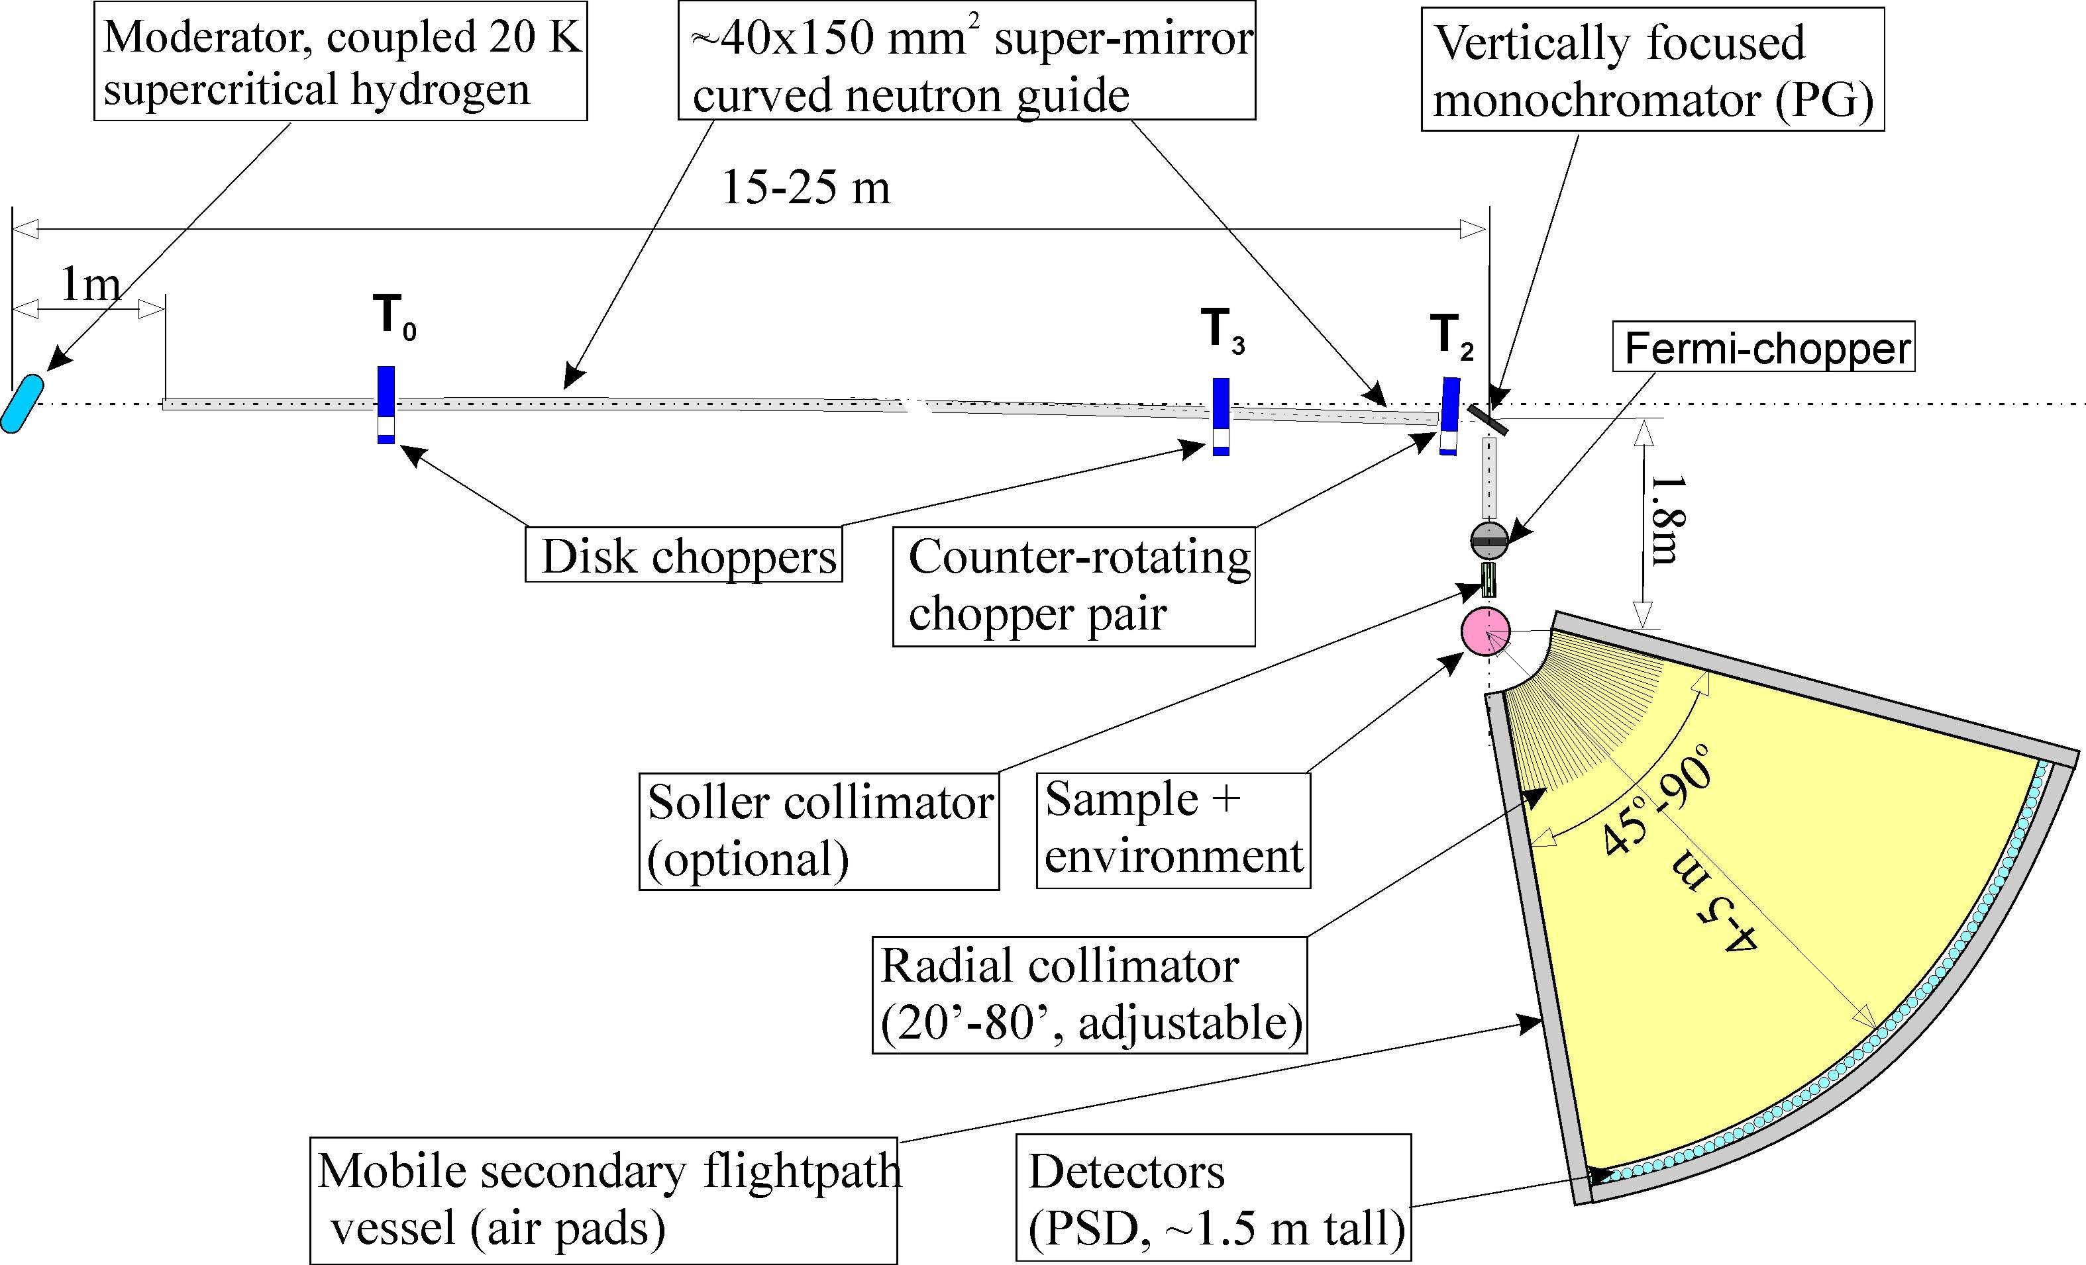
Figure 1. Schematics showing HYSPEC’s principle elements.

Primary spectrometer (Monochromator)
As is evident in the figure, the primary (monochromating) section of the instrument is envisioned as consisting of a 15-25 meter long guide with a center section composed of 40 mm wide by 150 mm high, supermirror-coated, pseudo-curved modules and with 40 mm wide expander sections at each end. Placed at intervals along the guide would be three disk choppers; two – the T₀ and frame-overlap choppers - rotating at either the source frequency or a sub-multiple and the third - a counter-rotating disk chopper pair

Table I: Instrument Parameters
Moderator | Coupled, 20K, supercritical H₂
Incident energy | 5-100 meV
Energy resolution | 0.03<ΔE/E<0.10 (for elastic scattering) depending on neutron energy and rotation rates of choppers
Q resolution | ΔQ/Q ~ .01 - .03
Primary flight path | Curved guide with expander and compressor sections 15-25 m long
Secondary flight path | 4-5 m
Energy defining choppers | Counter rotating disk and Fermi choppers. Maximum rotation rate 300Hz
Frame-overlap/order suppressor chopper | Disk chopper. Maximum rotation rate 60 Hz
Flux focussing crystal | Segmeted, vertically curved PG and fluorinated mica. Heusler for polarized beam
Sample position | 1.8 m from crystal
Beam size at sample (optimally focussed) | 4 (w) x 2 (h) cm²
Detectors | 275 position sensitive ³He tubes. Horizontal pixel resolution 20 min. Vertical pixel resolution 20 min. Horizontal array acceptance: 60°. Vertical array acceptance: ±7.5°
Sample environment | Will accept all standard sample environment equipment

- rotating at integral multiples of the source frequency. At the guide’s downstream end we plan to place a rotating drum shield containing a vertical-focussing crystal, a beam stop, a vertically tapered guide (downstream of the crystal), a Fermi chopper and a Soller collimator. Attached to the shield - and moving with it – would be a conventional sample axis with a goniometer capable of supporting large, off-center loads. In such an arrangement, neutron energies are determined both by the beam exit angle (as defined by the crystal and the in-shield collimator), and by the phase of rotation of the counter-rotating chopper pair and/or the Fermi chopper relative to the source. Apart from its energy defining function, the crystal - together with the section of vertically tapered supermirror guide in the drum shield – also has the important function of efficiently focussing the beam at the sample position.
Each chopper has a unique part to play in monochromating the beam. The T₀ chopper blocks the gamma rays and high energy neutrons emitted in the earliest part of the source pulse. The frame overlap chopper (T₃) assures that unwanted, higher order (shorter wavelength) contamination is removed. Also, its rotation rate can be reduced to block alternate source pulses in cases where the scattered energy spectrum is so broad that spectral overlap becomes a problem. When the instrument is operated in a low-resolution, high-data-collection- rate mode, the counter-rotating disk choppers T₂ (together with the crystal) will define both the energy of the beam and the spectral and time width of the pulse at the sample position, the latter being the major factor in determining the energy resolution of the analyzing section. In cases where higher energy resolution is needed, it is envisioned that the time width of the sample pulse would be further reduced by the addition of a Fermi chopper (T₄). This chopper would have short, straight slots and a vertical axis of rotation and be located in the shield immediately upstream of the collimator. Like the counter-rotating disk choppers, it would rotate at integral multiples of the source frequency.
For the monochromating crystal, we propose using (for non-polarized applications at incident neutron energies of 5 meV and higher) individual pyrolytic graphite (PG) plates attached to a segmented GMI-type holder. This arrangement provides optimal vertical focussing. Because a relatively broad horizontal mosaic (probably 1.0 º) will be needed for optimum performance, our present thinking is to use sets of three ZYA grade PG plates stacked with spacers to slightly offset the angles between them. This so-called “fanned arrangement” has been demonstrated to expand the horizontal mosaic while keeping the vertical mosaic (and thus the vertical focussing properties of the crystal) unchanged. At incident neutron energies below 5 meV, where the very high monochromator resolution introduced by the PG crystal in a near backscattering geometry might have an unacceptable impact on the intensity, we envision substituting an equivalent crystal composed of fanned plates of fluorinated synthetic mica.

Secondary Spectrometer (Analyzer/Detector)
Scattered neutron energy analysis would be done by time-of-flight alone. We propose using a 4-5 meter radius array made up of 275 one-dimensional, position-sensitive, tube-type ³He detectors. A radial collimator interposed between the sample and detectors would restrict their horizontal field of view to the sample area alone. Individual horizontal and vertical pixel resolutions are envisioned as being 20 minutes of arc. Additionally, the array would span a 60 degree arc horizontally and have a vertical acceptance of plus and minus 7.5 degrees with respect to the scattering plane. It would be mounted on air pads on a tanzboden so that it could both move with the drum shield and be rotated about the sample axis to permit accurate positioning with respect to the monochromatic beam incident on the sample.

Polarization Analysis
When a need for polarization analysis arises, the PG crystal would either be replaced by a Heusler alloy crystal or, (at incident neutron energies < 15 meV) a high efficiency, beam-bender type polarizer would be positioned downstream. Additionally, one or more beam bender type polarizers with high vertical angular acceptance would be placed in the flight path between the sample and the detector bank to serve as polarization analyzers for E_{f} < 15 meV. Use of beam benders for neutron polarization is a well established method for producing polarized beams of low energy neutrons. They are commercially available and either in use or planned at NIST, ILL and other state of the art facilities. The use of well-established, highly efficient methods of both incident neutron polarization and analysis of scattered neutron polarization is a unique and especially attractive feature of HYSPEC. It is not duplicated by any other currently planned SNS instrument.

Sample Area
Also of note is the convenience with which specialized sample environments can be utilized. Because collimation upstream and downstream of the sample will restrict the horizontal field of view of the detectors to the sample area alone, the sample axis will not have to be part of the instrument vacuum system as is the case in other planned inelastic instruments. Thus we expect to be able to employ conventional cryostats, magnets, furnaces, pressure cells, etc. without creating sample environment related background problems. This is another unique feature of HYSPEC.

PERFORMANCE
Of the many special features of the instrument, the most important from the viewpoint of efficient use of source neutrons is the utilization of the superior focussing properties of curved crystals to concentrate the monochromatic flux on small samples.
To quantify the advantage of the HYSPEC concept in this respect, a number of Monte- Carlo-based, flux-on-sample simulations were made using, for comparison, an optimized version of the instrument in which the HYSPEC chopper-crystal monochromating section is replaced by a more conventional, multi-chopper, IN-5 type monochromator (see Fig 2). All simulations were made with the LANL NISP Monte Carlo program. To assure they were as balanced as possible, both instruments were assumed to be supplied with neutrons by identical, coupled, 20 K, supercritical H₂ SNS moderators and both were given primary and secondary flight paths of the same length and guides of the same width (4 cm). The heights of the various guide sections and (for HYSPEC) the curvature of the
crystal were then iteratively adjusted to give the maximum monochromatic flux on a 2 cm high sample. As is evident in Fig. 3, despite the finite reflectivity of the PG crystal, its superior focussing properties concentrate the monochromatic flux on small samples much more effectively. For the moderate resolution, (small) single crystal sample studies for which it is planned, the HYSPEC approach is markedly superior.
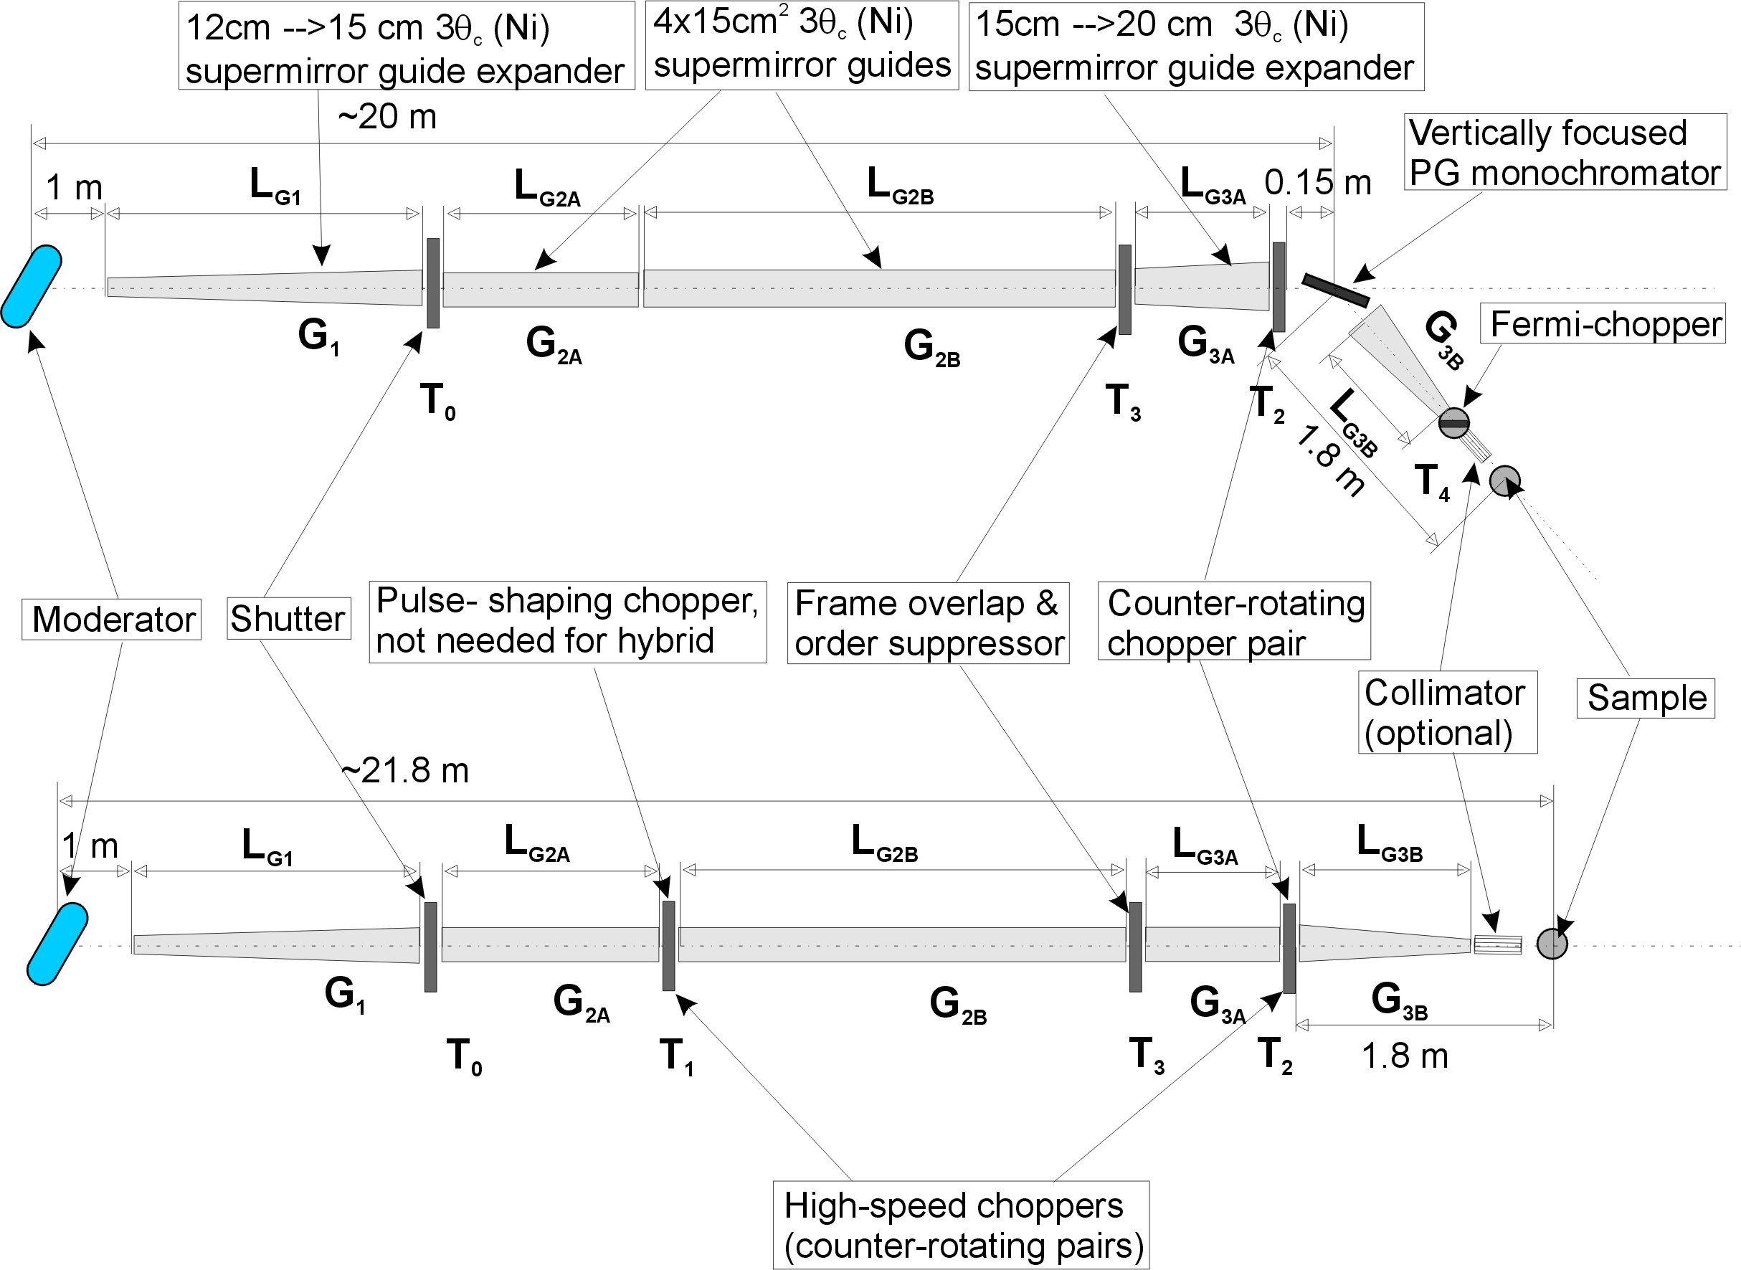
Figure 2. Primary spectrometers for the two models compared: HYSPEC (top) and the traditional “straight-through TOF setup (bottom).

Figure 3. Neutron flux on 2 cm x 2 cm sample as a function of energy for the optimized hybrid (red) and “straight-through” (black) models.
MODERATOR CHOICE:
Monte Carlo simulations have also shown that to perform optimally over the incident neutron energy range of interest (5-100 meV), a spectrometer of this type needs to be located on a beamline served by a coupled, 20 K, supercritical H₂ moderator. Our first choice would be beam Line #13. Because optimum performance requires that the monochromator and analyzer energy resolutions be reasonably well matched, it is highly desirable that the 20-25 m long monochromating section end at a place on the SNS experimental floor where there is sufficient space to accommodate both the rotating drum shield and the relatively extended time-of-flight analyzer and its associated shielding. Extending the instrument to an outside building would lead to a detrimental mismatch between the monochromating and analyzing resolutions and a significant
reduction of monochromatic flux at the sample position.

ADDITIONAL ADVANTAGES OF THE HYSPEC CONCEPT:
Apart from the special features emphasized above, HYSPEC has many other attractive properties:
• Incident neutron energy selection would be primarily by time-of-flight as would
analysis of scattered neutron energies. Thus full advantage is taken of the pulsed
nature of the beam.
• Only two components - the counter-rotating chopper pair and the Fermi chopper –
would operate at high rotation speeds. Both would be of conventional design and
would operate well within the limits imposed by the tensile strengths of the available
materials.
- Moving the sample out of the direct beam and placing shielding between it and the detectors is expected to reduce beam-related background to a minimum.
- Near-forward sample scattering will be easily accessible to investigation.
- Depending on the type of measurement, the spectrometer could be operated in either a wide-angular-acceptance or Q-selective mode.
- Apart from its focussing properties, the crystal also has the effect of substantially reducing the (source produced) spectral asymmetry of the beam incident on the sample.
- A relatively wide primary beam will be available thus making it possible to fully illuminate large as well as small samples.
- A broad and continuous range of incident neutron energies (5≤E_{n}≤100 meV) will be accessible without order contamination.
- Energy resolution can be incrementally varied simply by changing the rotation rate of the counter-rotating and /or Fermi choppers.
- Changing the collimation of the incident monochromatic beam or the angular acceptance at the analyzer (or both) is all that is needed to vary the longitudinal Q-resolution.
- Various kinds of monochromating crystals with a variety of focussing options could be employed such as, for example, two-dimensional focussing, asymmetrically-cut, perfect crystal focussing, etc.

FUTURE CONSIDERATIONS:
Yet to be addressed in detail are two design issues. The first relates to keeping the background to a minimum: the beam stop will either have to be fitted into a confined space in the shielding drum or mounted at the end of a “get-lost” pipe, (the latter would restrict the swing of the analyzer at the highest incident neutron energies). The second issue is purely mechanical: the large (and heavy) analyzer of the spectrometer will have to be rigidly coupled to the large (and heavy) monochromator shield and move with it when the incident energy is changed. Additionally, the detector array will have to rotate in a precise and reproducible fashion about the sample axis.
There is also the earlier-mentioned limitation on location that the Committee will need to take into consideration: Because the sample axis is significantly offset from the primary beam, the combined drum shield, analyzer and associated analyzer shielding will require a more-than-normal amount of space on the experimental floor and place significant constraints on the choice of beamline.

Members of the IDT and their Institutional Affiliations
Igor Zaliznyak, co-PI BNL
S. M. Shapiro, co-PI BNL
G. Shirane BNL
J. Tranquada BNL
L. Passell (retired) BNL

D. Abernathy SNS
L. Daemon Los Alamos
M. Greven Stanford
B. Gaulin McMaster
V. Kiryukhin Rutgers
Y. Lee MIT
S. Nagler ORNL
R. Osborn ANL
J. Rhyne U. Missouri
C. Stassis Ames Lab/Iowa St.
A. Zheludev ORNL

Tentative Cost Estimates

HYSPEC COSTS | k$
CHOPPERS | 1120
SHUTTERS | 120
SHIELDING | 2350
SUPERMIRROR GUIDES | 500
MONOCHROMATORS | 250
COLLIMATORS | 100
SAMPLE GONIOMETER | 50
BEAM MONITORS | 15
EXTERNAL BUILDING* | 1500
DETECTORS | 700
DETECTOR STRUCTURE | 685
POLAR. ANALYSIS | 480
DATA COLLECTION | 200
ANCILLARY EQUIPMENT | 50
TOTAL (CAPITAL) | 8120
LABOR | 3000
TOTAL | 11120
*if necessary

