

SNS INSTRUMENTS
NEXT GENERATION – (SING)

Bandwidth Limiting Disk Chopper Specification
HYSPEC Highly Oriented
Pyrolitic Graphite Crystals
Document Number
SING14B-20-EQ0008-R00A

This report was prepared as an account of work sponsored by an agency of the United States government. Neither the United States government nor any agency thereof, nor any of their employees, makes any warranty, express or implied, or assumes any legal liability or responsibility for the accuracy, completeness, or usefulness of any information, apparatus, product, or process disclosed, or represents that its use would not infringe privately owned rights. Reference herein to any specific commercial product, process, or service by trade name, trademark, manufacturer, or otherwise, does not necessarily constitute or imply its endorsement, recommendation, or favoring by the United States government or any agency thereof. The views and opinions of authors expressed herein do not necessarily state or reflect those of the United States government or any agency thereof.
SNS SING14B-20-EQ0008-R00A

SNS INSTRUMENTS
NEXT GENERATION (SING)
HYSPEC Highly Oriented Pyrolitic Graphite Crystals

Date Published: August 2006

Prepared by
OAK RIDGE NATIONAL LABORATORY
P.O. Box 2008
Oak Ridge, Tennessee 37831-6285
managed by
UT-Battelle, LLC
for the
U.S. DEPARTMENT OF ENERGY
Office of Science
Basic Energy Science
under contract DE-AC05-00OR22725

Specification for |  |  |  |  | Issue Date
HYSPEC HOPG FOCUSING CRYSTALS |  |  |  |  | 08/10/06
Laboratory |  |  | Division / Group |  | Specification No
ORNL |  |  | Experimental Facilities / Instrument Systems |  | SING14B-20-EQ0008-R00A
Prepared by |  |  | Level IV Manager |  | Lead Engineer
M.E. Hagen |  |  |  |  | D. M. Williams
Other WBS elements affected
 |  | Signature / Date
 |  | Rev 0 |  | Rev 1 |  | Rev 2 | Rev 3
Prepared by: |  | M.E. Hagen
Level IV Manager:
Lead Engineer |  | W. J. Leonhardt
Engineering Manager: |  | D. M Williams
Senior Team Leader:
(if required)
QA Representative: |  | M. L. Gildner
Other approvals as required:
Rev No | Revision Description
R00 | Original Issue

TABLE OF CONTENTS
1 Scope 6
2 Introduction 6
3 Technical Requirements 7

Scope
This specification defines the requirements for crystals of High Oriented Pyrolitic Graphite (HOPG) to be used in a focusing crystal array on the HYSPEC beamline at the Spallation Neutron Source facility (SNS) at Oak Ridge National Laboratory (ORNL).
Buyer shall be defined in the solicitation and the equipment specified herein shall be delivered to the Buyer at the Spallation Neutron Source facility (SNS) of the Oak Ridge National Laboratory (ORNL) under the U.S. Department of Energy (DOE). Seller shall refer to all parties responsible for providing the HOPG crystals.

Introduction
The SNS facility, being constructed in Oak Ridge, Tennessee, is a new neutron scattering facility with a powerful, pulsed neutron source. From the target or core of the facility, neutrons will be guided to various instruments via mirrored neutron guides creating a “neutron beam”. Along these guides, various neutron choppers will be inserted to filter neutrons of a desired velocity or wavelength.
This specification refers to the HYSPEC instrument, which is located on beamline 14B at the SNS. In Figure 1 a schematic rendering of beamline 14B is shown. The neutron beam is carried from the SNS moderator out to an external building via a curved neutron guide and passes through 4 beam defining choppers. In the external building the beam enters a drum shield that contains a focusing array of HOPG crystals that will be used to focus the beam onto the sample. This specification sets out the requirements for the HOPG crystals in this array.

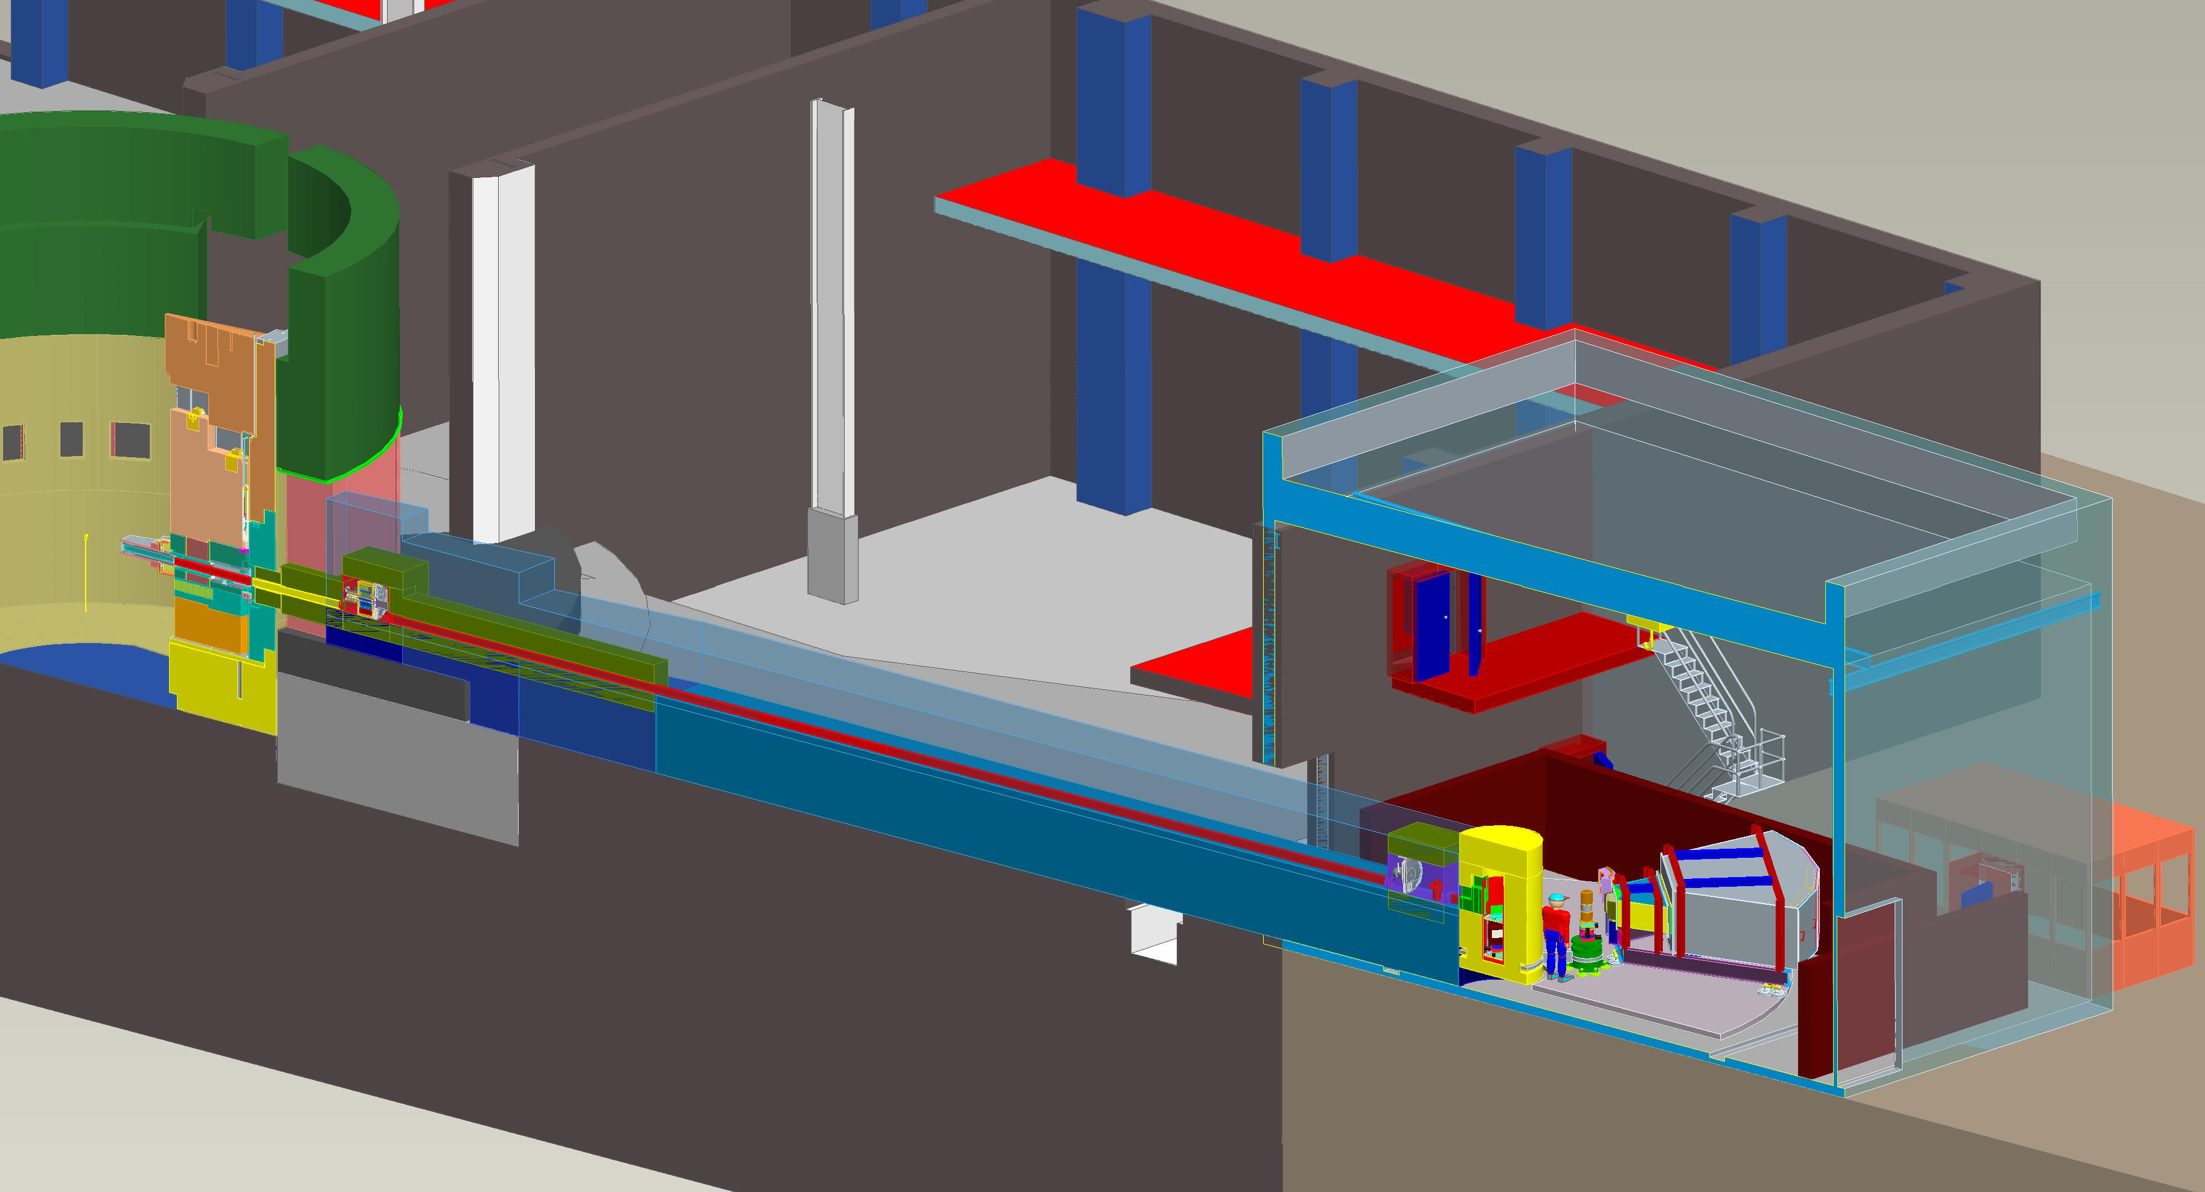
CVI
Shutter
External Building
Control Cabin
Detector Vessel
Sample
Chopper Box B
Drum Shield
Chopper Box A
Steel Shielding
Curved Beam Guide
Concrete Shielding
Focusing
Crystal Array
Figure 1: A 3-d rendering of the HYSPEC beamline from the Pro-E model.
It should be noted that this specification only covers the crystals and that the focusing array mechanism is not part of this specification.

Technical Requirements
The crystals required are of a flat plate shape as illustrated in Figure 2. The length (L), height (H) and thickness (T), as defined in Figure 2 for the crystals required along with the appropriate tolerances are given in Table 1.
Length L
Height H
Thickness T
Figure 2: The dimensions of the HOPG crystal plates.

Table 1: Dimensions of the crystals required
Dimension | Value (mm) | Tolerance (mm)
Length (L) | 50 | ±0.1
Height (H) | 12 | ±0.1
Thickness (T) | 2 | ±1

The crystals should have a mosaic spread of 0.8°±0.2° full width at half maximum (FWHM).

A total number of 84 individual crystals, each of the dimensions given in Table 1, each with a mosaic spread of 0.8°±0.2° FWHM, are required.

