

SNS INSTRUMENTS
NEXT GENERATION – (SING)

Bandwidth Limiting Disk Chopper Specification
HYSPEC Heusler
(Cu₂MnAl) Crystals
Document Number
SING14B-20-EQ0009-R00A

This report was prepared as an account of work sponsored by an agency of the United States government. Neither the United States government nor any agency thereof, nor any of their employees, makes any warranty, express or implied, or assumes any legal liability or responsibility for the accuracy, completeness, or usefulness of any information, apparatus, product, or process disclosed, or represents that its use would not infringe privately owned rights. Reference herein to any specific commercial product, process, or service by trade name, trademark, manufacturer, or otherwise, does not necessarily constitute or imply its endorsement, recommendation, or favoring by the United States government or any agency thereof. The views and opinions of authors expressed herein do not necessarily state or reflect those of the United States government or any agency thereof.
SNS SING14B-20-EQ0009-R00A

SNS INSTRUMENTS
NEXT GENERATION (SING)
HYSPEC Heusler (Cu₂MnAl) Crystals

Date Published: August 2006

Prepared by
OAK RIDGE NATIONAL LABORATORY
P.O. Box 2008
Oak Ridge, Tennessee 37831-6285
managed by
UT-Battelle, LLC
for the
U.S. DEPARTMENT OF ENERGY
Office of Science
Basic Energy Science
under contract DE-AC05-00OR22725

Specification for |  |  |  |  | Issue Date
HYSPEC HEUSLER (Cu₂MnAl) CRYSTALS |  |  |  |  | 08/10/06
Laboratory |  |  | Division / Group |  | Specification No
ORNL |  |  | Experimental Facilities / Instrument Systems |  | SING14B-20-EQ0009-R00A
Prepared by |  |  | Level IV Manager |  | Lead Engineer
M.E. Hagen |  |  |  |  | D. M. Williams
Other WBS elements affected
 |  | Signature / Date
 |  | Rev 0 |  | Rev 1 |  | Rev 2 | Rev 3
Prepared by: |  | M.E. Hagen
Level IV Manager:
Lead Engineer |  | W. J. Leonhardt
Engineering Manager: |  | D. M Williams
Senior Team Leader:
(if required)
QA Representative: |  | M. L. Gildner
Other approvals as required:
Rev No | Revision Description
R00 | Original Issue

TABLE OF CONTENTS
1 Scope 6
2 Introduction 6
3 Technical Requirements 7
4 testing and reporting 7

Scope
This specification defines the requirements for single crystals of the Cu₂MnAl Heusler alloy to be used in a focusing crystal array on the HYSPEC beamline at the Spallation Neutron Source facility (SNS) at Oak Ridge National Laboratory (ORNL).
Buyer shall be defined in the solicitation and the equipment specified herein shall be delivered to the Buyer at the Spallation Neutron Source facility (SNS) of the Oak Ridge National Laboratory (ORNL) under the U.S. Department of Energy (DOE). Seller shall refer to all parties responsible for providing the HOPG crystals.

Introduction
The SNS facility, being constructed in Oak Ridge, Tennessee, is a new neutron scattering facility with a powerful, pulsed neutron source. From the target or core of the facility, neutrons will be guided to various instruments via mirrored neutron guides creating a “neutron beam”. Along these guides, various neutron choppers will be inserted to filter neutrons of a desired velocity or wavelength.
This specification refers to the HYSPEC instrument, which is located on beamline 14B at the SNS. In Figure 1 a schematic rendering of beamline 14B is shown. The neutron beam is carried from the SNS moderator out to an external building via a curved neutron guide and passes through 4 beam defining choppers. In the external building the beam enters a drum shield that contains a focusing array of Heusler crystals that will be used to focus the beam onto the sample and also to polarize the neutron beam. This specification sets out the requirements for the Heusler crystals in this array.

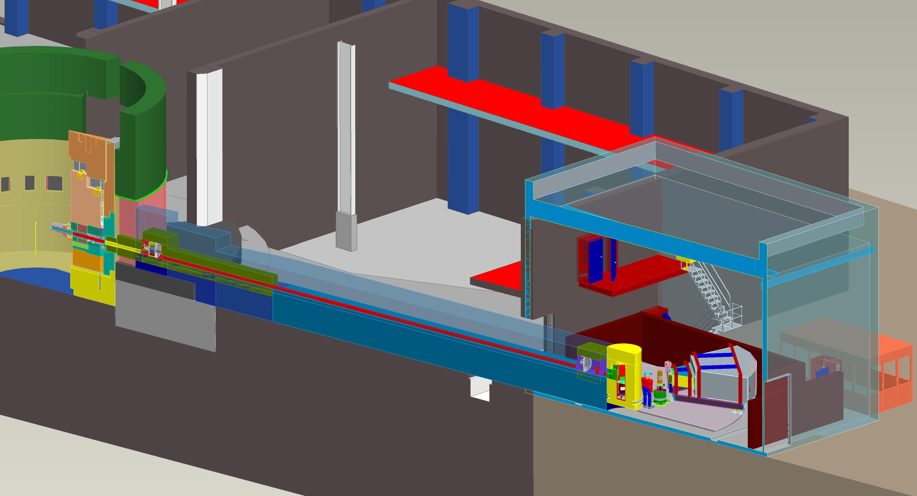
CVI
Shutter
External Building
Control Cabin
Detector Vessel
Sample
Chopper Box B
Drum Shield
Chopper Box A
Steel Shielding
Curved Beam Guide
Concrete Shielding
Focusing
Crystal Array
Figure 1: A 3-d rendering of the HYSPEC beamline from the Pro-E model.
It should be noted that this specification only covers the crystals and that the focusing array mechanism is not part of this specification.

Technical Requirements
The crystals required are of a flat plate shape as illustrated in Figure 2. The length (L), height (H) and thickness (T), as defined in Figure 2 for the crystals required along with the appropriate tolerances are given in Table 1.
Length L
Height H
Thickness T
Figure 2: The dimensions of the Heusler crystal blocks.

Table 1: Dimensions of the crystals required
Dimension | Value (mm) | Tolerance (mm)
Length (L) | 75 | ±0.1
Height (H) | 15 | ±0.1
Thickness (T) | 5 | ±0.5

The crystals should have a mosaic spread of 0.5°±0.2° full width at half maximum (FWHM).
The reflectivity of a typical 0.5° degree crystal for unpolarized neutrons of wavelength 1.8Å should be greater than 25% and when magnetized crystal should have a flipping ratio for neutrons of this wavelength of greater than 25.
The long axis of the crystal block should correspond with the (111) crystallographic axis of the Heusler crystal structure to within ±1°.
A total of 20 individual crystals, each of the dimensions given in Table 1, each with a mosaic spread of 0.5°±0.2° FWHM, and each with the reflectivity and flipping ratio described above are required.

testing and reporting
Each of the 20 crystals to be supplied by the seller should be individually identifiable and labeled, either by marking the crystals in a way that does not damage them, or by an appropriate packaging scheme that individually identifies the crystals.
Testing should be carried using a neutron beam of wavelength λ = 1.8Å, or a wavelength within 5% of this value, which has been suitably filtered to reduce any contamination from neutrons of wavelength λ/n where n = 2 or greater to less than 2%. Each crystal should be tested as follows.
- Two orthogonal rocking curves of the (111) reflection should be performed with unpolarized neutrons to verify (a) the mosaic spread distribution is within the range 0.5°±0.2° and (b) the coincidence within ±1° of the (111) reflection with the long axis of the crystal block and (c) the required reflectivity of greater than 25%.
- A polarized neutron beam should be used to perform a flipping ratio measurement of the (111) reflection from the appropriately magnetized crystal, to verify that the required flipping ratio of 25 or greater has been met.
A certified test report of these measurements should be supplied by the seller that contains the following.
- Details of the experimental configuration used to perform tests 1 and 2 above.
- The rocking curves, and flipping ratio measurement, for each of the crystals as described in 1 and 2 above labeled appropriately so that each individual crystal can be identified.
- For each crystal the angle made by the (111) reflection to the edges of the cut crystal block. The labeling of the cut crystal blocks should be such that, along with this angular information, the (111) reflection of each crystal could be uniquely oriented on a monochromator device.

