Template for Submission Abstracts to the
Early Career Researcher Symposium (ECRS 2018)

This template is a guide to be used to prepare abstracts for submission. Abbreviated instructions for using the template follow. Consult the ECRS website for specific information.
- If typing your abstract directly into the template, select (highlight) the text of the template that you want to replace and begin typing your abstract (i.e., select the Title section for typing in your title).
- If you have already prepared your document in a Word file, you will need to attach this template to your working document in order to apply the Word Style tags.
- Go to the Word Style list on the formatting toolbar and you will see all the Word Styles from the template that has now been imported into the current document. A Styles toolbar has been generated that will display the different Styles for you to choose from. If this is not present, select View, Toolbars, and then select Styles and it should appear. You can close this at any time and then reopen it when needed.
- Click in the sentence or paragraph and then go to the Word Style menu on the toolbar and select the relevant Word Style. This will apply the Word Style to the entire text (sentence or paragraph). Do this for all sections of the abstract.
- Proof the abstract to ensure that all parts are present and clearly legible.
- The abstract must be prepared on a single 8.5 x 11 page with one-inch margins. The font type must be Times New Roman.
- TITLE: It should be as concise as possible. One line is preferred.
- AUTHOR NAMES: The presenting author must be listed first. The supervisor must be designated with an asterisk (*). Please note that the presenting author will be the corresponding author.
- AUTHOR ADDRESS: The affiliation should be the institution where the work was conducted. If more than one address, use symbols to match author names to address(es).
- AUTHOR EMAIL: List the primary email address of the presenting author and supervisor.
- ABSTRACT: It must be comprehensible to a wider audience. The body of the abstract should highlight the significance of the research problem in an overall context, describe the purpose of research, and include a brief overview of research methods, key results and conclusions. Please do not include diagrams, tables, or references. The text should be single-spaced and may not exceed one page. The abstract should not exceed 250 words.
- IMAGE: You may attach one image to your abstract as long as it fits within the margin requirements and the one page requirement. An accompanying caption must be below the image, use the same word style as the abstract text, and is included in the 250 word limit.
- ACKNOWLEDGEMENT: Please indicate the funding agency that supported the work.
- Delete these instructions and any sections that are not needed.

TITLE (Word Style “BA_Title”). The title should accurately, clearly, and concisely reflect the emphasis and content of the paper. The title must be brief and grammatically correct. Limit to one line if possible.
AUTHOR NAMES (Word Style “BB_Author_Name”). Include in the byline all those who have made substantial contributions to the work. Use first names, initials, and surnames (e.g., John R. Smith) or first initials, second names, and surnames (e.g., J. Robert Smith). Do not use only initials with surnames (e.g., J. R. Smith) because this causes indexing and retrieval difficulties and interferes with unique identification of an author. Do not include professional or official titles or academic degrees. The presenting author (same as the corresponding author) should be listed first. At least one author must be designated with an asterisk as the supervisor.
AUTHOR ADDRESS (Word Style “BC_Author_Address”). The affiliation should be the institution where the work was conducted. If more than one address, use symbols to match author names to address(es).
AUTHOR EMAIL (Word Style “BD_Author Email”). Enter preferred email address for presenting author (same as corresponding author) followed by preferred email address for supervisor, separated by a semicolon.
ABSTRACT (Word Style “BE_Abstract”). The abstract should briefly state the problem or purpose of the research, highlight the significance of the research in the context of the field, indicate the theoretical or experimental plan used, summarize the principal findings, and point out major conclusions. It must be comprehensible to a wider audience. Please do not include diagrams, tables, or references. Abstract length is one paragraph with a maximum of 250 words.
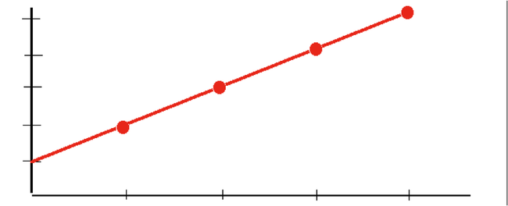
CAPTION (Word Style “BE_Abstract”). The caption should be a concise description of the image that can explain the image independently of the abstract. The image and the caption must keep to the one page and 250 words limits.
ACKNOWLEDGMENT (Word Style “BF_Acknowledgments”). Generally, the last paragraph of the paper is the place to acknowledge people, organizations, and financing (you may state grant numbers and sponsors here).

