I. Work Scope

Project Title/Work Description: Click here to enter text.

Date of Submission: Click here to enter a date.

Application Type

☐ Renewal without modifications
☐ Renewal with modifications
☐ Addendum – modification – Submit change in protocol or material
☐ New Expected Start Date: Click here to enter a date.

Personnel
List all personnel involved with this project. List Principal Investigator first, if applicable. Include all workers including lab technicians, animal handlers, etc.

Name | Institution | Contact  Phone # | Citizenship | Experience** | # years
*
* Principal Investigator

E-mail of PI or primary contact: Click here to enter text.

**Experience:
- Prior hands on experience in working with infectious agents
- For Principal Investigator: No prior hands-on experience, but will be collaborating
- For Principal Investigator: No prior hands-on experience, but will be receiving training .
- For other personnel: No prior hands-on experience, but will receive training from Principal Investigator.

Funding Status: ☐Internally funded ☐Seeking External Funding ☐Externally Funded
Sponsoring Agency/Agencies: Click here to enter text.

Please insert below or attach a lay summary of the proposed work. It should be written so that laypersons can understand it. Describe the importance of the research project to the furtherance of biological or medical science. If the project involves infectious material, the summary should emphasize the potential pathogenicity of the microorganisms and recombinants to be used, and the safety precautions to be taken.

Click here to enter text.
II. Biological Material Information

- Biological Agent or Toxin Name: Click here to enter text.

- Biosafety Level
☐ BSL-1 Go to Section III and IV and detail the PPE and Controls, and Transportation and Waste

☐ BSL-2

From BMBL https://www.cdc.gov/labs/pdf/CDC-BiosafetyMicrobiologicalBiomedicalLaboratories-2020-P.pdf p. 68 6th edition
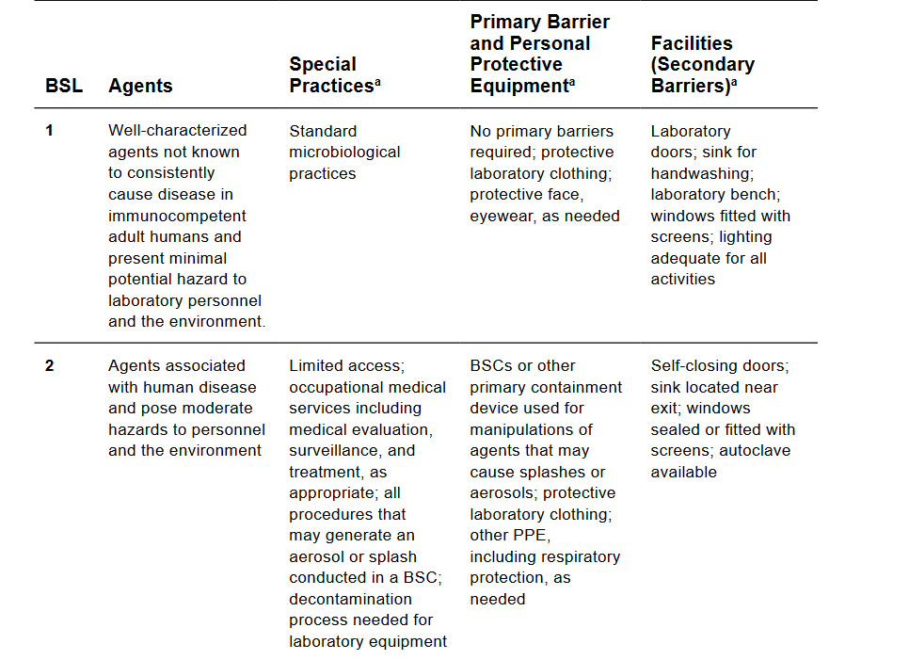

For RSNAMs Fill out the Recombinant of Synthetic Nucleic Acid Molecules Form and Attach it to this form.

For all other BSL-2 Materials: Internal Use Only: IBC #Click here to enter text.

- Specific strains, genotype or CAS number: Click here to enter text.

- Quantity of material: Click here to enter text.

- Risk Group
For details, see CDC BMBL or the American Biological Safety Association, Risk Group Classification for Infectious Agents.
☐ RG1 Agents that are not associated with disease in healthy adult humans.
☐ RG2 Agents that are associated with human disease which is rarely serious and for which preventive or therapeutic interventions are often available.
☐ RG3 Agents that are associated with serious or lethal human disease for which preventive or therapeutic interventions may be available (high individual risk but low community risk.)
☐ RG4 Agents that likely to cause serious or lethal human disease for which preventive or therapeutic interventions are not usually available (high individual risk and high community risk.)

- Where does this material come from? Provide name of commercial or other source and product number, if applicable. If it is a gift from a collaborator include a statement verifying contents and how it was prepared. Click here to enter text.

- What is the DOT/IATA shipping classification if known? Click here to enter text.
Note: Approval from BNL Transportation Safety Officer is required

- Is this on the CDC List of Select Agents 42 CFR 73 Choose an item.
For details, go to CDC Select Agent Regulations and Select Agent/Toxin List
Is the LD50 greater than 100 ng/kg of body weight? ☐ Yes ☐ No
Is this agent an FDA approved vaccine strain? ☐ Yes ☐ No

- Recombinant Organisms/molecules
☐ Yes ☐ No Genetically modified microorganisms or genetic elements from organisms listed on the CDC List of Select Agents, shown to produce or encode for a factor associated with a disease.
☐ Yes ☐ No Genetically modified microorganisms or genetic elements that contain nucleic acid sequences coding for any of the toxins listed in the CDC List of Select Agents, Appendix A, or their toxic subunits.
If applicable, what is the IBC RSNAM Approval number for this protocol? Click here to enter text.

- Other considerations
☐ Yes ☐ No Live animals (If Yes, IACUC Protocol Number: Click here to enter text.)
☐ Yes ☐ No OSHA Highly Acute Toxin
☐ Yes ☐ No Human Tissues/samples? If Yes, IRB # Click here to enter text.
☐ Yes ☐ No Does the experiment involve more than 10 liters of culture?
☐ Yes ☐ No Radioactive Material use (If Yes, RWP Number: Click here to enter text.)

III. Controls and PPE

- Engineering Controls
☐ Yes ☐ No Will a biosafety cabinet (tissue culture hood) be used?
If Yes, where? Click here to enter text.
Note that if aerosols can be produced as part of the handling of the material, a BSC or hood is required, unless alternate controls are specified.

☐ Yes ☐ No Will a fume hood be used?
If Yes, where? Click here to enter text.
☐ Yes ☐ No Will a Cold Room/Environmental Chamber be used?
If Yes, where? Click here to enter text.
Note if protective measures are different from recommendations in CDC BMBL, please provide a separate analysis and explanation

- Occupational Medicine Review
☐ Yes ☐ No Require special medical surveillance?
☐ Yes ☐ No Is there a specific vaccine or other preventive pre or post-exposure treatment recommended or required for work with this agent?
If Yes, specify Click here to enter text
☐ Yes ☐ No Does this agent pose a reproductive risk (see CDC guidance)?

- PPE
☐ Gloves, Specify type: Click here to enter text. ☐ Double gloves
☐ Safety glasses ☐ Face shield
☐ Lab coat ☐ Disposable lab coat
☐ Other, Specify Click here to enter text. ☐ Respirator- Specify Type: Click here to enter text.

- What is the method for inactivating the biohazard (Cite Reference: BMBL or other)? Click here to enter text.
☐ Common disinfectant
☐ sodium hypochlorite solution
( ¼ to ¾ cup bleach in 1 gallon of water, let stand for 2 minutes before wiping)
☐ > 70% ethanol
☐ Specialized disinfectant Specify Click here to enter text.
☐ Corrosive disinfectant Specify Click here to enter text.
☐ Autoclaving
☐ Other, specify Specify Click here to enter text.

- Emergency Response
☐ Yes ☐ No Will special emergency procedures be required to protect employees, coworkers and/or others in the event of an unplanned release of this agent? If yes, attach plan.

IV. Transportation and Waste

☐ Yes ☐ No Will there be any transporting of the material on or off-site? (Contact the TSO)
☐ Yes ☐ No Will any infectious material be received/sent from outside the U.S.?
If Yes, Import Permit # Click here to enter text.
☐ Yes ☐ No Will material be disposed at BNL?
If Yes, check all that apply
☐ Solid waste in biohazard labeled bag
☐ Liquid waste
☐ Autoclave
☐ Decontaminated and sent to sanitary
☐ Put in 5 gallon plastic pail with screw top lid and biohazard label
☐ Biohazard sharps

V. Risk Assessment

Based on material hazard and controls, please assign a risk level as per the matrix below:
Probability  Consequence↓ | Frequent | Probable | Occasional | Remote | Ext. Remote | Impossible
Multiple deaths or serious injury | High | High | High | Mod. | Low | Routine
Death or serious injury | High | High | Mod. | Low | Low | Routine
Moderate injuries | Mod. | Mod. | Low | Low | Routine | Routine
Minor Injuries | Routine | Routine | Routine | Routine | Routine | Routine

Choose a Risk Level based on Probability and Consequence, Enter it here Choose an item.

Investigator Assurance of Compliance

By signing this document, the Principal Investigator is ensuring that the information is accurate and complete, the workers are trained appropriately, and that any changes in scope or materials will be reported to the IBC prior to implementation.

Signature Date

Ensure that all experimenters sign or acknowledge the appropriate work planning documentation.

