Project Title: Click here to enter text.

Date of Submission: Click here to enter a date.

Principal Investigator:

Application Type

☐ Renewal without modifications
☐ Renewal with modifications
☐ Addendum – modification – Submit change in protocol or material
☐ New Expected Start Date: Click here to enter a date.

Biological Material Information

A. . Source(s) and origin of Inserted DNA Sequences (e.g., mammalian, prokaryotic, non mammalian eukaryotic and vendor or other source.):

B. Biological function of the Inserted DNA Sequence(s):

C. Vectors(s) to be Used:

D. Host(s) to be Used:

E. Will you attempt to obtain expression of a foreign gene?
☐ No ☐Yes
If yes, identify the protein to be produced:

Experiment Category
(For additional guidance see NIH Guidelines for Research Involving Recombinant or Synthetic Nucleic Acid Molecules

Experiment Categories are presented in increasing order of complexity. Check all that apply to your RSNAM experiments:

Note: If an experiment falls into Sections III-A, III-B, or III-C and one of the other sections, the rules pertaining to Sections III-A, III-B, or III-C shall be followed. If an experiment falls into Section III-F and into either Sections III-D or III-E as well, the experiment is considered exempt from the NIH Guidelines.

☐Exempt Experiments (refer to NIH Guidelines, Section III-F)
The following RSNAMs are considered exempt from the NIH Guidelines.
☐ F-1. Those synthetic nucleic acids that: (1) can neither replicate nor generate nucleic acids that can replicate in any living cell (e.g., oligonucleotides or other synthetic nucleic acids that do not contain an origin of replication or contain elements known to interact with either DNA or RNA polymerase), and (2) are not designed to integrate into DNA, and (3) do not produce a toxin that is lethal for vertebrates at an LD50 of less than 100 nanograms per kilogram body weight. If a synthetic nucleic acid is deliberately transferred into one or more human research participants and meets the criteria of Section III-C, it is not exempt under this Section.
☐ F-2. Those that are not in organisms, cells, or viruses and that have not been modified or manipulated (e.g., encapsulated into synthetic or natural vehicles) to render them capable of penetrating cellular membranes.
☐ F-3. Those that consist solely of the exact recombinant or synthetic nucleic acid sequence from a single source that exists contemporaneously in nature.
☐ F-4. Those that consist entirely of nucleic acids from a prokaryotic host, including its indigenous plasmids or viruses when propagated only in that host (or a closely related strain of the same species), or when transferred to another host by well-established physiological means.
☐ F-5. Those that consist entirely of nucleic acids from a eukaryotic host including its chloroplasts, mitochondria, or plasmids (but excluding viruses) when propagated only in that host (or a closely related strain of the same species).
☐ F-6. Those that consist entirely of DNA segments from different species that exchange DNA by known physiological processes, though one or more of the segments may be a synthetic equivalent. A list of such exchangers will be prepared and periodically revised by the NIH Director with advice of the RAC after appropriate notice and opportunity for public comment (see Section IV-C-1-b-(1)-(c), Major Actions). See Appendices A-I through A-VI, Exemptions under Section III-F-6--Sublists of Natural Exchangers, for a list of natural exchangers that are exempt from the NIH Guidelines.
☐ F-7. Those genomic DNA molecules that have acquired a transposable element, provided the transposable element does not contain any recombinant and/or synthetic DNA.
☐ F-8. Those that do not present a significant risk to health or the environment (see Section IV-C-1-b-(1)-(c), Major Actions), as determined by the NIH Director, with the advice of the RAC, and following appropriate notice and opportunity for public comment. See Appendix C, Exemptions under Section III-F-8 for other classes of experiments which are exempt from the NIH Guidelines.

☐Experiments that Require IBC Notification Simultaneous with Initiation of the Experiment (refer to NIH Guidelines, Section III-E)
☐ E-1. Experiments Involving the Formation of Recombinant or Synthetic Nucleic Acid Molecules Containing No More than Two-Thirds of the Genome of any Eukaryotic Virus
☐ E-2. Experiments Involving Whole Plants
☐ E-3. Experiments Involving Transgenic Rodents

☐Experiments that Require Local (IBC) Approval before Initiation (refer to NIH Guidelines, Section III-D)
☒ D-1. Experiments using Risk Group 2, 3, or 4, or Restricted Agents as Host-Vector Systems
☐ D-2. Experiments in Which DNA From Risk Group 2, 3 or 4, or Restricted Agents is Cloned into Nonpathogenic Prokaryotic or Lower Eukaryotic Host-Vector Systems
☐ D-3. Experiments Involving the Use of Infectious DNA or RNA Viruses or Defective DNA or RNA Viruses in the Presence of Helper Virus in Tissue Culture Systems
☐ D-4. Experiments Involving Whole Animals
☐ D-5. Experiments Involving Whole Plants
☐ D-6. Experiments Involving More than 10 Liters of Culture
☐ D-7. Experiments Involving Influenza Viruses

Note: Experiments in NIH Guidelines, Section III A, B, and C are not allowed at BNL

☐ Experiments not included in any of the above categories.
Describe:

If you plan and have checked only Exempt Experiments, sign here and submit (you do not have to complete the next part of the form):

Signature Date

Ensure that all experimenters sign or acknowledge the appropriate work planning documentation.

For Non-Exempt Experiments

The IBC and the NIH Guidelines require that the Principal Investigator make an initial risk assessment based on the Risk Group of the parent agent, how the agent will be manipulated, virulence, pathogenicity, infectious dose, environmental stability, route of spread, communicability, operations, quantity, and allergenicity. The initial determination of containment conditions needs to be included in the assessment.

- Risk Group
For details, see CDC BMBL or the American Biological Safety Association, Risk Group Classification for Infectious Agents.
☐ RG1 Agents that are not associated with disease in healthy adult humans.
☐ RG2 Agents that are associated with human disease which is rarely serious and for which preventive or therapeutic interventions are often available.
☐ RG3 Agents that are associated with serious or lethal human disease for which preventive or therapeutic interventions may be available (high individual risk but low community risk.)
☐ RG4 Agents that are likely to cause serious or lethal human disease for which preventive or therapeutic interventions are not usually available (high individual risk and high community risk.)

- Host-Vector Systems (refer to NIH Guidelines Appendix E)
Host-Vector 1 Systems provide a moderate level of containment
☐ Certified Host-Vector 1 System – specify Click here to enter text.
☐ Un-Certified Host-Vector 1 System – specify Click here to enter text.

Host-Vector 2 Systems provide a high level of biological containment as demonstrated by data from suitable test performed in the laboratory.
☐ Host-Vector 2 System – specify Click here to enter text.

- Describe the Physical Containment

- Describe the Biological or Natural Barriers

- Biological Containment

Biosafety Level ☐ BL-1 ☐ BL-2
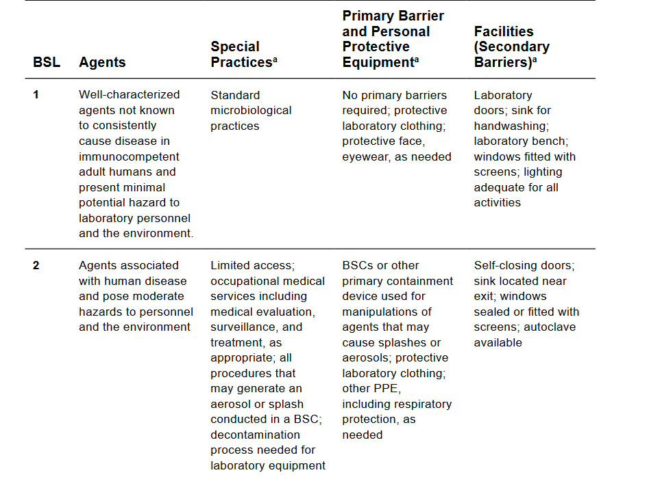

Investigator Assurance of Compliance

By signing this document, the Principal Investigator is ensuring that the information is accurate and complete, the workers are trained appropriately, and that any changes in scope will be reported to the IBC prior to implementation.

Signature Date

Ensure that all experimenters sign or acknowledge the appropriate work planning documentation.

IBC Approval Sheet

Full Committee Approval (A quorum will approve and must consist of a simple majority of the term members.)
Name | Signature | Date

