Urban Dispersion Virtual Workshop: Designing the Next Generation Urban Dispersion Field Programs
Brookhaven National Laboratory, Stony Brook University, and Stevens Institute of Technology
November 13, 2017
Prepared by Thomas Watson from transcripts of the workshop
April 20, 2018

Table of Contents
Table of Contents 2
1.0 Next Generation Urban Dispersion Studies: Introduction and Objectives 7
Martin Schoonen, Associate Laboratory Director, Environment, Biology, Nuclear Science & Nonproliferation Directorate, Brookhaven National Laboratory 7
2.0 What Model Improvements do User Communities Need? 8
Leonard Willitts, Jr., FEMA IMAAC Program Manager 8
CAPT Joselito Ignacio, FEMA CBRN Science Advisor 8
2.1 Inter-Agency Modeling and Atmospheric Assessment Center (IMAAC) 8
2.2 Key Decisions during Response 9
2.3 Model Inputs & Limitations 10
2.4 What Model Improvements do User Communities Need? 10
2.5 What is the value to CBRN Models Now and Into Future? 11
2.6 Inform response decisions 12
2.7 Discussion 12
Dave Brown 12
CAPT Joselito Ignacio 12
Dave Brown 13
CAPT Joselito Ignacio, FEMA 13
Paul Kalb, BNL 13
Leonard Willitts, Jr., FEMA IMAAC Program Manager 13
Paul Kalb, BNL 13
Ron Baskett, LLNL 14
CAPT Joselito Ignacio, FEMA 14
John Nasstrom, Lawrence Livermore, NARAC 14
Paul Kalb, BNL 15
John Nasstrom, Lawrence Livermore, NARAC 15
Leonard Willitts, Jr., FEMA IMAAC Program Manager 15
Michael Dillon, Livermore 15
CAPT Joselito Ignacio, FEMA 16
Tom Watson, BNL 16
CAPT Joselito Ignacio, FEMA 16
Julie Pullen, Stevens Institute of Technology/BNL 16
Leonard Willitts, Jr., FEMA IMAAC Program Manager 16
Julie Pullen, Stevens Institute of Technology/BNL 17
Leonard Willitts, Jr., FEMA IMAAC Program Manager 17
Martin Schoonen, Brookhaven National Laboratory 17
John Nasstrom, Lawrence Livermore, NARAC 17
Akshay Gowardhan, LLNL, NARAC 17
Wayne Boulton, RWDI 18
Dave Brown, Argonne 18
3.0 What model improvements do the user communities need? Urban Modeling Improvements and Validation? 19
Mr. Rick Fry, Defense Threat Reduction Agency 19
3.1 Outline 19
3.2 Modeling architecture 19
3.3 Best Model depends on data and application 21
3.4 DTRA Urban Models: Introduction to HPAC: 21
3.5 Urban Modeling in HPAC 22
3.6 Internal Building Hazard Model 22
3.7 Urban Sub-System 23
3.8 Urban Dispersion Model 23
3.9 BVIM 23
3.10 CONTAM 23
3.11 Where are the gaps? 24
3.12 Discussion 24
Julie Pullen: 24
Rick Fry 24
Julie Pullen: 24
Rick Fry 24
Julie Pullen: 24
Rick Fry 25
Dave Brown 25
Rick Fry 25
Dave Brown 25
Rick Fry 25
Dave Brown 25
Paul Kalb 26
Dave Brown 26
Rick Fry 26
Dave Brown 26
Julie Pullen: 26
Joe Chang 26
Dave Brown 26
Julie Pullen 27
Jeff McQueen NWS NCEP 27
Rick Fry 27
Jeff McQueen NWS NCEP 27
Dave Brown 27
Rick Fry 27
Dave Brown 27
Wayne Boulton 28
Julie Pullen 28
John Nasstrom 28
Akshay Gowardhan, LLNL/ NARAC 28
Julie Pullen 29
Akshay Gowardhan, LLNL/ NARAC 29
Julie Pullen 29
Akshay Gowardhan, LLNL/ NARAC 29
Julie Pullen 30
Akshay Gowardhan, LLNL/ NARAC 30
Julie Pullen 30
Akshay Gowardhan, LLNL/ NARAC 30
Jeff McQueen, NOAA 30
4.0 How do we design tracer release and sampling to address questions temporal (e.g., diurnal and seasonal variation) and spatial (e.g., land/urban/water gradients) for the broadest applicability 31
Joseph Chang, Rand Corporation, Arlington, VA 31
Steven Hanna, Hanna Consultants, Kennebunkport, ME 31
4.1 Introduction 31
4.2 Urban 2000 (Salt Lake City) 32
4.3 Joint Urban 2003 (Oklahoma City) 33
4.4 Madison Square Garden 2005 33
4.5 Midtown Manhattan 2005 34
4.6 2015 Jack Rabbit II Mock Urban with Dense Gas Release 34
4.8 Source Considerations 36
4.9 Tracer Sampling 36
4.10 Sampling network 37
4.11 Tracer Data Considerations 37
4.12 Meteorological Sampling 38
4.14 Some Outstanding Questions 38
4.15 Discussion 39
Dave Brown 39
Michael Dillon 40
Tom Watson 40
Dave Brown 41
Tom Watson 41
Dave Brown 41
Joe Chang 41
Julie Pullen 41
Martin Schoonen 41
Pavlos Kollias 42
Julie Pullen 42
Pavlos Kollias 42
Julie Pullen 42
Martin Schoonen 42
Julie Pullen 42
Martin Schoonen 42
Pavlos Kollias 43
Julie Pullen 43
Joe Chang 43
Julie Pullen 43
Martin Schoonen 43
Pavlos Kollias 43
Julie Pullen 44
5.0- What are the next-generation measurements needed to improve the Urban Dispersion data sets? 45
Pavlos Kollias, Center for Multiscale Applied Sensing, BNL/Stony Brook University 45
5.1 Introduction 45
5.2 How simple can we afford to make our urban dispersion models? 46
5.3 Street level conditions 46
5.4 Fast response wind data 46
5.6 Referencing height 46
5.7 System for Atmospheric Modeling (SAM) 48
5.8 Example simulation 48
5.9 Wind retrieval from NexRad clear-air radar data 49
5.10 Measurement gap: Turbulence and transport information is available at street level or a mile above 50
5.11 Wind retrieval from NexRad clear air data 52
5.12 NYU/Aerospace Hyperspectral Imager Pilot Deployment at Hoboken NJ 52
5.13 Doppler LIDAR 53
5.14 BNL: Mobile Wind Interceptor 55
5.15 Remote Sensing: Filling the gap from street level to free troposphere 56
5.16 Multi-scale Measurement Strategy 56
5.17 Discussion points 57
References 57
Discussion 57
Martin Schoonen 57
Pavlos Kollias 57
Paul Kalb 57
Jaime Benavides 58
Ron Basket 58
Jaime Benavides 59
Martin Schoonen 59
Pavlos Kollias 59
6.0 How do we implement the next generation urban dispersion experiments? 60
William Schulz, Office of the Federal Coordinator for Meteorological Services and Supporting Research (OFCM), NOAA 60
6.1 Introduction 60
6.2 Coordination: Mission and Vision 60
6.3 OFCM is administered within NOAA 61
6.4 We facilitate inter-agency efforts of the Federal Weather Enterprise (FWE) 62
6.5 Administrator of the FWE Coordinating Infrastructure 62
6.6 Federal Committee for Meteorological Services and Supporting Research (FCMSSR) 63
6.7 Interdepartmental Committee for Meteorological Services and Supporting Research (ICMSSR) 63
6.8 FCMSSSR agenda Item: Strategic Plan 65
6.9 The Weather Act of 2017 66
6.10 ICMSSR 67
6.11 ICMSSR Recent/Current Issues 67
6.12 Interagency Weather Research Coordination Committee (IWRCC) 68
6.13 IWRCC Recent/Current Issues 68
6.14 Part 2: Urban Dispersion Workshop 69
6.15 Points to raise in the “pitch” to leadership 70
6.16 Recommendations 72
6.17 Discussion: 72
Martin Schoonen 72
Tom Watson 73
Bill Schulz 73
Julie Pullen 73
Bill Schulz 73
Julie Pullen 73
Bill Schulz 73
Martin Schoonen 74
Bill Schulz 74
Martin Schoonen 74
Tom Watson 74
Julie Pullen 74
Bill Schulz 74
Martin Schoonen 74
Joe Chang 75
Tom Watson 75
Martin Schoonen 75
Pavlos Kollias 75
Wayne Boulton 75
Terry Sullivan 76
Appendix 1: Registered Participants 77

1.0 Next Generation Urban Dispersion Studies: Introduction and Objectives

Martin Schoonen, Associate Laboratory Director, Environment, Biology, Nuclear Science & Nonproliferation Directorate, Brookhaven National Laboratory
The overarching objective of this workshop is to start the process of planning and implementing the “Next Generation of Urban Dispersion Studies”. We have organized this program to bring people interested in this complex problem together. We have representation from different disciplines, different agencies, and different academic institutions. The workshop is organized around several questions:
- What are the needs of the emergency response community and how do we design models and experiments to address them?
- What model improvements do the user communities need?
- How do we design tracer release and sampling to address questions temporal (e.g., diurnal and seasonal variation) and spatial (e.g., land/urban/water gradients) for the broadest applicability?
- What are the next-generation measurements needed to improve the data sets?
- How do we implement the next generation urban dispersion experiments?
The Virtual workshop format is exciting. We view this as an experiment which, if successful, will bring a large group of people together from the community to design the next generation urban experiments. We have many agencies participating: DOE-BER, DHS, FEMA, NNSA, NARAC, DTRA, NYPD, and NIST. The registration list includes over 40 people including participants from well beyond the US including Spain and Canada.

2.0 What Model Improvements do User Communities Need?

Leonard Willitts, Jr., FEMA IMAAC Program Manager

CAPT Joselito Ignacio, FEMA CBRN Science Advisor

2.1 Inter-Agency Modeling and Atmospheric Assessment Center (IMAAC)
The Inter-Agency Modeling and Atmospheric Assessment Center (IMAAC) is a FEMA led Program. IMACC provides a single federal source for collaboration on plume modeling. The modeling for IMAAC is done at the Defense threat Reduction Agency (DTRA) Technical Reachback hub. There are seven organizations under the IMACC umbrella:
- DHS FEMA
- EPA
- NOAA
- HHS
- DOD
- DOE
- NRC
IMACC does not talk to the first responder community or leadership on a continuous basis, but does get feedback through interaction with the first responder community. IMACC supports real world incidents and planning events. We consider three target audiences during an immediate incident response:
- Leaders
- Responders
  - Public Health/
  - Emergency Management/
- Public
A partial list of general information requirements for these three target audiences is:
- Leaders
  - Magnitude of Impact (to immediate area, region, nationally);
  - Resources required;
  - Public Messaging;
- Responders
  - Magnitude of Impact (to immediate area);
  - Resources required;
  - Public Messaging;
  - Life-saving actions;
  - Responder Protective Measures;
  - Incident Management & Support
- Public
  - Immediate self-protective actions;
  - Reunification;
  - Where, when, how to evacuate?
  - Where, when, how to shelter in place (SIP)
  - Resources to seek assistance

2.2 Key Decisions during Response
The goals of IMACC response are to provide information to protect the life and safety of the public and protection of the first responders and medical personnel treating injured civilians and response personnel. The key questions that need to be answered for the decision makers during an incident are:
- Do they issue a directive to shelter-in-place (SIP)?
  - For how long?
  - What are the areas covered by the order?
  - How do I define SIP?
    - Indoors only, basement or upper floors?
    - Sealing doors, windows and stopping ventilation?
- Do they issue a directive to evacuate?
  - What areas to evacuate?
  - Is the order voluntary or mandatory?
  - Where? Designated shelters?
  - When? Now all at once? Can I prioritize to reduce traffic?
  - How? What routes?
- What areas to restrict entry and egress?
  - What are the alternate routes?
  - What routes to bring in additional response assets and resources?
- Where do I stage my response assets and resources?
- What PPE is required for this event? For how long?
- Do I need decontamination assets? What kind? Where? How much? For public and responders?
- What do I tell the public?
  - What are my key messages?
  - What are the immediate actions required for impacted citizens?
IMACC has existed since 2004 and provides a 24/7 reach back capability and has worked continuously to refine the decision making products. This information is necessary so that local officials can make informed decisions. IMACC can provide modeling support within 30 minutes. Any emergency official at the state or local level can call IMACC. It is not a decision making body. If a fire chief calls IMACC requesting a model product IMACC will help them interpret the models and provide advice, but decisions are made by the state and local officials. In addition to CBRN the experts at IMACC provide support for toxic industrial chemicals (TIC) Toxic Industrial Materials (TIM).

2.3 Model Inputs & Limitations
There are limitations on the output models can provide based on the quality of the input.
It is necessary to know the type of agent released to get accurate information from the models. Unless you can identify the CBRN agent within the first few hours, the model can only provide a guess. This makes it difficult to provide useful model support. If the release is TIC or TIM, the first responder community can probably identify the agent. If not, it is necessary to determine the agent from evidence such as the signs and symptoms of people exposed, level A entry to contaminated area for field identification, or observations of the environment in and around release area.
It is also necessary to know the quantity of the release or the continuing release rate. If it is a terrorist attack, the agent is likely unknown and may remain unknown for a few hours. This information can be obtained from observation at the release site, an estimate based on numbers of affected individuals in a given area, witness statements, and level an entry to the release site.
The models currently in use provide a “snapshot” based on current conditions and available knowledge of the incident. CBRN agents can degrade, be mixed and diluted, and undergo chemical reactions in the atmosphere producing by-products. The changing weather patterns will change concentrations as well. This means model updates must be run often and that they reflect current meteorological conditions, such as rain or snow and ice conditions and changing wind fields.

2.4 What Model Improvements do User Communities Need?
IMACC is working to improve their products. IMACC will be issued to the users after an event and asks about the usefulness of the products provided. The ask questions such as:
- Was there information in the product that they were able to use?
- Was the language understandable
Not everybody is a CBRN expert. The information provided by IMACC needs to be understandable to both the emergency responders and senior leadership if it is to inform key decisions being made at the local, state and Federal levels.
It is important to incorporate local real time data within an hour of the incident to be able to provide the information necessary to inform immediate concerns of public for life-saving actions to occur. This includes any significant weather changes. Model results are inaccurate if they do not have real time weather data. There is an effort to integrate the output of various models to address these uncertainties.
IMACC is also exploring the development of 3-#D graphic models, which will present a 3-dimensional graphical representation, rather than flat 2-dimensional picture. Current 2-d models do not take into account buildings where toxic agents can build up and be released later. They are considering continuous live-feed capabilities to reflect real-time weather changes. Currently weather data comes from the NWS. If Hazardous Material response teams are on the ground and they have a weather station set up, there is the ground truth for this input.
Different types of modeling software have strengths and weaknesses. Models are a snapshot in time. NWS does a good job of integrating models, such as the spaghetti models used in hurricane prediction. Is there something comparable in CBRN models? Can the models see the change from something like a continuous release? Can the developers who have developed products like HAPC or ALOAH work to overlay the various models so we can recognize the strengths of the various models and the uncertainties? Right now we are challenged with picking the best model. This often leads to contentious discussions among developers and users. I know we can do this with GIS and ESRI platforms but this involves an additional step that must be performed manually. Is there something that can incorporate the outputs from HPAC and National Weather Service HYSPLIT model on the same geographical map?
IMAAC is developing a water modeling. Who has the ability to do water modeling? Who has the responsibility to do water modeling?
What are the end users asking for?
- Deposition of particulates or condensation of gas/vapors;
- Urban terrain effects;
- Water surface contamination and distribution down-stream;
- Executive leadership, incident management, and public-releasable model products;
One of the challenges with IMAAC is the question of how to structure the output released to the general public.
- How to communicate hazards to avoid panic?
- How do we inform the general public that there is something going on in their area?

2.5 What is the value to CBRN Models Now and Into Future?
One of the best uses of IMAAC input is to provide information necessary to plan actions before an impending event. A good example of this was during hurricane Harvey, where there was an impending chemical release from a Crosby Texas chemical plant that lost refrigeration critical to keeping chemicals from combusting. The EPA regional HQ contacted IMAAC to get information before the inevitable release of this material. IMAAC provided modeling input to emergency managers over a period of five or six days, which helped them prepare for the release. The chemicals ignited and the evacuation zones were already determined. Officials were able to let the chemicals burn. The important point is IMAAC was part of the process even before the incident and IMAAC input helped design the mitigation actions.

2.6 Inform response decisions
IMAAC is a great resource. Depending on the situation, we try to deliver products to the first responder community within 30 minutes. Some events are more complex than others and require more input and interpretation. We recognize if models are not helpful, we are not doing our job and we look to the users to provide feedback to ensure that the products we are providing are useful and provide situational awareness of immediate event impacts.
Our models are complex, but they are user friendly. They provide a lot of useful information. We are open to changing those products in response to the user community.
An unexplored area is how these products can be used to examine long-term community impacts. We do not provide much input into recovery efforts. Once life and safety issues are dealt with we shut down. This is something we are looking at now but it is not something we do on a regular basis. Our products can be used to inform remediation and recovery decisions. They can be used to help with determination of compensation for survivors such as “Who Pays?”

2.7 Discussion
IMAAC should to go out into the user community more often and make sure our products are still useful. It is helpful to get feedback, such as learning if there are there other models that the user community would like to see.

Dave Brown
Model integration, particularly the coupling of outdoor and indoor modeling is important. We have demonstrated this with our modeling of subway transit facilities. There is a value in coupling outdoor and indoor models, particularly using indoor results as input to outdoor models. An important question to address is: What are the consequences of venting a CBRN agent from a subway?

CAPT Joselito Ignacio
An area where the issue of integration gets fuzzy is in determining how we use indoor models. The response decision you are trying to make must be defined. Most jurisdictions would opt for evacuation of the entire system even if some locations will be impacted more than others. The value of CBRN integrated atmospheric transport and indoor models needs to be addressed.

Dave Brown
In the urban environment, things move around. There is transport in and out of buildings and subways. The whole system is highly interconnected. When you look at terrorist events, there are a number of high value targets around the country that are on every bodies list. IMAAC may be the first people called in the event of a release. The coupling of buildings and subways and atmospheric transport should be a priority.

CAPT Joselito Ignacio, FEMA
Understood.

Paul Kalb, BNL
I have a comment on the statement that accurate, real time weather data is important. Some of the work that we have done in NYC has shown and given us a feeling for how local, "local" is. For example, we have looked at using some of the weather data from around Manhattan, particularly the airports. We have set up meteorological stations in downtown Manhattan where the actual study was taking place and we found significant differences in wind speed and direction between the airport data and measurements made in the urban center. Our take home lesson was modeling and predicting the effects of an incident in an urban setting, you need to have the meteorological data at the release site or as close to the release site as possible if you want an accurate model run. As a consequence of what we have learned, NYPD, through DHS, is installing met stations in lower Manhattan to improve the input to models. So, your point about real time meteorological data is very well taken and based on our experiments it may be even more important than you think.

Leonard Willitts, Jr., FEMA IMAAC Program Manager
It is definitely a problem for us. It is not that we don’t want the data; it is a problem of how do we get that data. If the emergency response community is not providing that to us we don’t have it. We can’t ask them if they do not provide it – there is a lot going on in any incident. We would love to have that data.

Paul Kalb, BNL
One thing that comes out of the work we are doing collectively is the need for this real-time local meteorological data. We are trying to get the message out that we need to have better data in these critical, targeted areas. Meteorological data is one of the easier types of data to collect. One of the things that we have to deal with is that organizations like to run their own models. NYPD and FDNY have their own models and they are more comfortable running their own models than in using outside products.

Ron Baskett, LLNL
I would like to expand on what Dave Brown was saying and mention, in collaboration with the folks in Galveston at the University of Texas medical branch, and Michael Brown, I just attended, that addressed the effects of a catastrophic hydrofluoric acid (HF) release from a refinery. The point I want to make is there is a big difference in what models predict for human exposure and the exposure that actually is measured. Exposure depends on where people are, and as we know, people are indoors 90% of the time. I want to point out our models treat CBR differently from or N. We know there are differences in a chemical release if it is a leak, such as a tank rupture, or if it results from a fire. That said, I think it is very important the community move forward and produce a product the incident command can use to make decisions about sheltering in place or evacuation and to decide how long to shelter-in-place. Providing support for those two key decisions are something the models can do. Our thinking about chemical releases is that the chances of using a model in a real time to support incident command decisions are small, because of the short time frame. This is not necessary the case for fire, because the response time is longer. Models have an important role in forecasting impacts in the case of a release resulting from a fire.
Our community needs to provide tools for predicting the results of chemical releases to enhance preparation under a range of possibilities and a range of meteorological conditions. This kind of information stored at an incident command center, or office of emergency services would really assist decision making. I go back to what Mark Miller used to say about ALOHA - it is mostly used to support preparedness and planning and rarely in emergency response.

CAPT Joselito Ignacio, FEMA
As investigators refine and develop new models, particularly models, which are intended for emergency response use, it is necessary to keep in mind the types of key decisions made by emergency responders. The list in section 2.2 can help model developers determine whether their models are actually helping people on the ground or at the Federal level to make these kinds of decisions. For example, the model should help the incident commander determine if the intrusion of an agent into a building from outdoors should result in evacuation or shelter in place. We need to look at the model output from the viewpoint of the incident commander. That is the challenge to keep in mind how these models are to be ultimately interpreted and used in the field.

John Nasstrom, Lawrence Livermore, NARAC
It has been pointed out the weather can change from block to block very dramatically within an urban area. What is important about these changes from our perspective at NARAC, is the availability of representative weather observations at or above the building tops. These observations provide data on the prevailing winds. Wind speed and direction and other quantities measured near street level will change within a few feet. I don’t know if the NYPD sensors are being installed on rooftops. Does anyone know where they ae being installed?

Paul Kalb, BNL
They are going in on rooftops of very tall buildings in key locations.

John Nasstrom, Lawrence Livermore, NARAC
That is great to hear. This does tie in to urban experiments as well because these observations as well as observations at street level are needed to drive the models. This is the information you would be using during an emergency.

Leonard Willitts, Jr., FEMA IMAAC Program Manager
Is this just NYC or are there other major cities where these observations are collected?

Michael Dillon, Livermore
We have talked about weather measurements and how the spatial resolution matters. If we are saying what matters is a meter or a few meters, then we need to pay attention to trees, mailboxes, people, and other small scale features. If we want to make sure our models are accurate, high resolution measurements should be included in the next generation experiment. First, however, we need to address the questions “What is the scale of decision or scale of action”? To what degree can responders initiate actions? Can they implement a response at a neighborhood scale or do they have to take actions for an entire city. The scale of action informs the resolution the model output. It is great to want high resolution very local information, but if the scale of practical action is larger, then high resolution guidance is not useful.
Sheltering decisions also depend strongly on the type of threat. If the incident is a nuclear power plant accident, then the decision to SIP is extremely important. For other sorts of hazards, TIC for example, getting shelter in a timely fashion is not as important.
In going through these model efforts and analyses we should be looking for sweet spots where the model can provide a responder with output that allows a decision about shelter duration for the particular hazard. We should be looking to provide folks some easy rules of thumb, no regrets information.
Evaluation of airborne hazards is a critical component for making decisions. The models should provide details on integrated exposures times and transport pathways for radiological events such as a Nuclear power plant accident or dirty bomb or for infectious disease agents. Determining the transport pathways that could expose people during an evacuating is important.
We should be thinking holistically. In developing the next generation of dispersion models we should be looking at all the pieces and how they fit together in an integrated manner.

CAPT Joselito Ignacio, FEMA
The more information you can provide holistically, and not just focused on respiratory exposure type agents, makes sense. We have all learned the lessons from the World Trade Center. Hazards are not only respiratory, but also thermal. Can models help with that?

Tom Watson, BNL
One thing I am hearing is that we need to have a lot more dialogue between the people who are creating these models and those who are using them. This is one of the reasons we ae very happy that FEMA here to help make this connection. What do we need to do to start that dialogue?

CAPT Joselito Ignacio, FEMA
DHS S&T has established the SAFER Program. Under this program, they will develop a focus group of emergency response managers and other users of the dispersion model products. If the focus of the next generation urban dispersion experiments is to develop better models to support the response community, this program will help identify key stake holders and potential product users and layout a format for discussion. That, in my opinion, is a great start. It will be valuable to assemble the potential users and the developers to really look the data products. You may have to provide an introduction current model capabilities but the SAFER effort will provide a venue for broader discussion and feedback. Don Bansleben would have more information on this program.

Julie Pullen, Stevens Institute of Technology/BNL
I wanted to get back to the water borne contamination and the linkage between the water and the air and their transport pathways. I wanted to ask the FEMA representative from IMAAC in your work with NRC have you looked at the forcing’s that are driving the models between the air and the sea and consistency between those models when you look at transport across the air sea interface?

Leonard Willitts, Jr., FEMA IMAAC Program Manager
We really haven’t. Right now we are in the process of doing a data call to the IMAAC members. We are asking them which modeling products they currently use for simulating the land water interface. Right now I can’t speak to that.

Julie Pullen, Stevens Institute of Technology/BNL
Is the aim to consolidate some of those modeling tools within IMAAC?

Leonard Willitts, Jr., FEMA IMAAC Program Manager
We plan to use IMAAC as the collaborative body for water/air transport coupling modeling just like we do with atmospheric modeling. Currently, DTRA is our technical reach back. The current procedure is an official managing an incident, then would call DTRA and they would reach out to the organization with the type of water modeling capability that is needed, and begin the collaborative process. IMAAC is not focusing on developing new models. There are plenty of existing models. We are trying to focus in on the models that we would need in the event of an incident requiring linking water and land transport.

Martin Schoonen, Brookhaven National Laboratory
I was wondering, what kind of data sets are of highest priority to improve models. NARAC has a number of models, what would be of most value to you to improve those models?

John Nasstrom, Lawrence Livermore, NARAC
That is a big question. There are a lot of types of data that would be useful. One of the big challenges is further developing our understanding of the details of how material disperses in different urban settings. There have been several field experiments done in urban areas but they are always limited in terms of meteorological conditions, the wind speed conditions, terrain around the buildings themselves, and also the natural terrain.
Field experiments are costly, as everyone knows. There are limitations on the types of flow conditions in urban areas that have been studied. It is important to learn from previous experiments and to try and fill in gaps in meteorological conditions, types of urban settings, and types of natural terrain around urban areas. In general, it is also important to simulate the details around individual buildings as the cloud grows. How does the neighborhood scale affect the transport and what is the connection between the local and the regional scales? All those things are obviously coupled. We need to understand how flow regimes on one scale are coupled to the next to get an accurate picture of the dispersion. We need to have good information on the building and neighborhood effects on the suburban scale as well.

Akshay Gowardhan, LLNL, NARAC
We need more information about urban terrain, such as the presence of parking garages and trees. We need more vegetation information because we see that these kinds of features have important effects on dispersion. Downtown areas have many garages. Garages have very different effects than buildings and significantly impact dispersion patterns.
Another important aspect is deposition on the vertical surfaces of buildings. We have very little information on building deposition. We need data to validate our models.
The more data we have the better. We need more wind sensors and samplers at the ground level and more rooftop samplers to determine how high the clouds mix.

Wayne Boulton, RWDI
This is Wayne Boulton with RWDI, a private consulting engineering firm based in Canada
Where do people see the direction this work is heading? This discussion is about urban dispersion. We do a lot of work with wind tunnels, Gaussian plume models, and Lagrangian puff models in our work as engineers. Our community uses RANDS type CFD simulations, large eddy simulations or direct eddy simulations, and smooth hydrodynamic particle SPH methods. I am just wondering if there is a common nomenclature for urban dispersion and if the engineering and scientific communities are all talking about the same thing when we talk about dispersion. It seems models are evolving so quickly, incorporating more sophisticated physics to simulate dispersion that I would like to know if these communities are headed in the same direction or are different approaches being pursued.

Dave Brown, Argonne
On the outdoor side there are a variety of different ways of addressing urban dispersion. I do not have faith in the results of a Gaussian model in an urban setting. I think the more critical element is adding more physics to the model rather than to pick and chooses between approaches. Livermore has done some great work developing a high fidelity urban model. As computer resources continue to grow, these more powerful approaches, are going to become more and more practical for response and planning applications. Certainly as we incorporate more information from the urban databases; building footprints and heights, trees, and other vegetation can be accounted for. The work that has been done in the Jack Rabbit tests and other related efforts have shown that there is natural attenuation of toxic materials, in particular chlorine, by the environment because of vegetation. There is an equal disconnect between the effects that models predict and the observations occur in the field such as the extent of vegetation damage. I think that there has been a lot of progress on flow and dispersion without consideration of deposition and other attenuation effects. I am not saying that passive dispersion is completely solved issue – obviously more data is always good, but the absorption effects of gas phase agents and deposition effects on particulate concentration need more research.

3.0 What model improvements do the user communities need? Urban Modeling Improvements and Validation?

Mr. Rick Fry, Defense Threat Reduction Agency

3.1 Outline
I am going to talk about our current modeling capabilities at DTRA, some of the validation that we have been looking at for these models, and the future direction of our modeling efforts. I will address:
- Buildings, their complexities, and indoor models
- DTRA urban models
- Where are the gaps
I will also present some of the concepts behind the modeling we have been doing and how we are trying to link these different models.

3.2 Modeling architecture
A chain of models connect outdoor concentrations to indoor health effects. One of the biggest concerns these days is connecting the outdoor modeling to indoor modeling and the coupling moving from outdoor releases to indoor concentrations and conversely from indoor releases to outdoor concentrations. In addition, the subsequent contamination of buildings downwind in both cases.
We are trying to figure out the spatial relationships and how databases interact with the local meteorology and also pull in building characteristics. We want to know:
- How do particles get into and out of buildings?
- And, what are the subsequent human toxicity effects?
It is a very complicated system that we are trying to produce for our operational users. It requires determining the conditions at building envelope, spatial resolution of concentrations, the wind effects of “urban canyons” on building envelopes, transport across the envelope, and incorporating the effects of building characteristics such as leaks and the effects of ventilation systems. Particle penetration has to be addressed directly.
We need to know if it is necessary to model two-way exchange. We need to know the effects of indoor transport, and be able to accurately model the airflows and optimal “zoning” inside a building. We need to know the extent particles adsorb into surfaces, and competition of absorption, with other effects such as coagulation and how all these processes depend on other factors such as humidity. The models should be able to provide information on the effects of particle filtration, tracking, resuspension, and coagulation and to predict human health effects such as toxicity and exposure.
Complexity arises at all levels of modeling. Making it simple is always better and is more cost effective. It is best to keep the number of parameters to a minimum. Some of the questions that need to be addressed are:
- Do we have suitable models with the right spatial and temporal resolution?
- Do we understand the physics?
- What processes can we safely neglect? For example, when is well-mixed assumption justified?
- At what level of detail do we need to know all of the different parameters that go into the models?
- Do we have to resolve trees, cars, mailboxes?
- How do choices of spatial and temporal resolution affect the resulting physics?
- Do the models cover all applications (e.g., planning, monitoring)?
- What are we trying to do are we trying to develop these models for planning?
- Are we interested in developing emergency response models?
- Are we trying to link into warning and reporting, integrated early warning systems?
- Do we have suitable models?
  - Do the models have the right spatial and temporal resolution?
  - Do the models cover all applications? Can they be used for planning and monitoring as well as incident response?
- Can disjoint models communicate?
  - Can indoor and outdoor models be coupled?
  - Do they operate at similar spatial and temporal resolution?
  - Do they share the same variables?
  - What variables need to be transferred?
  - Do we need to transfer contamination information?
- Can you link a Lagrangian particle model to a Gaussian puff model?
- How do you link a box model to a Gaussian puff model?
- Do we have the necessary data?
  - Do we have the data to initialize a model of a particular building?
  - For instance, at DTRA Reachback, we have about 133 cities in the external databases. This database has geometric information and does not necessarily include the internal information necessary to a make a calculation for a building.
- And, more generally, do we have the data to validate model assumptions?
- Can we use the results?
- Once we make all these connections, how do we use the results?
- Are we looking at human effects information inside of buildings?
- Are we going to just give a hazard warning area on evacuation routes?
- Also how do we determine and communicate uncertainty? I think this is a big problem. I heard earlier somebody talking about combining models and putting them onto a GIS.
- Is it of interest to make some sort of multi-model ensemble for urban areas?
- Does that make sense and how do you represent the uncertainty?
  - How do we:
    - Extract meaning from large-scale simulations?
    - Interpret real-time sensor measurements?
    - Optimize output in the face of uncertainty and variability?

3.3 Best Model depends on data and application
The best model depends on available data and the specific application. What model do we want to use for what application? Which product is good enough to meet the needs of the user?
A simple box model requires air exchange rates and concentrations as input and produces gross concentrations for a building as output.
The Multi-zone models provide more detail. These models simulate dispersion in each zone and output average concentrations. The multi-zone approach is modular with zones and flow elements that can be added to address different building configurations. It uses a lumped-parameter approach and provides fast, medium-fidelity results. The outputs are zonally averaged concentrations.
A Computational Fluid Dynamics (CFD) solution may be more appropriate. A CFD approach provides very high fidelity information anywhere inside of a building. It requires a large number of grid points and detailed physics to calculate quantities such as momentum and temperature gradients. CFD models produce high-fidelity results, but are computationally intensive and therefore slow.

3.4 DTRA Urban Models: Introduction to HPAC:
The Hazard Prediction and Assessment Capability (HPAC) model has been in development at DTRA for over 20 years and has been used by the DOD. HPAC is the mechanism we use to develop new modeling technologies and to pass these new technologies along to users. An example is our urban dispersion modeling and indoor dispersion modeling forward-deployable software tools. This tool uses of a suite of models and can be accessed through HPAC. These models use fast-running, physics-based algorithms to simulate atmospheric transport and dispersion. The platform utilizes real-time weather data, embedded climatology, historical weather, and high resolution terrain data; and can simulate source terms from CBRN and TIC/TIM. The outputs are predictions of geographical hazard areas and human collateral effects resulting from releases of toxic materials.

3.5 Urban Modeling in HPAC
HPAC contains models for simulating dispersion of material into, within, and out of buildings. These models are coupled to urban transport models that provide concentration source terms and building surface conditions. The Internal Building Hazard Model can be run as a box model or as a multi-zone model. It can be used to produce an indoor exposure profile resulting from an outdoor plum or an outdoor plume resulting from an indoor release.
We have an external urban sub system within HPAC that can simulate an exterior source and be used to create indoor exposure profiles using a box model for multiple buildings. It can simulate exterior source dispersion and calculate indoor exposure profiles of multiple buildings based on the exterior concentrations passed to by the Gaussian Puff Urban Dispersion Model.

3.6 Internal Building Hazard Model
The Internal Building Hazard Model (IBH) is a graphical user interface (GUI) inside HPAC that allows the user to choose between six notional buildings or to design a building with multiple rooms and multiple zones. Indoor dispersion is calculated using one of two codes: the Building Ventilation and Infiltration Model (BVIM) or CONTAM. IBH provides the user with choices of release type such as instantaneous burst, continuous, spray, or pool and can also be generated by HPAC from the Gaussian Puff Urban Dispersion Model. The source term can be liquid, chemical, or biological agents. The deposition velocity must be specified. The results provided by IBH are a graph of mass leaving the building (Figure 1) and table of zone and concentration highlighting when critical concentration thresholds are exceeded.
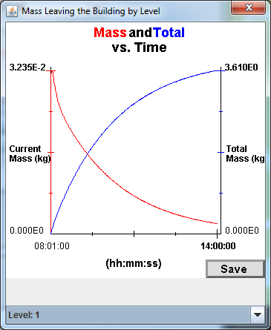
Figure 1: IBH graphical output.

3.7 Urban Sub-System
The urban subsystem links outdoor dispersion and indoor dispersion models. The outdoor dispersion model is a Gaussian puff model. It is linked with the Building Ventilation and Infiltration model (BVIM). BVIM is a simple box model which can simulate the concentrations in single buildings by integrating CONTAM. A CONTAM model that a user develops can be linked through to the Gaussian puff model using the urban subsystem. The puff model calculates external concentrations and the results used as input to the CONTAM module to calculate concentrations and exposures in buildings. This coupled system can be used to simulate exposures for arrays of buildings. The user inputs air exchange rates and parameters for blocks of buildings and defines the external release parameters The external model calculates the concentrations a the building skin and uses these values to initialize BIVM, which then calculates the internal concentrations. Building data for the external dispersion model are supplied by the Geographic and Environmental Database Information System (GEDIS).

3.8 Urban Dispersion Model
The Urban Dispersion Model (UDM) is a Gaussian puff model and it links with SCIPUF. SCIPUF is another Gaussian Puff model but designed for simulating dispersion in open terrain. This is all linked through HPAC. The atmospheric transport and dispersion model predicts dispersion in urban environment using a Gaussian puff approach. It accounts for effects of topology of an array of buildings and works alongside other dispersion models inside HPAC such as SCIPUFF and MSS.

3.9 BVIM
BVIM is our simple single zone building model. It treats buildings as a single, well-mixed volume. It runs very rapidly and can be run for multiple buildings in a large urban area. Material is transferred into and out of the building depending on the air exchange rate. It is useful for rapid calculation of potential indoor exposures.

3.10 CONTAM
The CONTAM model, developed by NIST, is a complex, multi-zone indoor dispersion model. The user can define different building configuration parameters such as rooms, doors, windows, and air handling systems. CONTAM models individual rooms and the connections between compartments of a building and the outside environment. The resulting concentrations calculations can vary between zones. It is possible to include scheduled changes in building configuration such as those occurring when programmed changes in HVAC configuration are implemented. CONTAM projects are run outside of HPAC and the project files are ingested by Urban Sub System (USS) in HPAC.
You can see we are trying to integrate all of these models in HPAC in a way that will provide a pathway to selecting modeling capability appropriate to the user’s application. It is possible to run projects externally and import the results into the urban subsystem and to model one building or many buildings. These choices determine what model you start with and the how models interlink.

3.11 Where are the gaps?
I think one of the biggest gaps we have right now, with our validation of these models, is the data to validate the simulations of coupled outdoor to indoor and indoor to outdoor releases. How do we validate these models? I don’t think we have the data sets that will support indoor model validation. Somebody mentioned earlier vertical deposition on buildings. We don’t have any data or even have any models that treat this phenomenon. These data and the ability to simulate these effects are very important for supporting decontamination efforts and also for responding to radiological releases.

3.12 Discussion

Julie Pullen:
How do you think about data assimilation in the context of these tools that you were mentioning?

Rick Fry
Data assimilation in what sense?

Julie Pullen:
Assuming you have data on the scales that are of interest to you. Would you endeavor to do data assimilation or would you use the data for validation?

Rick Fry
We are mostly concerned with data for model validation - we are not trying to develop new empirical type models. Do you mean taking in high resolution weather data and putting it into the models and making use of that?

Julie Pullen:
It could be either. I was thinking more about contaminant measurements, but also weather as well. Could address that?

Rick Fry
I don’t think we have determined best weather data to use. How much value do we get from using microscale weather versus using mesoscale forecast data? That has not been determined for the current modeling systems. Where do we get the best bang for the buck? A lot of money could be spent on setting up a very highly resolved weather network and it is not clear is that effort will be worth the increased fidelity. We would definitely be interested in looking at the research that helps with this issue.

Dave Brown
We are working on a modeling project with DHS S&T to integrate CONTAM, our own internal subway model, and the QUICK model from LANL. One of the tasks we have that we are particularly excited about is the dynamic integration of these models instead of just chaining them. It is pretty simple to just chain these models. Is that something you are looking at this point? It is a real tricky problem.

Rick Fry
Do you mean like a fully coupled model?

Dave Brown
Exactly.

Rick Fry
I am not sure that we have figured that out. We are just trying to come to grips with some of the results we have now with the urban subsystem. Modeling multiple buildings makes the resulting ground level concentration last about 4 to 8 times longer because infiltration and the slow exfiltration from these buildings increases the persistence more than when only an external release is assumed.

Dave Brown
That makes sense because the buildings cause a hysteresis effect. I think that was actually empirically observed in both the UDP tests. I am not really sure if that was seen in SSAFE. The buildings themselves cause substantial effects, especially in an urban area like NYC where the large volume buildings have a substantial downtown footprint. The subway system has this effect as well. The subway collects material, holds it, and then it releases it over several hours. Similar building effects can take place over longer time scales. If you have a significant wind speed, the unimpeded plume would move through the urban area more quickly without these effects. I think your modeling results are reproducing a real effect. But, I don’t think have the data to support this conclusion yet. There are some very limited data sets from our work with BNL and the work we have done with MIT Lincoln Labs and Livermore that might support these observations. There might be some things we can share.

Paul Kalb
I think that you are right. I think that some of this information is a little bit sensitive and probably want to delay a discussion of that for another time. But, there is certainly a wealth of information that we have learned through UDP and SSAFE that bears on this question of interchange in the subways and building infiltration and exfiltration. I think these points are very well taken. I think we have information on this but we are probably not where we want to be. I think that is a continuing need.

Dave Brown
I would definitely agree that we are not where we need to be on this. We have some information including particle information coming off some May 2016 tests we did.

Rick Fry
That would be great, because all of the UDM and other particle models were developed using water channel and wind tunnel data which assume a solid block for the building.

Dave Brown
Buildings are not the only urban features that cause these effects. In a city like New York, or even DC, we see the effects of subways. Looking at the data and model results has really opened my eyes in the last couple years to the importance of integrating indoor-outdoor coupling.
Julie Pullen:
We had a question from Joe Chang.

Joe Chang
By fully coupled models do you mean inclusion of the feedback? I would paraphrase that to mean the modification within one model and transfer back to the other model

Dave Brown
That is exactly what I mean; dynamic integration between the models.

Julie Pullen
Jeff, are you able to ask your question?

Jeff McQueen NWS NCEP
Our models are generally too coarse to directly supply the type of data that dispersion modelers are interested in. Two and a half kilometer resolution real time analysis is probably one of our best tools. There has been some work by Wayne Boulton and other groups at HPAC to down scale the NOAA weather models to the urban canyon. It would be of interest to me to see how these models perform. This is one of the outcomes of a new field experiment would be of interest to us here at NWS. Operationally it would be very difficult to run a CFD model in the next few years

Rick Fry
Some of the other things we have been looking at to get that type of high resolution wind information are GPU systems with an LES model. It runs a lot faster than real time so you can do these really quick forecasts or diagnostic runs taking mesoscale input and turning it into microscale wind data and do it very quickly. Also you can use Quick to get a wind field like that as well and Microswift - those are all similar models based on the Rockwell approach.

Jeff McQueen NWS NCEP
A field experiment would be useful to evaluate these models

Dave Brown
Other important provided by Quick are the pressure fields on the outside of buildings. These are important for the CONTAM model. We are not sure if these fields are accurate but they are the only information we can use as input to CONTAM at this time. Using this output from QUICK has proven useful in looking at the building exchange in both directions.

Rick Fry
We actually use Mike Brown’s algorithm to do that for us.

Dave Brown
I am just pointing that out because it is not just the wind fields.

Wayne Boulton
I just wanted to add that there are other disciplines that could provide input on this discussion pertaining to pressure fields on buildings.
Studies that are done in wind tunnels or using numerical methods in order to assist architects and engineers to design the cladding and glazing systems on buildings are designed to estimate differential pressures on the faces of buildings and, on the lee side, provide an ideas of the turbulent effects that occur as the wind blows through that urban environment. There are other disciplines that have a fairly mature understanding of some of the effects that are being discussed here. This is a completely different field of science and engineering which the urban dispersion community might not be aware of. These data could be relevant. I think that it is worth keeping an eye on these other communities. This work can help the urban dispersion community to map out surface pressures and air exchanges, stack effects, and some of these things that take place in and around buildings.

Julie Pullen
Since we have Rick Fry on the line as well as the IMACC people, I was wondering if we could explore a little more the engagement with the first responders and the ways in which you all get feedback from them on the products. Do you have a targeted set of cities that you visit with and interact with on a regular basis? Do you have plans to roll out programs for engagement with the emergency response community around the field and model products in relation to the decision making that was mentioned earlier?

John Nasstrom
We have a project right now with DHS S&T to operationalize an urban dispersion model. As part of that effort, we are engaging with cities to show them example products, make them aware of what the model can do, and also show them the products for decision making purposes. Public protection, responder protection, and making sure the model output are products they can use to make real decisions or plans to respond to real emergencies.

Akshay Gowardhan, LLNL/ NARAC
We have a database of 133 cities that is completely integrated into our urban model here at NARAC. The model is called AOLIS. I want to start with the downscaling of mesoscale models. This is very important. It is one of the most important inputs into any urban dispersion model because you need the regional scale winds to drive the model. We use the 3km NOAA High-Resolution Rapid Refresh (HRRR) model which is updated hourly. We use the HRRR winds as boundary conditions for our urban dispersion model, which is a CFD RAMS model. It is very important to have a mesoscale model which can accurately give us the boundary conditions for this model, especially in coastal regions where the regional wind fields are changing dramatically because of the sea surface interaction or larger scale features. We need a good mesoscale model to feed into CFD type urban dispersion models. We have developed one such model where we can downscale the mesoscale model, interpolate the data onto the urban grid, and then use the CFD model to calculate the winds inside the urban areas and resolve the buildings and other features. This approach is fast. We can give you a result in under 5 minutes. We have developed, with the DHS funding, a full-fledged model which goes from point A, using the mesoscale winds, to point Z, which is the end user product. We can provide maps of contamination and the population affected by an event. This is all accomplished with CFD urban dispersion model that starts with the winds which are calculated using RAMS methodology. In addition we have a Lagrangian dispersion model which can predict concentration and deposition on building surfaces and on ground surfaces. Using this information we can produce dispersion pattern or the area where people will be affected and overlay the results on population maps to provide a graphical representation of how many people will be affected by an incident. We have developed a seamless model that starts from the initial conditions and results in end user products. This model can also produce a pressure field on the buildings because it is a CFD model. Predicting pressure is an inherent term in CFD models. Our model provides all the pressures on the building surfaces which can be linked to models like CONTAM

Julie Pullen
How many cities is that system set up for and what are the cities that you are interacting with?

Akshay Gowardhan, LLNL/ NARAC
We have the data base for 133 cities US cities in our system. You just specify the latitude and longitude of a release location and the system will automatically look into the data base and pull the city into the system. We have a method to incorporate more cities if somebody provides shape files. We can register new areas to our data base and they will be available to be used with the urban dispersion model.

Julie Pullen
How have you gone about the validation of this system?

Akshay Gowardhan, LLNL/ NARAC
We have used 2003 Joint Urban 2003 Oklahoma City data base for validation. That has been the gold standard. Joint Urban 2003 resulted in a lot of data for model validation; including the wind fields inside the urban area as well as the dispersion patterns. Oklahoma City is not a truly representative urban area because the building density low and the flow is pretty steady. But it is still the best data base we have for validation. We have also validated our model the using data from Urban 2000, which was in Salt Lake City, and using a lot of wind tunnel studies.

Julie Pullen
I was going to ask: What the plans are for that system and your engagement with individual cities around this system?

Akshay Gowardhan, LLNL/ NARAC
We are working with DHS to figure out how to get in touch with the first responders to communicate to this community the existence and capabilities of this kind of model. The plan is to operationalize the model by the end of this fiscal year FY 18 for use by NARAC personnel at Livermore. We will be able to produce end user products for radiological dispersal devices. But we have a frame work that is flexible enough to incorporate different kinds of sources. In the future we will be building upon that.

Julie Pullen
Do you have plans to continue to use the NOAA model products at 3 km resolution or would you aim to get higher resolution and better representation of coastal effects?

Akshay Gowardhan, LLNL/ NARAC
Absolutely, getting higher resolution is always better. Right now we export the three km regions sometimes your urban domain is only 6 km or 5 km. That boils down to 6 of 9 grid points that you can use to interpolate the boundary conditions. If the model could provide data at 1.5 km resolution, it will be much better. We have ways to run the WRF model in house and register that data base if there is a need during a particular event. If there is a more standardized way of getting high resolution data in a standardized format similar to the NOAA High-Resolution Rapid Refresh (HRRR) model output, that would be great.

Jeff McQueen, NOAA
HRRR is a very important model for the Weather Forecast Office since it is run hourly, its run for the whole continental US, which is huge, and it is run for Alaska as well. So every hour you get an updated 21 hours forecast and every 6 hours you get an updated 36 hour forecast. It is probably one of the best systems the NWS Forecast Office has developed. However, I agree it is course so it is necessary to downscale it somehow. HRRR is a great application and I am glad to hear that people are using it for dispersion modeling. I have only seen HRRR applied to wildfire smoke incidents. This is the first I heard of it being used in this application. That is encouraging to me.

4.0 How do we design tracer release and sampling to address questions temporal (e.g., diurnal and seasonal variation) and spatial (e.g., land/urban/water gradients) for the broadest applicability

Joseph Chang, Rand Corporation, Arlington, VA

Steven Hanna, Hanna Consultants, Kennebunkport, ME
I want to acknowledge Steve Hanna who also provided some ideas for this presentation.

4.1 Introduction
Ideally, we should collect high-resolution meteorological and concentration data in all three spatial dimensions and time (x, y, z, and t) over the spatial and temporal domain of interest. This is not a practical answer because of the availability of resources. So, the experimental design depends on the research questions we want to address and the available resources.
I don’t know if everybody is familiar with the urban dispersion field programs that have been run since the year 2000. So, I will quickly summarizing recent experiments starting with Urban 2000, which was done in Salt Lake City, and finishing with the Midtown Manhattan project which was executed in 2005, more than 12 years ago. Table 2 lists these experiments and some of their characteristics.

Table 1: Previous Urban dispersion experiments and their characteristics.
Urban 2000 (Salt Lake City) | Joint Urban 2003 (Oklahoma City) | Madison Square Garden 2005
October 2000 | July 2003 | March 2005
6 IOPs | 7 IOPs (IOP 7 not considered due to thunderstorms) | 2 IOPs
3 releases/IOP | 3 releases/IOP | 2 releases/IOP
SF₆ | SF₆ | PDCH, PMCH, PMCP, PPCH, PECH, and PTCH tracers from different locations
18 tracer releases in total | 21 tracer releases in total | 20 tracer releases in total
Line source for the first 4 IOPs; point source for the last 2 IOPs | Point source | Point source
All nighttime continuous surface releases (some were line sources) | Daytime and nighttime continuous and puff surface releases | All daytime continuous surface releases
~100 samplers extending to ~6 km with 7 sampling arcs | ~120 samplers extending to ~4 km with 6 sampling arcs | ~20 samplers extending to ~0.5 km with 2 sampling arcs
In Urban 2000, the only tracer releases were done at night. For Urban 2003, there were both nighttime and daytime releases. Urban 2003 was unique among the experiments because there were released in a puff as well as continuously. In Madison Square Garden we started using perfluorocarbons (PFTs) instead of SF₆ which resulted in significantly more releases. During Midtown 2005 we used SF₆ in addition to the PFTs. The data analysis for Midtown 2005 is complicated. There were more releases than in previous experiments and both indoor and outdoor releases. You can see the progressive degree of sophistication for all these field experiments. We have been learning more as the sophistication of the experiments increases. Of course as we have just discussed there are still significant gaps in our understanding.

4.2 Urban 2000 (Salt Lake City)
In Figure 2 I show the placement of the samplers during the Urban 2000 experiment conducted in Salt Lake City. You can see the large domain overall domain and the central business district and urban domains.
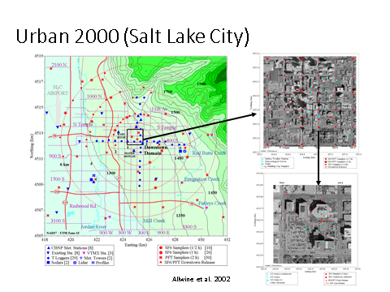
Figure 2: Study domain of the Urban 2000 , Salt Lake City field campaign (Alwine et al. 2002).

4.3 Joint Urban 2003 (Oklahoma City)
In Figure 3 I show the Oklahoma City Joint Urban 2003 sampler locations.
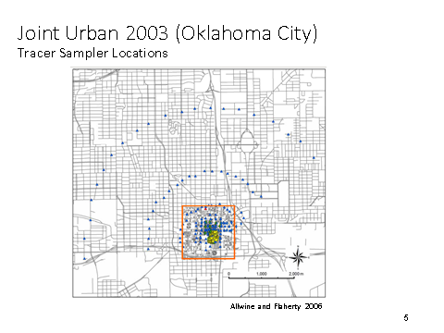
Figure 3: Joint Urban 2003 sampling locations. (Alwine and Flaherty 2006).

4.4 Madison Square Garden 2005
In Figure 4, I am showing the Madison Square Garden 2005 tracer sampling locations on the right and the met stations in the vicinity of the study domain on the left. You can see the meteorological data were collected over a large domain relative to the sampling domain because we wanted to capture the overall synoptic meteorology, the transition from water to land, and other relevant processes.
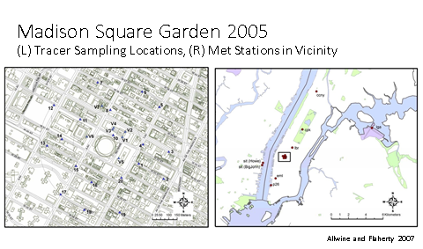
Figure 4: Madison Square Garden 2005 tracer sampling and meteorological monitoring domains.

4.5 Midtown Manhattan 2005
In Figure 5, on the left, you can see the surface sampler locations during Midtown Manhattan 2005. There were also a few samplers at roof top levels, which was discussed earlier. On the upper right is the same thing - the sampling locations on a larger scale. On the lower right is the met data which is similar to Madison square garden. Again, you can see we are sampling meteorological parameters over a larger area so we can capture the overall prevailing weather conditions.
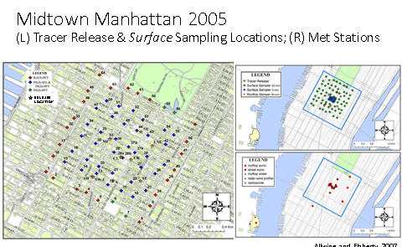
Figure 5: Midtown Manhattan 2005 tracer release and surface sampling locations *(Alwine and Flaherty 2007.

4.6 2015 Jack Rabbit II Mock Urban with Dense Gas Release
Jack Rabbit is a very unique field experiment, where we simulated an urban dense gas release of chlorine. Obviously, no one is going release significant amounts of chlorine in an urban area. In 2015, at Dugway Proving Ground, during the Jack Rabbit field experiment, we released between two to ten tons of chlorine. In Figure 6, you can see the storage tank, the visible chlorine cloud, and the gravity front captured about a half a second after the release. We are looking south in this picture.
In Figure 7 you can see the experimental site looking toward the north-west. This unique experiment was designed to simulate the conditions found in an urban area when there is a dense gas release. The containers were placed to create street canyon effects. There is a two by three container stack, called the Berkley Tower to simulate a multi-story building. It was instrumented to allow us to measure infiltration from outdoor to indoor. All the containers were heavily instrumented to measure the chlorine concentration inside along with the outdoor concentration. Jack Rabbit is a very good data source for indoor/outdoor studies.
Figure 6: Jack Rabbit 2 chlorine release, looking to the south. The chlorine tank and cloud are indicated with the red oval and the Berkley Tower with the blue oval.
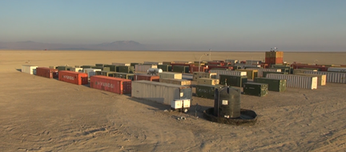
Figure 7: Jack Rabbit 2 chlorine release site looking toward the north-west. The Berkley Tower is indicated with the blue oval.

4.7 Tracers
Steve Hanna and I have a lot of experience analyzing field data sets and we were part of the design team for some of these programs,. Based on our experience we have some recommendations.
The first one is for the tracer source. The tracers that have been released in the previous urban dispersion programs have been SF₆ and perfluorocarbon tracers (PFTs). For the programs listed in Table 1, you can see that from Urban 2000 to Midtown Manhattan 2005, there were releases of SF₆ or PFTs, or both. PFTs have the advantage that you release 6 tracers in a single IOP. If there are 5 IOPs, you have 30 releases. This is a great data advantage even though the releases are not strictly independent. Of course there are also other tracers.

4.8 Source Considerations
The tracer release configuration depends on your research questions. We can configure the release to create a plume versus puff release, to release at surface versus an elevated release, to release the tracer indoors, outdoors, or both. We can release from a fixed location or from a moving platform such as a vehicle or aircraft, and the release can be neutral, dense, or/buoyant with respect to the atmosphere. Other considerations are selecting trial-specific release locations to maximize plume capture by the sampling array.
For example, an experiment to simulate a radiological dispersal device (RDD) would require a puff release, outdoors, at the surface, stationary, but buoyant. I believe that this type of field experiment has not been conducted. In Joint Urban 2003 there were puff releases, but they were neutrally buoyant.
To simulate a toxic inhalation hazard (TIH) the experimental design would consist of a plume release, outdoor, at the surface and stationary, but dense. We do not have any field experiments configured like this other than Jack Rabbit.
In Midtown Manhattan 2005, we had trial specific release locations to maximize plume rise and plume capture. Typically it is easier to move one release location rather than moving 100 or 200 samplers.

4.9 Tracer Sampling
Typically we use bag samplers. They are very reliable, but usually they collect samples over a relatively long averaging time, around 15 minutes. As analysts, we always want high frequency samples to determine plume arrival and departure times. I am not an instrumentation person and do not know if there have been any significant advance since 2005 in sampling technology. I don’t know if continuous sampling instruments have become much cheaper. In joint urban 2003 we only had 10 continuous samplers compared to dozens and dozens of bag samplers. An important question is: Are continuous samplers more practical now because of new technology?

4.10 Sampling network
Sampling networks are usually rectangular grids, or concentric arcs or both. They should be dense enough to determine horizontal cloud structure. With this design, you have to accept the fact that only 10 to 20 % of the samplers will be hit by the tracer cloud.
In some experiments, moving sampling platforms have been used. Sometimes vehicles or aircraft fly through the plume at a variety of distances downwind from the release. Data from moving platforms are valuable, however analyzing the data is difficult. A moving sampling platform requires using a Lagrangian time frame while stationary samplers require an Eulearian time frame. The Lagrangian time frame becomes a headache, at least for me personally.
Often, because we want a dense network horizontally, we forget about vertical data. I think determining the vertical concentration distribution is quite important. Others in this workshop have mentioned the importance of collecting rooftop concentration data. The vertical dimension has important implications because HVAC systems are typically located on rooftops in urban areas. In the case where you have an outdoor release and the plume is caught in an updraft, the material gets pulled into the building through air handlers. Vertically distributed samplers are also important for understanding vertical cloud structure.
Other techniques could be useful for exceeding low tracer concentrations. There are imaging techniques, for example for methane, but I am not sure these techniques are useful for low concentrations PFTs or SF₆.

4.11 Tracer Data Considerations
Documented QA/QC procedures and data are necessary to provide high confidence in the data. Detailed information on level of detection and level of quantitation are necessary and should be reported. We also need information on saturation if the tracer concentrations may be high enough to exceed the upper limits of the instruments. Saturation was an issue for joint urban 2003 and it was a major issue for Jack Rabbit 2015 and 2016. Saturation issues should be addressed in the planning stage rather during data analysis.
All the calibration procedures need to be documented in detail. Collocated samplers both horizontally and vertically are important. Duplicate samples at the same location help provide quality assurance. And, we need to have a sampler at the surface and when there is a sampler at on a rooftop. This is quite important to help with our understanding of the vertical cloud distribution. I think that is a major issue that we need to address.

4.12 Meteorological Sampling
Some of their major concerns have been raised in this workshop are the effects of terrain in the transitions from sea to land and to the urban environment. We need to collect momentum, heat, moisture, and energy flux data in addition to typical meteorological data. We need to have meteorological data on the horizontal and vertical gradients throughout the study domain and to characterize the transitions in the atmospheric boundary layers. There are multiple internal boundary layers that develop in regions of the transition from land, to marine, to urban environments. Detailed meteorological data from both horizontal and vertical profiles are necessary to capture the evolution of the boundary layer.
I think the community could learn a lot by talking with the people in the EPA that do regional air quality modeling. There have been a lot of regional air quality programs where horizontal and vertical gradient data have been collected throughout land/urban/water domains to characterize transition in atmosphere boundary layer and effects of land and sea breezes. We can learn from various regional air quality programs such as South Coast Cooperative Air Monitoring Program (SCCCAMP), Lake Michigan Ozone Study (LMOS), and Gulf of Mexico Air Quality Study (GMAQS).

4.13 Vertical profiles
Vertical profiles can be measured by carefully positioned towers, by radiosondes, by wind profilers (radar, SODAR, and LIDARLIDAR), and by radio acoustic sounding systems (RASS). Different profilers have different resolution and ranges. When we are considering which instruments to deploy, we need to consider the attributes of each instrument type.
The seasonal variation and the lack of sufficient seasonal information have been mentioned in the workshop discussions. Perhaps we can leverage existing network measurements which, by necessity, have less resolution than the instrumentation deployed in field programs. We have the data from intensive field campaigns that we can use capture local features and relate them to measurements on the larger scale. We need to leverage existing networks to capture seasonal variation because long-term high-resolution observations are probably unsustainable.

4.14 Some Outstanding Questions
Based on our experience, Steve [Hanna] and I have done a lot of model validation using the four urban experiments: Urban 2000, joint Urban 2003, MSG 2005 and Midtown 2005. We always try several different meteorological data sets when we run the models. We have not found any conclusive answer to the question: What is the preferred met input to an urban dispersion model so we will consistently get better performance? These meteorological inputs can be averaged over the whole sampling network, can be a single representative wind profile, or can be high resolution mesoscale model outputs, or be airport observations. Intuitively, you would think using high resolution meteorological input would give you better results, but that is not what we have found. Of course, I think that there can be many different answers. The next generation experiments need to be designed to address these questions.
We found vertical mixing is an important feature around and behind tall buildings in Madison Square Garden and Midtown Manhattan studies. We need to have more rooftop samplers. We also need to understand the wake cloud retention behind buildings, particularly in the case of parking garages as Ashkay mentioned. All these things have important implications for first responders.
And of course we have to gain a better understanding of the evolution of the boundary layer in coastal urban environments and, we all know that models are quite sensitive to the deposition that you assume.
Unfortunately, there is a lot of information we still do not know.

4.15 Discussion

Dave Brown
Joe, Thank you.
I do have a couple of comments and thoughts. You mentioned only gas phase tracers. SF₆ we all know and love, but it has some problems particularly in urban areas because of fugitive sources and because it is a significant greenhouse gas. However, it is very useful in certain areas. PFTS are really useful because the background is practically zero and, as Brookhaven has proven, we can measure down to background levels. You can release 7 or more at a time, but you really have to worry about cross contamination. This has been a real problem, but can be fairly easily solved by purification with distillation. The folks at DSTL have solved this and sent us materials for our last test in May of 2016 which worked out pretty well. The PFTs had less than a half percent contamination. If you have more than 3 or 4 % cross contamination, it starts to become very hard to de-convolve the tracer results. However, I think the cross contamination issue can be easily solved and should not be a real technical issue. The actual procurement of PFTs can also be an issue.
The direction of a lot of work we have been doing since 2008 has taken is the use of a particulate tracer. Unfortunately, in urban areas you cannot use the type of particulate tracers that you would like such as some kind of agent which was either biologically inactive such as BTK, or something that would mimic a bio-agent. DNA tagging of particulate tracers is the way simulate the release of solid biological particles that that do not evaporate. We had a lot of success a year and a half ago using a product developed at Lawrence Livermore called DNA Trax. This is a DNA tagged tracer in a mutldextrin substrate. It was more effective than we expected. These trails are sensitive, so I am not going to get into any details.
You mentioned deposition velocity. This is a major issue in the models. I have not found a lot of variability in the deposition results using outdoor models in urban areas, but I have found considerable variability in the results from indoor models because of the large deposition effects. Indoor deposition is something we need to understand. The only way we can understand indoor deposition is to use particulate tracers, with well-defined sizes, that we can detect with size resolution. That is the way we can resolve the deposition issue. Until we can understand this it is going to be difficult to develop and validate deposition in indoor models.

Michael Dillon
I was going to suggest that particle size resolved data and data on particles with other properties would be really helpful. I would add that human exposure measurements would also be useful to include in the next generation closure experiment. We have seen hints that there are multiple exposure pathways. We have been talking about the outdoor and indoor measurements, but actually looking at human exposure as people move through areas where there was a release and making sure that that models predictions are consistent with the measurements would be really useful. That has not been done in traditional experiments. I know that limited human exposure measurements were done in some of the New York programs, but we need to take human exposure data to the next level. This would be a worthy addition to the next generation experiments.

Tom Watson
There are a lot of improvements in PFT sampling technology. We have developed the next generation tracer samplers which are much better that the samplers we used in the Madison Square Garden and Midtown studies in 2005. They have a lot more features. They are much easier to use. We can program them remotely. And, we also 100 of them.
I wanted to speak just a little bit about the cross contamination. One of the problems with some tracer programs that have been done is the quantity of tracer that has been released. You can have cross contamination of a few percent, as Dave was referring to, in your primary tracer because the formulation reactions used to synthesize these compounds result in secondary products that are the same as the other tracers that you may be using. When you release large enough quantities of tracer, so you have 1000 times above your detectable limit, then cross contamination can be an issue, but when you are releasing quantities so the concentrations in the samples are from 10 or 100 times the detection limit, then it is not a problem.

Dave Brown
I understand what you are saying. I will just add to that for these types of tracer tests you really need 5 orders of magnitude of dynamic range in urban areas.

Tom Watson
This is really not a problem. Another thing we have done is to analyze the tracers when we get them and we can generally correct because we know the composition. But we can also purify them as well.

Dave Brown
Cross contamination is a problem with PFTs . It is a problem with some of the PFT compounds more than others. It is a problem that needs to be addressed. The problem is these things are not manufactured a lot so you are limited to one or two suppliers. If you are doing a big field test you might take the world’s supply, which we did once. But we release a lot more than typically released by BNL. The beauty of PTFS is that you can release 5 or 7 or even more compounds at a time. This really maximizes your test results but the releases need to be done carefully.

Joe Chang
I have a question for those who work in on field programs. Is there any existing mesoscale network where detailed meteorological data are collected both over water and over land.

Julie Pullen
The over water part is hard. It is especially hard to integrate over water data with land based measurements. Overwater measurements are usually part of intensive field campaigns unless they are measurements made on buoys.
In New York we do have an extensive mesonet.

Martin Schoonen
The New York mesonet consists of over 120 sites which are laid out in a grid over most of the state. It is now close to fully operational. There are also a number of enhanced sites that have more extensive instrumentation. A number of the enhanced sites are in and around New York City which provides a unique quantity of data. Maybe Pavlos can speak to the difference between the standard sites and the enhanced sites.

Pavlos Kollias
The New York mesonet is in the process of being established. It has two layers. A basic layer with about 100 stations across the state. These stations make a standard suite of measurements, like the ones we see in the Oklahoma mesonet. They consist of tipping bucket rain gauges, wind, and temperature, the common state variables. In addition there is another layer of 17 stations that have enhanced measurements with vertical capability. They have Doppler LIDAR which is important. They have ??? measurement and they collect data on the amount of liquid in the column. This is because these sites are focused on weather forecasting.

Julie Pullen
Do the enhanced sites also have flux measurements?

Pavlos Kollias
Yes, they make flux measurements.
Some of these stations will be in the Boroughs around New York City. I am not sure they are fully operational yet, because they are waiting to finish procurement and installation of some of the final instruments- but it will be finished quite soon. Also, the data from the enhanced sites the will be generally available.

Julie Pullen
They have soil moisture as well right?

Martin Schoonen
Yep.

Julie Pullen
That is a huge asset in terms of the commitment to put those out and maintain them at the state level.

Martin Schoonen
Then there are also other, smaller networks around the city. For example CCNY operates a meteorological network which has sites at several locations around the city. So, the state mesonet, the CCNY network, and several others measurement sites such as the weather service stations in Central Park, LaGuardia, and JFK can provide lots of different data streams, but they are segregated in different entities. I think getting all the data in one place is a bit challenging.

Pavlos Kollias
Brookhaven also has the capability to make 50 level measurement with the Mobile Wind Interceptor platform. We can deploy these assets in the city to enhance the existing mesonets and to couple the mesonet measurements with the street level.

Julie Pullen
We have been very impressed here with increase in the capabilities and coverage of the local and state networks. The CCNY-City college network, that Martin just mentioned, took over the stewardship of some of the assets that were deployed during the Urban Dispersion Program. Some of those vertical profilers now are still maintained as part of the CCNY network. Are there other regional networks that attending the workshop would like to mention?

Joe Chang
As I mentioned, meteorological measurements over water is a gap. Is that correct?

Julie Pullen
Yes, it is a huge gap and, just as you mentioned, we see lots of cases where internal boundary layers form from the influence of colder sea surface temperature when the winds are blowing from land. It is a dynamic ocean, and in the case of New York, there is the influence of river system so we have the effects of an estuary to contend with. We have not had a sustained measurement campaign across the land to sea interface.

Martin Schoonen
I think that there are some possibilities that DE has some assets that could be brought to bear on this.

Pavlos Kollias
We are experimenting with the use of drones because we have other groups at BNL and Stony Brook that use drones for ecosystem monitoring. There is probably another application using drones over the ocean. With drones there is more flexibility. They can be moved to get some measurements across interfaces and collect profile data. There is also the potential to develop an autonomous mobile buoy to make measurements. You could park in in the water and move it around to get measurements at various locations. It is something that we are looking at as a possibility.

Julie Pullen
There are also some other autonomous systems for water borne sampling that have been developed recently. There is the Wave Glider system and there is a company, Ocean Arrow, that has an autonomous vehicle called a Submarin. It is about the size of a surfboard and it can fold up and submerge to avoid detection and to also sample subsurface down to about 50 meters. It can be used to measure the boundary layer in the water as well. These are all types of platforms that should be part of the next generation suite of measurements.

5.0- What are the next-generation measurements needed to improve the Urban Dispersion data sets?

Pavlos Kollias, Center for Multiscale Applied Sensing, BNL/Stony Brook University

5.1 Introduction
I work with Brookhaven National Laboratory and with the Stony Brook Center for Multi-scale Applied Sensing. I am also part of the Department of Environmental and Climate Science at BNL.
The urban environment is arguably the most critical interface between humans and the atmosphere. There are many papers in the literature that point out that the urban regions are the least understood systems and the most critical interface between humans and the environment. Cities, particularly New York City, provide an ideal location for research using multi-scale applied sensing. You cannot find a better, more complex environment than a city.
That sounds like a really good story, but before getting excited about the complexity it is important to look for simplicity. Some of the discussion we have had so far is about how much of this complexity really matters. We know there are building effects. How well do I need to know the flows at various levels in the atmosphere? How many sampling points do I need to order to get meaningful information. How simple can we make our urban dispersion models?
Which type of model we should have to go forward? My background is in atmospheric remote sensing with a focus on the study of weather and clouds. The practice in this community is to use all types of models. All types of models are of interest and have value depending on the application.
For emergency response applications we need at something fast and simple. The question again is “How simple can it be”? In effect you can convert this question to “How reproducible are the results of dispersion experiments?” If somebody was providing you the wind at 2 km can you actually reproduce the same urban dispersion experiment ten times and get the same plume dispersion. If that reproducibility is not obvious, it becomes the role of the model to explain the variability.
How much of this complexity matters in predicting urban dispersion? Perhaps some critical measurements are all we need. Maybe there is this critical number of measurements inside the street canyons and in the vertical column that would be enough to explain most of the variability and describe how agents are dispersing in an urban setting.

5.2 How simple can we afford to make our urban dispersion models?
What are the critical measurements that explain most of the variability in dispersion models and observations? A key question for this review is whether dispersion patterns from local sources have repeatable characteristics in urban areas as they do over level terrain. If so, this would enable robust and easily computable formulae to be used for the most common situations. It is important to identify the physical processes that control dispersion in urban areas through measurement and detailed simulation, and then implement the representation of these processes in simplified practical models. In so doing we aim to identify when the different existing methods are appropriate and when new methods are required.

5.3 Street level conditions
I looked at the papers on urban experiments that were done in the US, but also in Asia and in Europe and, of course, I found something that has been mentioned already - the emphasis on the street level conditions. At the street level, we are looking at fast response wind data. Flux measurements, which have been mentioned several times, are one of the basic boundary conditions that need to be determined for any model. The fluxes are the forcing, where the energy for transport is supplied to the system.
Flux measurements can be made with a 3-D sonic anemometer and some kind of CO₂ or water vapor fast response sensor. Many of these instruments in have been deployed in previous studies conducted within the US.
There were about 120 tracer sampling locations in Oklahoma City (Joint Urban 2003) and about 80 tracer sampling locations in New York City (Midtown 2005). My comment here is that we do have this kind of capability, we do have the kinds of measurement systems necessary for this type of program, and these measurements have been made in previous experiments.

5.4 Fast response wind data
There is a need to characterize boundary conditions at the surface and at the mesoscale and all scales in between. The eddy covariance method provides measurements of turbulent fluxes of sensible heat, H₂O (latent heat), and CO₂. BNL has several fixed and deployable units capable of making these measurements.

5.6 Referencing height
If you look at the literature on measurements made after 2005, most of the efforts have taken place in Europe. There have been urban test beds in Helsinki, Finland, experiments in Paris, and a lot of coordinated effort across agencies in the UK, particularly in London.
Results from the Dispersion of Air Pollution and its Penetration into the Local Environment (Dapple) field program executed in London are very relevant to this workshop. The question that was posed in Dapple was, “What is the appropriate reference level where data should be collected to provide the necessary understanding of street-level flow, and its coupling to the flow aloft”? In other words, at what height do measurements have to be made to be able to predict the mean flow and turbulence within the street level?
In London, the typical building height is low relative to New York City or other major US cities. In London, there is the British Telecommunications Tower, which is about 10 times higher than the average London rooftop height. This is a unique and particular useful feature. Investigators can mount instruments on an existing tower and get measurements at a significant height above the rooftops.
The main outcome of this study, summarized in a number of papers published since 2009, is that the height where measurements can be made that relate to the conditions at street level are about 10 times higher than the average rooftop height. This work suggests, for London at least, measurements should be made at 190 m, 10 times higher than the average city rooftop height. The wind measurements at that level correspond to the mean flow at the street level and also identify where turbulence, wakes, and vortices form at the street level. The DAPPLE results support the use of a central reference site in London in order to inform air quality or emergency response management studies (Barlow et al., 2009)
Measurements at a reference height are necessary to predict the turbulence and stability of the urban boundary layer and to determine the coupling of the layer aloft to the surface. In any city, it is very important is that measurements aloft be connected to the conditions at the surface. Are measurements at about 10 times higher than the average rooftop height relevant for every city?. In other words, how coupled are the urban boundary layer and the urban canopy with the overlying boundary layer.
In order to determine the coupling you have to have thermodynamic information. You can get this information by measuring fluxes at multiple levels within the boundary layer. For example, by making measurements with balloon sondes - this would be quite risky in urban settings. Perhaps drones would be more practical than balloons under the proper regulatory control. Drones could provide you with thermodynamic information up to 200 to 300 meters. This is important because, for example in London, very rarely were the measurement at 190 m decoupled from the street level.
However, in Oklahoma City, that is not the case. In Oklahoma City there was often the scenario that above the rooftop level, the measurements were not related to what was happening on the ground. That raises the questions:
- What is the fingerprint of each city and in particular for a place like New York City?
- How consistent are stable/unstable regimes in urban environment?
In stable conditions, are the surfaces decoupled from reference level measurements. Such decoupling is rare in London but occurs frequently in Oklahoma City. What types of coupling apply to NYC?
The urban surface energy balance is different from the rural environment. Generally, the sensible heat flux is higher in the urban environment because of the man-made materials and increased surface area. The latent heat flux is lower because of a lower fraction of vegetative land cover. The urban surfaces have a higher thermal effect because of the high heat capacity of the man-made surfaces, leading to a non-negligible storage flux. Complex processes of shadowing and multiple reflections affect short-wave radiation fluxes. The wide range of materials affects the emissivity. Therefore, long-wave fluxes result in surprisingly in little difference in net radiation flux, and anthropogenic heat sources, in addition to the solar-driven energy balance, effectively increases the sensible heat flux. The urban surface energy balance drives not only the temporal evolution of the urban heat island (UHI), but also the evolution and vertical structure of the UBL.

5.7 System for Atmospheric Modeling (SAM)
The system for atmospheric modeling (SAM) is a collaboration with Dr. Marat Khairoutdinov of Stony Brook University. SAM is a very high resolution, Large-Eddy Simulation model, in which large turbulent grid scale eddies are retained and small, sub-grid scale eddies are modeled using Kolmogorov’s internal scaling. The models assume an incompressible fluid so there are no sound wave effects. Buildings are represented by solid grid blocks. The land model uses several types of vegetation and soil layers. It contains a comprehensive radiative transfer model and cloud/rain microphysics. The code is designed for execution on massively parallel systems.

5.8 Example simulation
Figure 8 shows the SAM simulation of winds at a height of 52 m on a 5 x 5 m horizontal and 2000 m vertical domain. The spatial resolution is 5 m and the time step time step 0.2 seconds. The period modeled is 33 minutes. The result is shown for a background wind at 5 ms⁻¹ from the west. The data were obtained using a 3 tracer sources released at 2.5 m height after 10 minute model spin-up. The model was run assuming stable, nighttime boundary layer. The simulation took 2 hours to run on a supercomputer with 1025 processors.
Figure 8: Example of SAM u, v, and w wind simulations across a 5 x 5km horizontal and 2000 m vertical domain in lower Manhattan.
The New York City skyline, up to a height of 200 meters, is dominated by buildings (Figure 9). The 190 m British Telecom communication tower would be lost in this image. There is not a structure which is 10 times higher than the average building height in New York City. Where is the reference height for New York City? Are we going to construct a tower? Obviously that is impossible.
The velocity profiles that this simulation contains a lot of information. There is significant variability that must be understood. Although New York City is in an environment somewhat similar to London, there are a lot of US cities which are in very different environments. These differences also need to be considered.
I will discuss technologies which have been developed used extensively in the last 5 to 10 years to capture the vertical information.
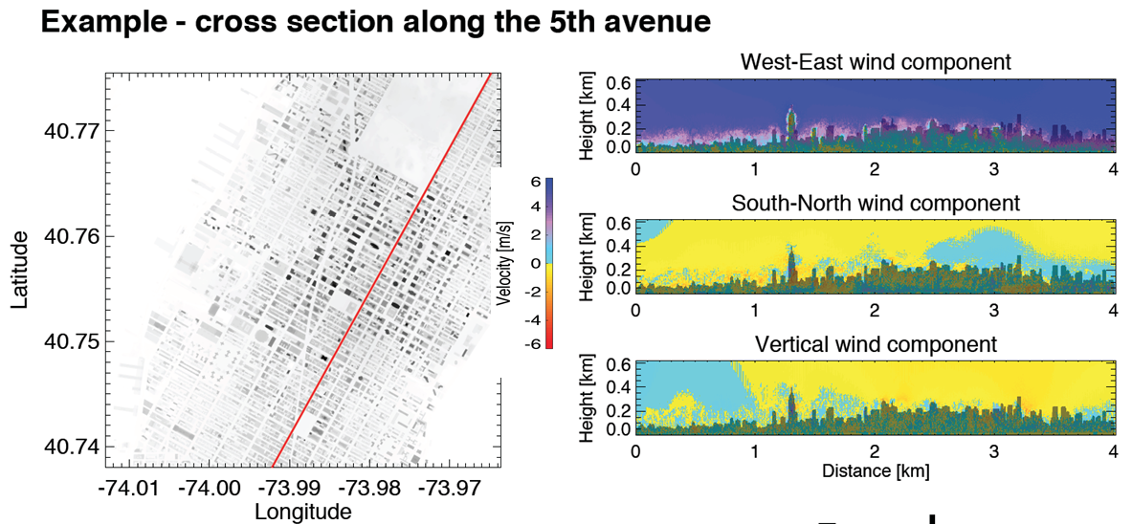
Figure 9: The red line on the left side indicates the position of the vertical sections. The right side shows the u, v, and w winds.

5.9 Wind retrieval from NexRad clear-air radar data
Some sources of the necessary data are the existing networks. One of the most sophisticated existing networks that the US has is the NEXRAD Weather Radar Network. There are about 160 NEXRAD weather radars in the United States. The weather radar network and other types of networks were never designed to provide information on the cities. They were put at a distance from cities because the purpose of these systems is to show conditions above the cities to create a 2-D maps so weather can be observed as it approaches populated areas.
Figure 10: Reflectivity, Doppler velocity, and radar echo classification from NexRad clear air data.
In Figure 10, you see a composite of four existing radars operating around New York City. The two at the extreme north and south of the spatial domain are weather radar. The weather radar on eastern Long Island is located on the Brookhaven Campus. The one farther south is in Philadelphia which is the second closest NEXRAD system to the New York City region.
You can see that vertical information is limited in the Nexrad network.
Pavlos starts an animation.
Radar reflections from biological targets of opportunity such as flocks of birds and insects can be tracked and analyzed to provide wind data. I have highlighted the biological targets. There are a lot of targets of opportunity above the cities.

5.10 Measurement gap: Turbulence and transport information is available at street level or a mile above
The yellow and blue lines in Figure 11 show the lowest height where measurements can be made with the NEXRAD radar relative to the skyline of New York City. The red and blue lines are the radar from the two air terminals at Newark and JFK. The airport radar can make measurements as low as 200-300 m while the weather radars providing information at about a kilometer and a half above the surface - almost a mile above the city. There is no vertical meteorological information directly above the city. This gap is not just over New York City but across the country. This gap is represented in the Logo from an NSF report by CASA Engineering Research Center for Collaborative Adaptive Sensing of the Atmosphere (www.casa.umass.edu, Figure 12 ). We are trying use emerging technologies to cover the gap, which means observing the weather where it really matters. Advances in remote sensing will fill the gap from street level to free troposphere.
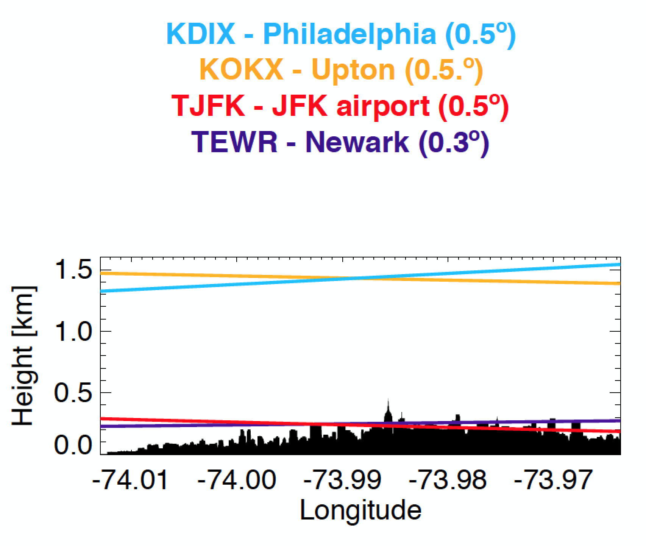
Figure 11: Vertical coverage of NexRad (yellow and blue lines) and Airport weather radar systems (purple and red lines).
Figure 12: Logo from an NSF report by CASA Engineering Research Center for Collaborative Adaptive Sensing of the Atmosphere emphasizing the gap in radar coverage in urban settings.

5.11 Wind retrieval from NexRad clear air data
In Figure 13, you can see a little more complicated image. In the first row you can see radar data on reflectivity. The images in the middle row are the Doppler radar data and the bottom row are the reflections from targets. The first column shows data from the Philadelphia NexRad radar, the second column the data from the Long Island NexRad, the third column data from the JFK terminal radar, and the forth column is data from the Newark terminal radar. The NexRad data are very coarse and often missing information. The quality of NexRad data are also seasonally dependent. It is easier to get wind data in the summer when there are more targets of opportunity – and harder in the winter. How do we fill this vertical gap?
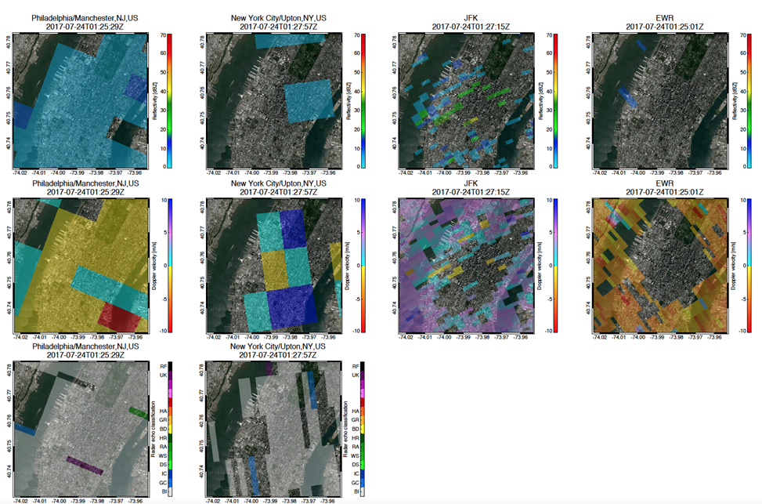
Figure 13: Examples of biological echoes (birds and insects) from NexRad radar.

5.12 NYU/Aerospace Hyperspectral Imager Pilot Deployment at Hoboken NJ
One of the methods of making measurements in the gap was addressed in a very nice effort from NYU and Aerospace presented in a paper published in the last few months (Ghandehari et al.). The first author is attending the workshop. This report is a very nice look at the lower atmosphere using a hyperspectral imager to map the location of different chemicals in New York City. This instrument used to make these images was located at the Stephens Institute of Technology in Hoboken. This is an emerging technology that has been demonstrated in NYC and in other settings and that can allow us to see beyond the rooftops.

5.13 Doppler LIDAR
Over the last ten years the researchers in Europe, and to a lesser in the US, have demonstrated that lasers and LIDAR can be used to get vertical meteorological information. LIDAR systems take advantage of the scattering from atmospheric aerosols to collect 3- wind and turbulence data. LIDARLIDARSs are portable systems. The Brookhaven Long range Doppler LIDAR system is shown in Figure 14. This system is manufactured by Halo Photonics and weighs about 60 Kg. It is easy to transport, easy to operate, is ready to use – essentially it is plug and play.
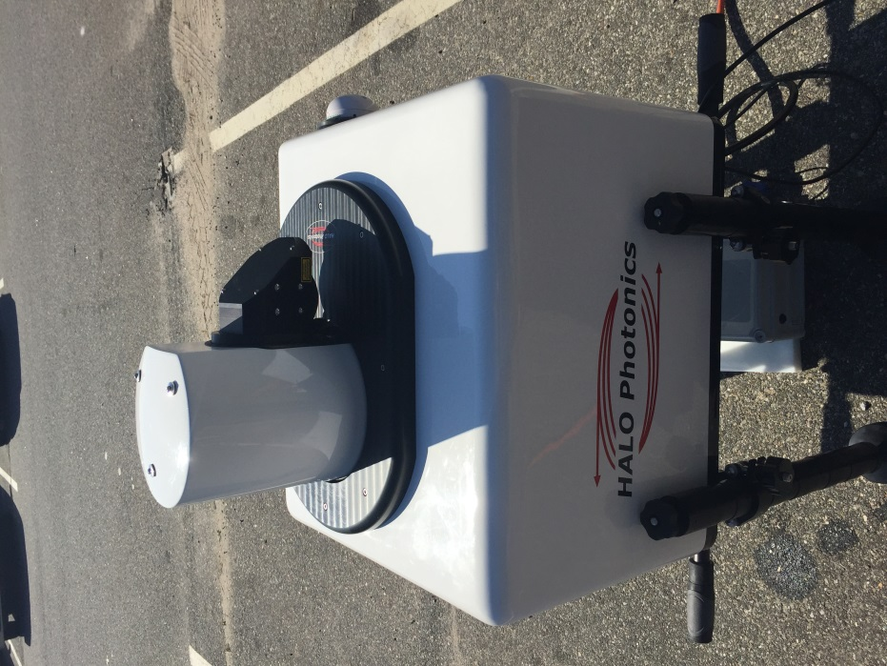
Figure 14: BNL long range Doppler LIDAR
One question that has been raised about Doppler LIDAR measurements is how well the data derived from these instruments correlate with the data collected with sonic anemometers. The plot in Figure 15 shows a one-to-one correspondence between the Doppler LIDAR data and that from a sonic anemometer.
Figure 15: Correlation plot of wind speed measurements made with Doppler LIDAR versus measurements made with a sonic anemometer.
Doppler LIDARLIDAR can reproduce the measurements that would otherwise require a tower. In addition, the Doppler LIDAR can collect wind profiles from 100 m to a few kilometers. It is effective until you run out of atmospheric targets, which is effectively at the top of the boundary layer.
Doppler LIDAR represents the state- of-the-art for vertical wind measurements during urban dispersion experiments. It is easy to deploy because it has a small footprint. These instruments have been used in Urban dispersion programs in the past. A Doppler LIDARLIDAR system was deployed for eight months in London as part of the DAPPLE program. There are several systems already deployed in New York City: CCNY has one and the New York Mesonet will have a number of LIDAR systems at the enhanced sites. There are many Doppler LIDAR systems that can be used to close the gap in the vertical meteorological data in the New York City area.
The scanning capability of these instruments makes it possible to determine the winds from configurations other than pointing the instrument vertically. The BNL radar and LIDARLIDAR instruments can be operated in a scanning mode to measure the u and v, winds from the surface to 100 m, and to several kilometers. The LIDARLIDAR can be directed like a laser pointer to scan along the streets and avenues. It has the extraordinary capability to provide vertical profiles of the winds in 2 dimensions and to resolve eddies moving within the urban canopy layer (Figure 16).
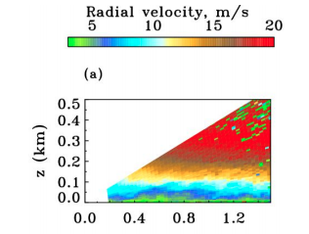
Figure 16: Vertical LIDAR scan in a street canyon.

5.14 BNL: Mobile Wind Interceptor
BNL in collaboration with Stony Brook and Raytheon is building the BNL Mobile Wind Interceptor. This a flat-bed truck (Figure 17) equipped with a Fast scanning (30-40 km, 1 sec) phased-array X-band radar with a dual polarization transceiver functionality and scan diversity. It is has a maximum range of 10-12 km. The synthetic aperture, or electronically scanning radar is being developed in a collaboration between BNl, Stony Brook, and Raytheon. We can actually deploy this smaller radar closer to the city which means that the signal is not limited by the curvature of the earth. This will enable us to measure winds closer to the ground, yet still obtain data on winds above the roof level, filling the data gap between the existing radar networks mentioned previously.
The advantage of phased-array, electronically scanning radars is that they require no infrastructure. Low-Power Phased Array Radar (LPAR) is an X-band phased-array, polarimetric system with a flat antenna and no moving parts. They can be deployed easily. It is an instrument about the size of a flat panel TV-something you can put in a small pickup truck and is can be moved to collect measurements in multiple locations. There are a lot of targets of opportunity that that give radar reflections in the atmosphere from the surface all the way to 1and a half or 2 kilometers. It is also possible to intentionally deploy artificial targets – chaff - if there are no targets of opportunity. As we saw in the case of the hyper spectral imager working with the infrared signals, there are plenty of targets of opportunity in the urban environment that will provide radar reflections that can be used to measure winds. These include anything from insects, to aerosols, or rain, or snow. There is no moving antenna, therefore is inertia in the system so it is capable of making rapid scans
The combination of the radar and LIDAR will fill the gap in the vertical dimension that been highlighted by several in several reports and not just within the urban dispersion community.
Figure 17: BNL Mobile Wind interceptor.

5.15 Remote Sensing: Filling the gap from street level to free troposphere
The urban environment is highly heterogeneous. Some of the complexity can be addressed by deploying a dense array of sampling stations at the street level. The key question is: What extent can the chaotic motions and dispersion that occur at the street level be explained with a limited number of measurement stations?
Perhaps the answer is in the vertical. It is likely that the connection between the vertical and the street level will not be resolved with a direct downscaling of a model. An understanding of the physics of the coupling is necessary. We need to understand the connection between the atmosphere above the buildings to the transport and dispersion occurring at the street level.

5.16 Multi-scale Measurement Strategy
A multi-scale measurement strategy is necessary to make sense of the connection between mesoscale meteorology and phenomena at the street level. Mesoscale measurements are made by weather radars, satellites, reanalysis, and upper air soundings. We need more measurements in the vertical dimension from street, and rooftop levels up to the free atmosphere. At the city scale, we need short range weather radars and in the vertical dimension we need scanning Doppler LIDARLIDARs. For measuring the thermodynamic properties such as thermal stability there are tower measurement systems and perhaps measurements from drones. At the street-level we need measurements of tracers and surface fluxes.

5.17 Discussion points
Next Generation Urban Dispersion Studies will require a coordinated approach. We will need to develop a dynamic network of networks. This will require a demonstration technology of the usefulness of emerging technologies and ultimately the standardization of measurements. We need to conduct long term baseline measurements as well as intensive observation field campaigns. Development of the cyber-infrastructure for collecting and processing the large amount of complex data that will be generated in the next generation experiments will be necessary.

References
Hart JK, Martinez K. 2006. Environmental sensor networks: a revolution in the earth system science? Earth-Science Reviews 78(3–4): 177–191.
Ghandehari et al., Nature, Scientific Report, 2017

Discussion

Martin Schoonen
Pavlos, when do you think that your mobile system will be ready to go?

Pavlos Kollias
The system is ready to go. Paul Kalb mentioned that they are putting a couple of weather stations in the city. The experience is that either at the city street level or at the rooftop, the ability to use these methods as a to determine the street level processes is limited.
The LIDARLIDAR is ready to be deployed in the city. Paul, could you talk a little bit about what your plans are in the city?

Paul Kalb
As I alluded to earlier in the meeting about meteorological towers in New York City, we are trying to answer the questions;
- How many meteorological stations do you need?
- And, where should they be located?
Based on the data we have collected in previous urban dispersion studies, we came up with a couple locations we felt were the optimal sites for meteorological measurements. We are moving ahead to install two met stations on building rooftops. But, to answer the questions about number of measurements and effective locations, this summer we will be deploying Pavlos’ mobile monitoring system in the city to do two things. One is to compare and validate the data from these permanent stations. The second is to use the mobile remote sensing platform to make measurements at different places in New York City from Manhattan to the boroughs. The purpose of this exercise is to determine exactly how the locally variability compares to the data we are collecting at the permanent, rooftop sites in downtown Manhattan. That will answer, beyond a shadow of a doubt, what the measurements needs are and will determine whether the two stations we are installing will provide the necessary data or if we need to build more permanent met stations. That is the plan going forward.

Jaime Benavides
I am becoming a modeler. I am doing a PhD developing an urban air quality model for Barcelona here in Spain. I have been lucky because we have some good meteorological and air quality data at the street level. There are not many points, but in three streets we have 2 months of data. I have been working on coupling WRF, the mesoscale meteorological model, with ADLINE, an American dispersion model for sources near roads. I have been adapting the WRF winds to the streets, simulating the channeling caused by the winds. Thanks to having data at the street level, we can calibrate and evaluate the model. The street level data has been very helpful in evaluating the modeling system. I would suggest that data at the street level on the wind conditions is necessary.
I have found in analyzing the data that even if the wind direction changes a lot, there are some patterns that are very distinct. For example in Barcelona we have the land sea breeze. When the wind is coming from the sea, in most of the streets, we have the same pattern. In Barcelona we have a highly structured grid in most of the city. I recommend collecting high resolution data at least in some streets.

Ron Basket
I have an observation based on modeling over 100 releases over IMAAC’s first six and a half years, it is extremely valuable to have more profiler data. I would say that I always would prefer one profiler to ten surface measurements. Thinking back I would even double or triple that. The value of a profiler is just fabulous in all settings regardless of whether it is urban or coastal – mountainous or flat. We rely on the MEDA system to collect profiler data. These data are primarily collected for the EPA. But then it would great if agencies could join together and enhance that network nation-wide.

Jaime Benavides
I can add the comment that the Doppler LIDAR have been a very reliable system for both urban research and weather research and have been used a lot in extreme environments from high latitudes to the tropics, in urban environments, and isolated islands. It is a very robust technology. It seems from my perspective the design of the next generation of urban dispersion experiments needs to include Doppler LIDAR measurements. Not a lot of assumptions needed to use the data. These instruments are easy to deploy, and data are easy to understand, the output is in a form that can be assimilated into the models.

Martin Schoonen
At one point we talked about having several of these systems permanently mounted at strategic locations on tall buildings in the city for example.

Pavlos Kollias
This is the future. The weather service has decided that 20 years from now the NEXRAD Radar and the terminal radar will be consolidated in the flat panel radar. However, this will not address the problem of observing the urban canyon or other areas of interest. If you want to address the problem of defeating the earth’s curvature you need to bring the radar closer to the city. It is difficult to find sites in cities, where real estate is expensive, for locating radar systems. These places require a flat panel.
We have been working with Raytheon to develop a test bed for the observing system of the future. There are a number of systems currently available that can be deployed for a demonstration project in New York City. There are at least four LIDAR systems that can be deployed in the city to show the feasibility and value of multiple systems and to provide a unique data set. A profiler or a Doppler LIDAR will provide measurements of the column. We can move the profiler or LIDAR to collect data at multiple locations. The LIDAR and radar in combination are complementary systems. The radar samples over the whole dome of the city, so it provides another level of information.
The value of these instruments and measurements needs to be demonstrated. The technology is there. We know how to analyze the data. It is a matter of discussing the value of having this high resolution data and implementing a measurement program.

6.0 How do we implement the next generation urban dispersion experiments?

William Schulz, Office of the Federal Coordinator for Meteorological Services and Supporting Research (OFCM), NOAA

6.1 Introduction
This will be a different presentation. It won’t be a technical talk.
I want to do this in two parts:
- Part 1: What is Office of the Federal Coordinator for Meteorological Services (OFCM) and the Federal Weather Enterprise (FWE) coordinating Infrastructure?
- Part 2: How can this community leverage OFCM to make progress on Urban Dispersion Experiments?
First, in part 1, I will explain what OFCM is and what we do within the Federal Weather Enterprise. Then, I will present part 2, where I describe how I think OFCM can help the urban dispersion community leverage the available resources to plan and execute the next generation urban dispersion experiments.

6.2 Coordination: Mission and Vision
OFCM manages a coordinating infrastructure. It does not control money or grants, nor does it set priorities for research or operations. OFCM does administer an infrastructure of formal, documented committees, working groups, conferences, and other ways for people to meet on a regular basis to promote collaboration among agencies with a stake in areas related to Federal meteorological services and research.
We aim to raise the right issues, with the right people, to advance the right goals.
We bring 15 agencies together to facilitate a well-coordinated Federal Weather Enterprise serving the needs of the nation. Our mission inside the OFCM is to foster and encourage systematic coordination.
OFCM started as a budget aggregator, and evolved into an agent to promote interagency effectiveness. There was a law in 1962 that assigned to the Bureau of the Budget the responsibility to report on the expenditures of the six agencies involved in meteorological services and research.

Public Law 87-843, Section 304 (1962)
“The Bureau of the Budget shall provide the Congress in connection with the budget presentation for fiscal year 1964 and each succeeding year thereafter, a horizontal budget showing (a) the totality of the programs for meteorology, (b) specific aspects of the program and funding assigned to each agency, and (c) the estimated goals and financial requirements.”
In the 50 years since OFCM was founded its mission has expanded. We were mentioned this April when the Weather Act was signed into Law. In this legislation we are directed to work with Office of Science and Technology Policy (OSTP) to continue the coordination of different weather agencies in the Federal Government to advance weather research and services.

Public Law 115-25, Section 402 (2017)
“The Director of the OSTP shall establish an Interagency Committee for Advancing Weather Services to improve coordination of relevant weather research and forecast innovation activities across the Federal Government…The Federal Coordinator for Meteorology shall serve as co-chair of this panel.”

6.3 OFCM is administered within NOAA
We are an office within NOAA. We are not part of the NOAA line offices: the National Weather Service or the National Ocean Service. We are off to the side of the NOAA headquarters organization (Figure 18). We work with the chief of staff and some of the assistants trying to get most of the line offices in NOAA and other federal agencies to come together.
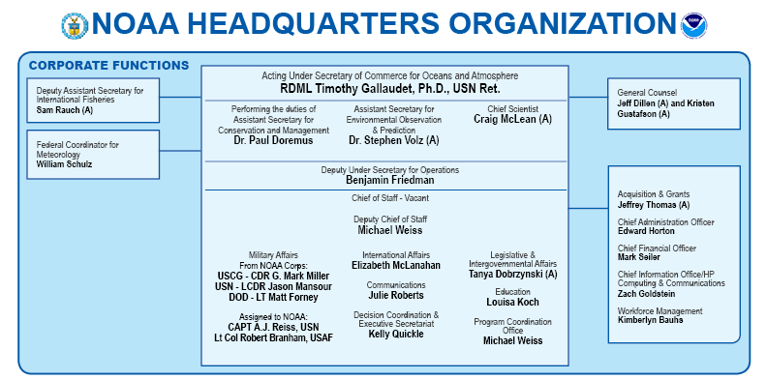
Figure 18: NOAA headquarters organization chart. OFCM is indicated by the red oval.

6.4 We facilitate inter-agency efforts of the Federal Weather Enterprise (FWE)
These are the agencies that are part of the federal weather enterprise that OFCM coordinates with.
- Agriculture
- Commerce (NOAA)
- NWS
- NESDIS
- OAR
- Defense
- USAF/USA
- USN/USMC
- Energy
- Homeland Security
- Science & Technology
- FEMA
- Coast Guard
- Interior
- USGS
- BLM
- State
- Transportation
- FAA
- FHWA
Independent agencies:
- Environmental Protection Agency
- National Aeronautics and Space Administration
- National Science Foundation
- National Transportation Safety Board
- Nuclear Regulatory Commission
Executive Office of the President:
- Office of Management and Budget
- Office of Science and Technology Policy

6.5 Administrator of the FWE Coordinating Infrastructure
The FWE Coordinating Infrastructure has two levels. Figure 19 shows the different committees and groups that we administer. Each of these committees draws its membership from three to fifteen agencies.
The Federal Committee for Meteorological Services and Supporting Research (FCMSSR) is a senior level committee that meets twice a year in April and October, and consists of representatives from the departments (Figure 19). The NOAA Administrator is the permanent chair. This committee determines policy.
There is also a working level committee, the Interdepartmental Committee for Meteorological Services and Supporting Research (ICMSSR). This committee has broader representation among Federal Agencies including the NOAA National Weather Service, Ocean and Atmospheric Research, and the different military services. This committee meets every three months.
Both of these committees consist of representatives from the independent agencies and they are both attended by representatives of the executive office of the president, particularly from OMB and OSTP. I think that that is where a lot of the value comes in to these meetings. When you come to an OSTM organized meeting your message is heard by people that are setting policy and controlling funds.

6.6 Federal Committee for Meteorological Services and Supporting Research (FCMSSR)
The FCMSSR “Provides a formal mechanism for interagency coordination on implementing national policy relating to, and developing plans and procedures for, cooperative federal agency efforts in the development, acquisition, continuous operability, and increased effectiveness of meteorological services for the Nation. These services include observation, data sharing, analysis, prediction, dissemination of operational weather and atmospheric information, and the developmental research that supports these services.”
Some of the issues before the FCMSSR are:
- Strategic Guidance on coordinating the Federal Weather Enterprise
- Guidance to FWE on executing portions of the Weather Act of 2017
- SENSR is the Spectrum Efficient National Surveillance Radar committee and is managed by SENSR and JPO. FCMSSR is maintains awareness among its members of requirements, development and funding issues relating to SENSR.
- ESPC – National Earth System Prediction Capability; support of long term/resource intensive hardware and coding requirements

6.7 Interdepartmental Committee for Meteorological Services and Supporting Research (ICMSSR)
At the next level in the hierarchy there are three groups with senior level members. The ICMSSR is the quarterback for the whole Federal Coordinating Committee infrastructure and consists or representatives all the individual agencies with a stake in federal weather research.
To give you an example of the level of people that meet with that group, the director of the NOAA, National Weather Service (NWS), Lou Uccellini, is on this committee, as are the director of Oceans and Atmospheric Research (OAR), the director of the National Environmental Satellite, Data, and Information Service (NESDIS), the Oceanographer of the Navy, and the director of Air Force Weather. It is a made up of senior level managers.
There are two committees are equally senior groups but made up of a much smaller cross section of the agencies:
- The NEXRAD Program council is made up of the three agencies concerned with the weather radars.
- The Earth System Prediction Capability (ESPC) Executive Steering Group focuses on long range modeling, improvements in computer hardware that are anticipated. It is made up of representatives of three agencies.
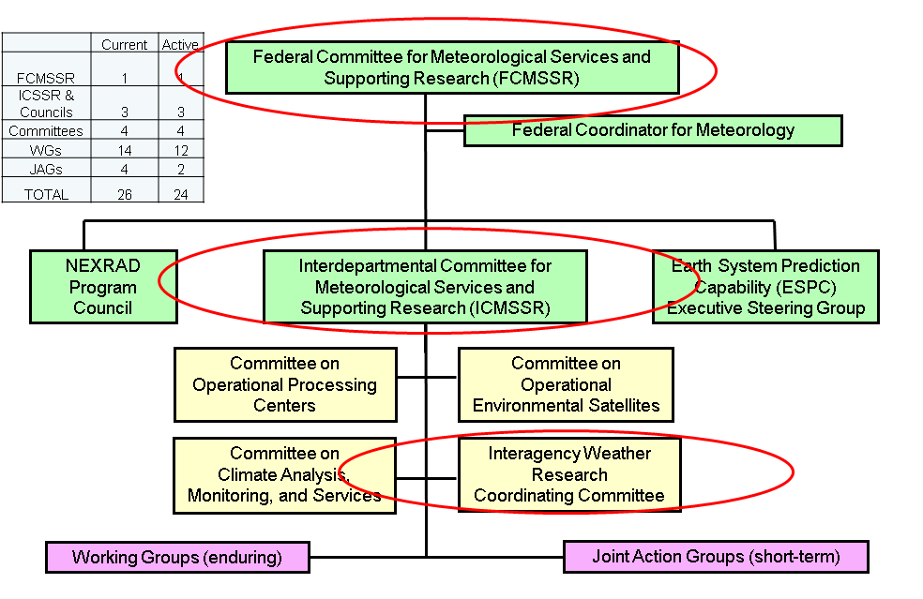
Figure 19: Federal weather Enterprise coordinating infrastructure.
The ICMSSR has four sub- committees with different responsibilities:
- The Committee on Operational Processing Centers consists of representatives of the five numerical weather processing centers that feed the national grid for weather products. These are NCEP (NOAA in College Park) and the military agencies: the Air Force Navy forecasting centers.
- The committee on operational environmental satellites has representatives from all the agencies that manage and buy satellites. This committee discusses coordinates satellite coverage, coverage gaps, and long range plans for satellite launches.
- We have a committee on planet modeling and monitoring.
- And there is the interagency Weather Research Committee.
Each of these groups deal with more specific issues in their domains as they arise. When this occurs, working groups or a joint action groups are formed to address specific problems.
The groups that I have indicated in red in Figure 19 are the committees that I think that the urban dispersion community should engage. Certainly, if you get the attention of the FCMSSR and the ICMSSR you have the senior level people in the agencies that make decisions aware of your plans. When budget time comes around they have would be aware of urban dispersion as they are deciding where to allocate funds.

FCMSSR, ICMSSR, Inter-Agency Weather Research Coordinating Committee
The Interagency Weather Research Coordinating Committee (IWRCC) is a fairly new addition. It was organized to coordinate US response to more World Meteorological issues, but is branching out to be more of an all topics weather research coordinating committee.

6.8 FCMSSSR agenda Item: Strategic Plan
Last month, for the first time in its 50 year history, the FCMSSR released a strategic plan. The plan specifies 6 areas that the senior leaders of the weather agencies in the federal government want to collaborate on.
“Through interagency collaboration and cooperation, including both formal and informal partnerships:
- Improve the resolution, frequency, information content, and sustainability of global observing capabilities.
- Make federal forecasting processes more resilient for all relevant time and spatial scales.
- Ensure availability of effective and consistent decision-support products, information, and services.
- Conduct productive, synergistic interagency research efforts.
- Develop, recruit, and sustain a diverse federal weather workforce.
- Coordinate messaging about FWE priorities and needs.”
I think the urban dispersion modeling speaks to elements of items 1 through 4 of the 6 strategic planks.
There was an earlier comment on one of the workshop presentations about how the models are interpreted. This parallels something that we are working on in the hurricane forecasting realm. NOAA is realizing that the probability cone that is released to communicate likely hurricane landfall has not been interpreted consistently by the public and emergency managers and has decided that it is time to take a hard look at how it is presented. NOAA and other agencies are looking to social science to improve how products are presented. We want to make sure that the technical information in our forecast is correctly interpreted by the emergency managers.
I think that this type of analysis is probably applicable to urban dispersion model products as well.
The fourth strategic plank “Conduct productive, synergistic interagency research efforts” is an obvious concern for a lot of agencies. You don’t want to duplicate efforts, but you do want to have .partnerships that benefit multiple stakeholders.

6.9 The Weather Act of 2017
The weather act of 2017 is a law that requires agencies to work together on meteorological services and supporting research. OSTP, as well as NOAA, are responsible for ensuring this coordination. The Act formalizes the structure:
“(a) Establishment
The Director of the Office of Science and Technology Policy (OSTP) shall establish an Interagency Committee for Advancing Weather Services to improve coordination of relevant weather research and forecast innovation activities across the Federal Government. The Interagency Committee shall—
- include participation by the National Aeronautics and Space Administration (NASA), the Federal Aviation Administration (FAA), National Oceanic and Atmospheric Administration (NOAA) and its constituent elements, the National Science Foundation (NSF), and such other agencies involved in weather forecasting research as the President determines are appropriate;
- identify and prioritize top forecast needs and coordinate those needs against budget requests and program initiatives across participating offices and agencies; and
- share information regarding operational needs and forecasting improvements across relevant agencies.
(b) Co-Chair
- The Federal Coordinator for Meteorology shall serve as a co-chair of this panel.
(c) Further coordination
“The Director of the OSTP shall take such other steps as are necessary to coordinate the activities of the Federal Government with those of the United States weather industry, State governments, emergency managers, and academic researchers.”

6.10 ICMSSR
I will talk later about how the urban dispersion community can leverage this whole organization, but the ICMSSR is probably key to engaging the federal weather enterprise with your community. This is a group that meets quarterly and is composed of senior managers from agencies such as the heads of the National Weather Service, Navy Oceanography, Air Force Weather, and senior people from NASA and NSF. This committee makes up the primary executive level - and by executive level I mean the managers directing execution of the OFCM policy decisions.

6.11 ICMSSR Recent/Current Issues
The ICMSSR is implementing the strategic plan. It has the task of tracking spending. It generates the report that goes to Congress every year. The committee meets quarterly in February, May, August, and November. There is a rotating chair who serves a one year term. The current chair is Craig McLean (NOAA/OAR). The Federal Coordinator is permanent vice-chair, currently Bill Schulz. The ICMSSR “[Serves as] the primary Executive-level management body of the Federal coordinating structure”. The ICMSSR provides advice to OFCM, implements FCMSSR policies, and oversees the committees and working groups that address the full range of meteorological services and supporting research.”
Some of the ICMSSR current concerns are:
- Strategic Plan for Federal Weather Coordination
- Federal Weather Enterprise Budget and Coordination Report – new format implementation
- Satellite data coverage gaps and plans to mitigate
- Operational Processing Centers interoperability (e.g. security protocols, data latency, continuity of operations)
- Disaster Impact Assessment coordination (NSF RAPIDS participation)
- Observing Systems effectiveness and conformance to WMO coding format updates
- Managing the satellite data gaps,
- Determining how the operational processing centers, the centers where the numerical modeling is performed, are working together and establishing continuity of operations.
- Disaster impact assessment coordination is an area the ICMSSR has recently begun to focus on.
The last bullet is related to urban dispersion modeling. Disaster assessment means coordinating the efforts of a lot of organizations such as academic institutions and federally funded research centers. These entities swarm the beach when hurricanes come. They set up mesonets and micro-nets, and they collect all kinds of observations as a hurricane comes ashore resulting in a short term high resolution data set. OFCM manages this effort to make sure everyone knows who is going where, what kind of data is being collected, and most importantly alert the National Centers for Environmental Information (NCEI) this data is being collected. The information centers know the data are being collected and can use them in real time. A secondary effect of this coordination is that these collective data sets are available and their existence is well known. This facilitates research efforts.
And the last issue – The ICMSSR is working with multiple agencies on their observing systems to make sure they are compliant with WMO coding formats as they are collected as outlined in the Strategic Plan for Federal Weather Coordination.

6.12 Interagency Weather Research Coordination Committee (IWRCC)
The last committee to highlight is the Interagency Weather Research Coordination Committee (IWRCC). The IWRCC “Promotes and helps to coordinate basic and applied U.S. research activities aimed at a better fundamental understanding and improved prediction of high impact weather with a potential for future socioeconomic and environmental benefits, including applications in support of weather-sensitive decision making at Federal, State, and other agencies” and provides a forum where “agencies can best leverage efforts among themselves and in the international community to achieve agency goals”. In particular, IWRCC helps to map U.S. agency weather research priorities onto The Observing System Research and Predictability Experiment (THORPEX) legacy projects; articulate US interests in the execution of WMO/WWRP projects, and explore and engage with new national and international weather research initiatives associated with the legacy projects.
This committee is made up of representatives of Navy, NOAA, NSF, and NASA. It was formed to leverage the existing tropical cyclone data collection efforts in the western Pacific and to be a coordinator for US research efforts in support of the World Meteorological Organization initiatives. It has expanded in scope and become a vehicle where the managers and program managers from multiple agencies with common interest certain research topics can get together to talk about what they are doing what and how they may be able to create synergy by coordinating their efforts.

6.13 IWRCC Recent/Current Issues
- Coordinate US research community response to World Meteorologial Organiztion (WMO) issues (e.g. Grand Challenges)
- Address Weather Act 2017 directives on coordination of research priorities
- Improve interaction among Program Managers in disparate agencies working related issues.
- Establish Science Working Group including academic and foreign (Environment Canada) members
The last bullet I included because one of the caveats of working with OFCM is we are exclusively federal. We get Federal agencies together to talk about plans. We really just talk to the Federal Managers. Contractors do not generally sit at the table because they have to operate under Federal Advisroy Committee Act (FACA) standards. With this group, we are starting to find ways around that issue. We are working with our lawyers and our international affairs people. We have representatives from Canada in this group as well. We can have other international partners in these meetings. NOAA NWS has multiple international partnerships that are one off separate agreements. We are trying to a more inclusive way to work with our international partners in this committee which I think is a benefit for the Urban Dispersion Group.

6.14 Part 2: Urban Dispersion Workshop
How can this community leverage OFCM to make progress on Urban Dispersion? The OFCM provides a forum to raise an issue within the Federal Weather enterprise. The OFCM is where the principle decision makers convene to make policy.
How do we implement the next generation urban dispersion experiments?
The first step is to build awareness at higher levels. The leadership must be kept informed. The Urban Dispersion Community needs to let the FCMSSR and the ICMSSR know what is going on. The FCMSSR has to approve OFCM Involvement. Because of all the agencies that have a stake in Urban Dispersion Modeling this would not be a difficult sell. This means making presentations, at:
- IWRCC – Visibility among leadership of research organizations
- ICMSSR – Gives OFCM authorization to establish a Working Group
- FCMSSR – Newly tasked with budget prioritization duties
The OFCM has a large influence on the agendas of these groups.
So, if we go that route and the ICMSSR is on board, the next step is to organize under the federal weather enterprise infrastructure. That usually means is establishing a working group.
Inside the working group you can have multiple program managers, working projects with complimentary objectives and resources. The advantage of this is that it gives you a routine opportunity to touch base and see what everybody is doing. The real benefits follow when everybody is standing around talking before and after the meetings. This is where the synergistic effects start to take place.
Demonstration of cooperation or intent to cooperate is favorably viewed by OSTP, OMB. Coordination is always something they emphasize. We can point to a couple of different topics like satellite purchases and satellite deployments where the general accounting office (GAO) has released reports stating that the agencies should have coordinated better or that they coordinated very well. And if your bosses can show that they are coordinating, they tend to be a little bit happier.
I think that one of the ways to do this would be to establish an Urban Dispersion working group under the ICMSSR realm. When we do that we generally want to have a chair or co-chair who is from one of the external agencies not from the OFCM shop, but someone who is a technical expert and a leader in the field that can help bring this together. The leg work would be done by OFCM. We send the emails that nag at everybody so the modelers and everybody can still be friends and if you want hat anybody you can hate OFCM. Once this gets going, the real way to make it valuable is to keep ICMSSR informed. You don’t report every three months, but every six months, and certainly, every year would be valuable. The ICMSSR needs to know what you are working on and that you are working together. ICMSSR members begin planning their budgets two to four years in advance. You want them to have a favorable impression of what you are doing. Those intangibles seem to go a long way.
After the Urban Dispersion Working Group is organized under the FWE umbrella, the working group would organize workshops, exploratory meetings, and conference sessions to identify funding sources and collaborative areas and to develop proposals that leverage multiple agency funding sources. The demonstration of cooperation or intent to cooperate will be viewed favorably by OSTP, and OMB
This community should establish a working group consisting of FFRDCs and Federal Agencies drawing the Chair and Co-Chairs from the project community. OFCM would provide an executive secretary. The working group should hold regular meetings and establish work plan. There are opportunities to keep leadership (ICMSSR) informed at their quarterly meetings.

6.15 Points to raise in the “pitch” to leadership
The need to develop the next generation urban dispersion experiment is a pretty good story to pitch to the ICMSSR. The urban dispersion community is already well established. Any new efforts will build on a history of solid science (Table 2). You can present the goals of the planned experiments and can make the case why the next generation urban dispersion experiment should be organized as part of the Federal Weather Enterprise. There are multiple agencies with similar goals. DOD, FEMA, as part of DHS, DOD, agriculture, commerce, and others are interested in improving urban dispersion models. Another driver is these experiments are expensive and require an intensive effort. They are too big for one agency to do by alone. All of these reasons make urban dispersion research a good area for interagency coordination.
There are many questions of interest to the Urban Dispersion Community that need to be answered. Some were discussed here today. An important question raised earlier was: What is the value in establishing a meteorological micro-net? Can we prove that it is worth doing? Another relevant question is: How do we evaluate the dynamic interaction of models? These are interesting questions and efforts to answer them would resonate with the ICMSSR.

Table 2: a partial summary of previous urban dispersion experiments.
Experiment | Location | Period | Release/downwind
St. Louis | St. Louis, MO | 1963-65 | Ground / 16km
Copenhagen | Copenhagen, Dk | 9/78-9/79 | 115m tower / 6km
Urban 2000 (DoE) | Salt Lake City, UT | October 2000 | Ground, elevated / 6km
Los Angeles | Los Angeles, CA | 2001
Barrio Logan | San Diego, CA | 8/21-31, 2001 | Ground / 2km
Birmingham | Birmingham, UK | 2002 | Ground, elevated
PHYSMOD 2003 | Basel, Switzerland | 2003 | Ground, elevated
Joint Urban 2003 (DHS) | Oklahoma City, OK | 2003 | Ground
DAPPLE | London, UK | Nov. 2004, 2007 | Ground, elevated & mobile
BUBBLE | Copenhagen, Dk | July 2004 | Roof/1.6 km
MSG05 (DHS) | New York City | March 2005 | Ground / 400 m
You must address the question Why is now the time to do this? One of the answers is that there are a lot of new sensors. These sensors are better and cheaper than they were 10 to 12 years ago and will provide better results obtained in previous experiments. Increases in model resolution and data handling capacity, decreases in sensor deployment costs, and improvements in sensor technology from years ago suggests valuable, improved results possible with a new generation of urban dispersion field programs.
Some of the goals of the next generation experiment I have compiled are:
- To develop a better understand 3D transport and diffusion around buildings;
- Analyze and understand urban turbulence during night and stable conditions
- Develop models and parameterizations for models
- Evaluate utility of 3D profiles
These goals are applicable to multiple agency missions and require coordination. Urban dispersion is a complex subject. The necessary effort will require basic research through development of operational capabilities. This research will be expensive and require an intensive, coordinated effort.

6.16 Recommendations
My recommendations for organizing the next generation experiments through the OFCM are:
Organize an exploratory meeting to discuss framework of a series of experiments. This meeting is a start.
- Designate a Chair.
- Establish meeting schedule
- Develop a plan of action.
- Brief ICMSSR (meets in November, February, May, and August) and gain authorization to establish a working group; have an ICMSSR agency representative introduce.
OFCM provides executive secretary services. We do the annoying things that you, as scientists, do not want to do. OFCM assists in drafting Terms of Reference, keeping ICMSSR apprised of Group actions, tracking the status action items, and maintaining a regular meeting schedule. OFCM services include conference rooms in Silver Spring, hosting conference calls or GoToMeeting connectivity, preparing Records of Action from the meeting minutes, tracking action items, providing web site assistance, maintaining group email lists and rosters, and driving a regular interval of meetings.

6.17 Discussion:

Martin Schoonen
I think that the path that Bill laid out is very appealing because right off the bat it brings all the agencies together in a framework that is already well established. I think that there is enormous value in that. I think what we need to do is to have one or two of these types of virtual meetings. We have 30 or 40 people that are involved in this workshop. The next task is to form a smaller group that can implement the path that Bill laid out. I think it is worthwhile thinking about.

Tom Watson
Bill, do you think that we need to get a subset of people and have a meeting with your office?

Bill Schulz
I think that that is probably the next step. It would be good to identify people from at least three agencies for the working group. You should probably get six or seven people together as a steering group first. That group can lay out a path forward, what the size of this group should be, and what agencies should be involved. Then we can make invitations and hold one or two meetings. Then we can draft a white paper and presentations outlining a plan and present that to the ICMSSR.

Julie Pullen
How many working groups do you have right now and is there any overlap with these topics?

Bill Schulz
Right now if you count the joint action groups and the working groups we have about 20. Which sounds like a lot, but a year ago we had 44. We have been culling the heard. We do this quite a bit.

Julie Pullen
Are there any topics that overlap with these? Are there any types of groups that already exist that this group could be talking with?

Bill Schulz
That is an interesting question. Off the top of my head I don’t see one group in our current structure with a mandate that would encompass urban dispersion modeling. Your community is a unique group. There might be overlap when you get down to specifics like standardizing data formatting, which actually might save us some work. I don’t see right now that this effort would dovetail easily with the existing working groups.

Martin Schoonen
Bill, let me throw something out just for kicks here. We have the GMU meeting, which is usually in June. If we were to organize ourselves between now and June and after the GMU meeting or before the GMU meeting we could have a meeting at Bill’s shop in Silver Springs. That might be a way to think about this in terms of a timeline.

Bill Schulz
I think the GMU meeting in June is probably a good target.

Martin Schoonen
Realistically, there is not going to be much happening between now and the end of this year. We now have a core group that has been interested in urban dispersion research and there are probably other researchers that would be interested in participation. We have more than agencies participating in this workshop. If we were to gather our thoughts and send it back out to the group and by the end of have another virtual meeting before the GMU meeting in June.

Tom Watson
We have recorded all the presentations and comments made at the workshop. I will work on a report based on these discussions and send it out to the participants for comment. Then we can see about identifying a few people - maybe getting some volunteers - so we can start to form a steering committee.

Julie Pullen
We should take a look at how some of the existing working groups organize themselves in terms of the documents they put together.

Bill Schulz
I can make some terms of reference as examples.

Martin Schoonen
Any other people have thoughts on this?

Joe Chang
I remember in some of the documents that Tom sent he mentioned about possible writing an article for AMS. Is that still part of the plan?

Tom Watson
I would like to make the report into an article after I write the report. I think it would be valuable to have an article to communicate with members of the community that we haven’t reached already and to have a plan that has credibility of a peer review..

Martin Schoonen
I think we should look collectively at people who should be involved in this but weren’t in this meeting today. We should send around the list of participants. Pavlos had a conversation with NFS at one point. I am not sure if anybody from NSF was on this call, but there are other agencies that might have an interest in this and need to be made aware of it.

Pavlos Kollias
There has been a lot of coordination in Europe. In the last Bulletin of the American Meteorological society there was a three page article on what an urban meteorological network should look like, what characteristics this type of network should have, how it should be operated, and its objectives. They have a plan. They are a bit ahead of us in organizing a coordinated effort. I think that this document could be a start. Tom can circulate it, we can get some feedback, and maybe have another meeting in midwinter.

Wayne Boulton
I do think that there are other communities that could help with other information. Most of the cities in which one might consider doing a field study will likely mandate, as part of their building code requirements, that pedestrian level wind studies be made, either through fluid dynamics simulations or through wind tunnel experiments, to predict the effects of new construction. Many building codes require an analysis of wind fields at the urban streetscape level. It is quite possible that, for the vast majority of locations that you might consider for field experiments, dozens of studies of micro scale wind flows a specific urban canyon may already exist. These studies haven’t been done from an air quality or urban dispersion perspective, but nonetheless, they may be an additional data source that would be of interest when validating models or even when siting monitors within that urban core. I think that there might be an awful lot of information available to the community just by expanding that community and bringing in other resources/ The building departments, the planning departments will have that information.

Terry Sullivan
I have a general comment. What I have seen today is something that we need to focus on and develop. What are we trying to accomplish. I have heard two areas discussed today. One of the areas addressed was the overarching urban dispersion modeling needs; and the other is emergency response modeling. We started off with emergency response and moved into urban dispersion modeling. Those are two different questions. Those are two different sets of models and two different sets of responses.

Appendix 1: Registered Participants
Title | First Name |  | Last Name |  | Affiliation
Mr. | Ron |  | Baskett |  | Consulting Meteorologis
Mr. | Jaime |  | Benavides |  | Barcelona Supercomputing Center
Mr. | Brian |  | Bigham |  | FEMA CBRN
Mr. | Wayne |  | Boulton |  | RWDI
Dr. | David |  | Brown |  | Argonne National Laboratory
Dr. | Joseph |  | Chang |  | RAND Corporation
Mr. | Darren |  | Cherneski |  | RWDI
Prof. | Kenneth |  | Davis |  | The Pennsylvania State University
Mr. | Michael |  | Dillon |  | Lawrence Livermore National Laboratory
Dr. | Benjamin |  | Ervin |  | MIT Lincoln Laboratory
Ms. | SUSAN |  | FRANCISCO |  | NYPD Counterterrorism
Mr. | Rick |  | Fry |  | Defense Threat Reduction Agency
Dr. | Gerald |  | Geernaert |  | Department of Energy
Prof. | Masoud |  | Ghandehari |  | NYU
dr. | Akshay |  | Gowardhan |  | LLNL/ NARAC
Mr. | John |  | Heiser |  | Brookhaven National Laboratory
Mr. | Robert |  | Hendry |  | MIT Lincoln Laboratory
Dr. | Nathan |  | Hoteling |  | DOE
Captain | Joselito |  | Ignacio |  | DHS/FEMA
Mr. | Paul |  | Kalb |  | BNL
Ms. | Anna |  | Karion |  | NIST
Dr. | Israel |  | Lopez Coto |  | NIST
Dr. | David |  | Lorenzetti |  | Berkeley Laboratory
Mr. | Edward |  | Luke |  | BNL
Mr. | ARTHUR |  | MOGIL |  | NYPD Counter Terrorism
Dr. |  | Stephen |  | Musolino |  | BNL
Dr. |  | John |  | Nasstrom |  | LLNL
Ms. |  | Stephanie |  | Neuscamman |  | Lawrence Livermore National Lab
Mrs. |  | Heather |  | Pennington |  | Sandia National Laboratories
Mr. |  | Rickey |  | Petty |  | US Department of Energy, Office of Science, SC-23.1
Dr. |  | Aaron |  | Piña |  | Aeris LLC
Dr. |  | Kuldeep |  | Prasad |  | NIST
Dr. |  | Meghan |  | Ramsey |  | MIT Lincoln Laboratory
Dr. |  | William |  | Schulz |  | NOAA OFCM
Mr. |  | Michael |  | Sheets |  | DOE NA-84
Dr. |  | Ariel |  | Stein |  | NOAA/ARL
Mr. |  | James |  | Stylinski |  | MIT Lincoln Laboratory
Dr. |  | Terry |  | Sullivan |  | Brookhaven National Laboratory
Ms. |  | Trina |  | Vian |  | MIT Lincoln Laboratory
Dr. |  | Thomas |  | Watson |  | Brookhaven National Laboratory
Dr. |  | Sonia |  | Wharton |  | Lawrence Livermore National Laboratory
Mr. |  | Len |  | Willitts |  | FEMA
Dr. |  | DANIMARGOT |  | ZAVASKY |  | NYPD Counterterrorism

